H

Higher Assignment
Guide Sheet : Vpeak v Vrms

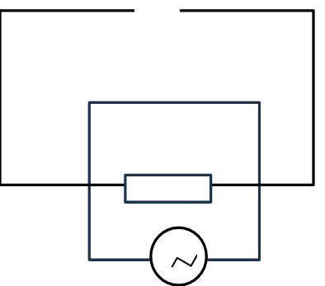

Instructions:
- Connect the circuit as shown.
- Switch on the a.c. power supply
- Determine the peak voltage from the oscilloscope, and the root mean squared voltage from the a.c. voltmeter
- Repeat for other voltages
- Use the appropriate format to determine the link between peak voltage and rms voltage.

