H

Higher Assignment
Guide Sheet A: A.C. D.C.

A.C. D.C relationship.
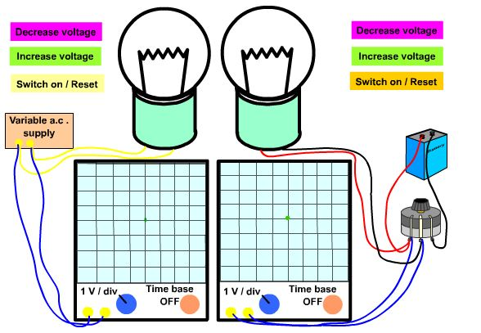
Instructions:
- Switch on the left hand lamp.
- Adjust the a.c. voltage to give a peak alternating voltage of 1 V
- Leave this circuit switched on.
- Switch on the right hand circuit.
- Adjust the d.c. voltage so that the lamp is the same brightness as the left hand lamp.
- Measure the deflection of the spot on the oscilloscope. This gives a measure of the direct voltage across the lamp.
- Alter the a.c. peak voltage.
- Plot a graph.
- State the relationship between V d.c. and V peak using the value obtained from the graph.

