Calculations for the crash scene involving car A and a pedestrian

In all serious collisions where Collision investigation is carried out ‘Skid Testing’ is carried out to ascertain the coefficient of sliding friction between in this case the road surface and the tyres.
Skid Testing is carried out in ideal conditions using the actual vehicle involved in the collision, but more normally a similar vehicle (normally a Police ‘Panda’ car), due to the damage sustained to the vehicles involved.
Skid testing is then carried out using a vehicle fitted with a ‘Skidman’ (brand name) accelerometer. The test vehicle is driven at a speed of approximately 40mph in the same direction as that travelled by the collision vehicle and in the same road and weather conditions.
The test is then carried out and the driver applies the brakes fully and quickly (like an emergency stop) with a view to locking all 4 road wheels and bringing the vehicle to a stop. If the vehicle is fitted with an Anti-Lock braking system then it is disabled prior to the skid test.
Two of these tests are carried out and if the results are within 10% of each other they are considered suitable for carrying forward for further calculations.
The lowest result is used for any subsequent calculations as this gives the lowest resultant speed for any calculations made. This is done in fairness to the driver involved.
The ‘Skidman’ provides a deceleration figure in ms⁻².
The results for this scenario are as follows
(1) -6.80 ms⁻²
(2) -7.01 ms⁻²

Car v Pedestrian answers and workings

Question 1 - What speed was the car travelling at when it started to skid?
To first calculate the velocity or speed of the car when it started to skid we use the formula v² = u² +2as.
Where v = Final velocity = 0
u = Initial velocity = ?
a = acceleration = -6.80 ms⁻²
(- figure due to it being a deceleration obtained from skid test results)
s = displacement = 24.45m (total length of the tyre skid mark)
Using v² = u² +2as
0 = u² +(2 x -6.8 x 24.45)
u² = 332.52
so u = 18.23 ms⁻¹ or 41mph.

------------------------------------------------------------------------------
Question 2 - What speed was the car doing when it collided with the pedestrian?
To calculate the velocity or speed of the car when it collided with the pedestrian we use the same formula v² = u² +2as.
To find the point of collision with the pedestrian we have to measure from the centre of the front wheels back to where the skid mark deviates slightly indicating where the contact took place. This is 7.17metres.
Where v = Final velocity = 0
u = Initial velocity = ?
a = acceleration = -6.80 ms⁻²
(- figure due to it being a deceleration obtained from skid test results)
s = displacement = 7.17m (Length of skid mark after collision with pedestrian)

Using v² = u² +2as
0 = u² +(2 x -6.8 x 7.17)
u² = 97.512
so u = 9.87 ms⁻¹. or 22mph.
-----------------------------------------------------------------------------
Question 3 - If the car had been travelling at the speed limit of 30mph would the car have still collided with the pedestrian?
Again using the same formula v² = u² +2as
Where v = Final velocity = 0
u = Initial velocity = 13.4 ms⁻¹ (30mph)
a = acceleration = -6.80 ms⁻² (- due to it being a deceleration)
s =displacement = ?

0 = 13.4112² + (2 x -6.8 x s)
13.4112² = 13.6s so s = 179.86 = 13.22m
13.6

Therefore had the car been traveling at 30mph then it would have stopped approximately 4 metres short of the pedestrian’s position, and therefore would not have hit the pedestrian.

PEDESTRIAN COLLISIONS

Direct frontal impacts are those in which the pedestrian is struck by any part of the front of the vehicle, other than the corners.
In this type of impact, the pedestrian is accelerated to close to the speed of the vehicle. The direction in which the pedestrian is projected depends on a variety of factors including:
- the point of impact on the vehicle
- the shape of the vehicle
- the pre-impact speed and direction of the pedestrian
- the speed of the vehicle.
Firstly, let's look at the case of an impact involving a car or light goods vehicle.
Pedestrians are not normally 'run over', but are 'run under'.
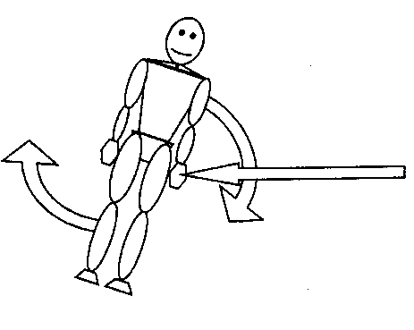
If the first point of contact with the vehicle is below the pedestrian's centre of gravity (usually about the navel), the body is thrown upwards and the vehicle passes under the pedestrian. Therefore it can be said that the pedestrian was 'run under'.
If however the initial contact strikes the pedestrian above their centre of gravity the pedestrian would be pushed downwards and would be 'run over' by the vehicle.

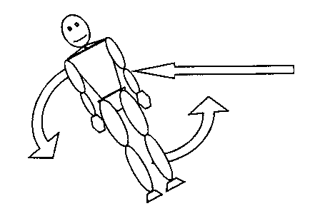
'Run over' situations are comparatively rare with cars and small vans unless the pedestrian is a child, small in stature, or is lying in the road before impact.

The final resting place of the casualty in respect to the vehicle can assist in determining whether or not there was braking at impact.

At impact, the pedestrian is accelerated up to the speed of the vehicle. If it wasn't, the vehicle would have to pass straight through the pedestrian – not the case. Should there be braking during the impact, and this is the most common situation, the pedestrian first matches velocity with the vehicle and then, as the vehicle slows at a higher rate than the pedestrian (the vehicle is subject to braking, the pedestrian is not), the pedestrian flies through the air in advance of the slowing vehicle before being brought to rest after striking the ground.

If, however, there is no braking during the collision, or braking does not occur until a very late stage, the pedestrian may pass over the top or down the side of the vehicle rather than being projected in front of it. Each of these separate contacts with the vehicle and ground may, and frequently do, cause injury.

The struck pedestrian finally comes to rest some distance from the point of impact and this distance is commonly known as the 'throw distance'. This distance has been found to be a function of the location of the pedestrian's initial contact with the vehicle, the impact speed of the vehicle and the vehicle deceleration during the time that the pedestrian is in contact with the vehicle.

Now let's examine the case of the vehicle being a lorry or a bus. Due to the shape of the vehicle, the pedestrian is most likely going to gain the full speed of the vehicle – there is no route for the pedestrian to be thrown off, other than in the direction of travel of the vehicle.

If the vehicle is undergoing braking, the pedestrian will be projected forward and will land some distance in front of the vehicle. If there is no braking, or insufficient braking, the vehicle will likely 'catch up' with the pedestrian who will probably be run over.

DAMAGE INDICATING PEDESTRIAN DIRECTION
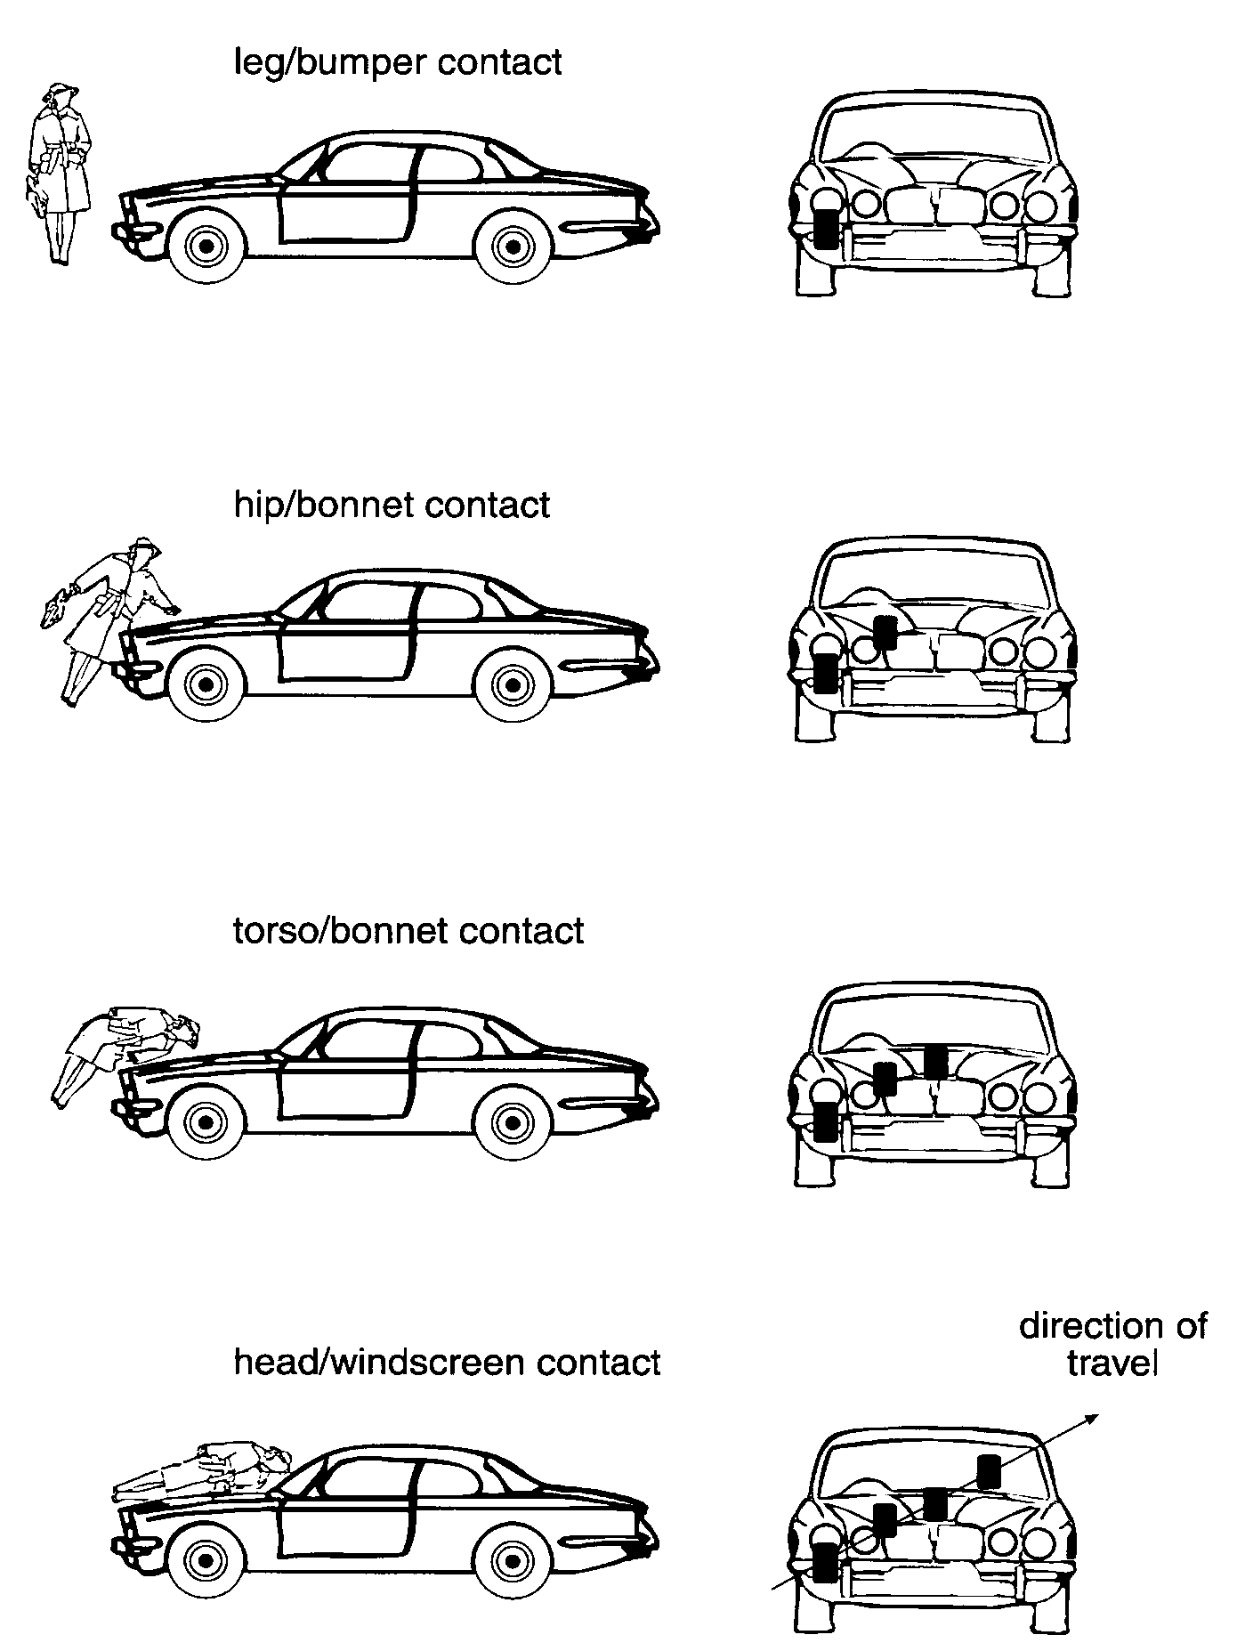

The line of damage would not normally be as obvious as this, but could still indicate a possible direction of travel for the pedestrian, when added to other evidence such as injuries to the person or the resting position after the collision for example.

