Student Activity 2
Climate Modelling
Science Background
How do forcing factors such as ozone depletion or volcanic eruptions change Earth’s average temperature? In this activity, you will explore how a climate model can be used to answer this question. A climate model is a computer program that allows scientists to isolate variables called forcing factors to determine the impact of each variable on the global temperature anomaly. The global temperature anomaly describes the change in average temperature relative to a baseline period. Normally, the energy flowing into our planet would be equal to the energy flowing out, and the temperature anomaly would fluctuate around zero. Your group will examine the data generated by the NASA Goddard Institute for Space Studies (GISS) climate model.
Part 1: Analyzing Individual Forcing Factors
1. Examine the graph assigned to your group. Read the information on the back. Discuss the following and record your consensus answers.
(a) Look at the scale and units for the vertical axis. How much has the temperature changed over the time shown? Does this seem significant to you?

(b) Look for patterns in the data. Are there cycles? Are there trends? Are there exceptions? Briefly describe three patterns that you notice.

(c) What questions do you have about the data?

2. The overwhelming majority of scientists agree that climate change is happening and that humans are the primary cause of it. However, there is still debate in the media and general public about this. Write a 140-character tweet that a climate change denier might write, using the data you have been studying to support their message. Then, describe what is misinterpreted or misrepresented in the tweet.

3. Discuss the question below that matches your assigned graph, and develop an answer as a group.
(a) AEROSOLS: Some experts have proposed increasing the level of aerosols to offset global warming. How would this work? What are some possible consequences of this idea?
(b) GREENHOUSE GASES: Some politicians have stated that an increase in carbon dioxide is good for agriculture. Describe other ways that increased carbon dioxide might impact agriculture.
(c) LAND USE: Dark-coloured objects absorb more energy than light-coloured ones. As Earth warms, there is less snow and ice covering the ground. How will melting glaciers affect the rate of climate change?
(d) OZONE DEPLETION: Ozone depletion is caused by chemicals such as chlorofluorocarbons (CFCs), which were banned in 1989. How is it possible that they are still affecting the temperature?
(e) SOLAR VARIATION: You know that the seasons on Earth are caused by the tilt of the planet. This tilt is slowly changing. How would a changing tilt affect the seasons?
(f) VOLCANIC ERUPTIONS: Volcanic eruptions are short-lived events. How long does their impact on climate last? Where do you think the material ejected by the volcanoes ends up?
Part 2: Comparing Forcing Factors
1. Form new groups with one person from each data group acting as the expert on the forcing factor considered above. Examine all of the graphs together.
(a) Put the factors in order from largest to smallest contributor. (Hint: The vertical scales are not the same for all graphs.)

(b) Group the factors by their effects: Do they increase temperature, decrease temperature, or have a negligible effect on temperature?
Effect of Forcing Factors on Temperature
Increase Temperature | Decrease Temperature | Negligible Effect
(c) Which factors are anthropogenic (made by humans)?

(d) Are you surprised by any of the graphs? Discuss.

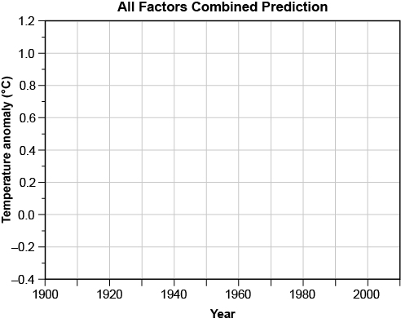
2. Use the axes provided to sketch a prediction of the temperature anomaly that you would get when you consider all of these factors at the same time. (Hint: Three of the factors have essentially no impact and can be omitted.) When you are finished, show your prediction to your teacher and get the actual modelling data for all forcings combined.

3. The Temperature Change Due to All Forcings Combined graph shows the average temperature anomaly generated by the model when all forcing factors are included. Examine it closely, and compare it to your prediction and the individual graphs to answer the following questions.
(a) What is the overall trend when all the forcing factors are combined?

(b) There are several noticeable dips in the graph. What do you think caused these changes?

4. The Observed Global Temperature Anomaly graph combines data collected by thousands of weather stations around the world since 1900. Examine it closely and discuss the following with your group:
(a) What is the overall trend? Does it match up with the trend predicted by the models?

(b) The Paris Accord set a target of keeping the anomaly below 2°C above pre-industrial levels. Use the data to estimate when we will reach that level if we don’t change anything.

Consolidate Your Learning
Answer the following questions to check your understanding of climate modelling, forcing factors, and climate change data.
1. What are the two most significant forcing factors? How are they similar? How are they different?

2. Some climate change deniers say that the current trend in temperature is due to natural events.
Is this statement supported by data? Give examples.

3. Write a 140-character tweet that expresses your opinion on climate change data.

4. Your cousins don’t believe that climate change is caused by humans. Refer to the information in this activity, and outline how you would respond to them.

5. What personal actions are you willing to take to reduce your impact on the climate? List at least two, and explain how these actions will help.

