Student Activity 3
A Warming World
Part 1: Where will the heat go?
Humans are emitting greenhouse gases into the atmosphere, causing more and more heat to be trapped. But what effect will this have? Your teacher will demonstrate a set of simplified models of Earth’s climate, which you will use to explore the answer to this question.
1. Form a group of three or four. Before watching each demonstration, predict and explain what you think will happen in column 2 of Table 1.
Safety Alert
Heat sources can cause burns. Follow the safety rules outlined by your teacher.

2. Observe and explain the demonstrations and record your observations and explanations in column 3. Use the space in column 4 to make a sketch to support your explanation. Some demonstrations may take 10–15 minutes, so take turns checking their progress.
3. These models allow us to make inferences about our changing climate. Using your observations, answer the questions in column 5.
Part 2: Data from the Sea
Our oceans have absorbed 90% of the excess heat trapped by increasing amounts of greenhouse gases. Measurements of the oceans suggest they are undergoing significant changes. Your teacher will provide you with a set of data cards. Take turns reading the cards, and use the data to answer these questions.
1. What does Argo tell us about how the volume of the ocean is changing over time?

2. What does GRACE tell us about how the mass of land ice in Antarctica and Greenland has changed over time?

3. What do satellite altimetry measurements tell us about how sea level has changed over time? How do these measurements compare to historic tide gauge measurements?

4. Examine the images below, showing the retreat of a glacier and the decline of sea ice in the Canadian Arctic. Brainstorm possible consequences of these changes for humans and animals.
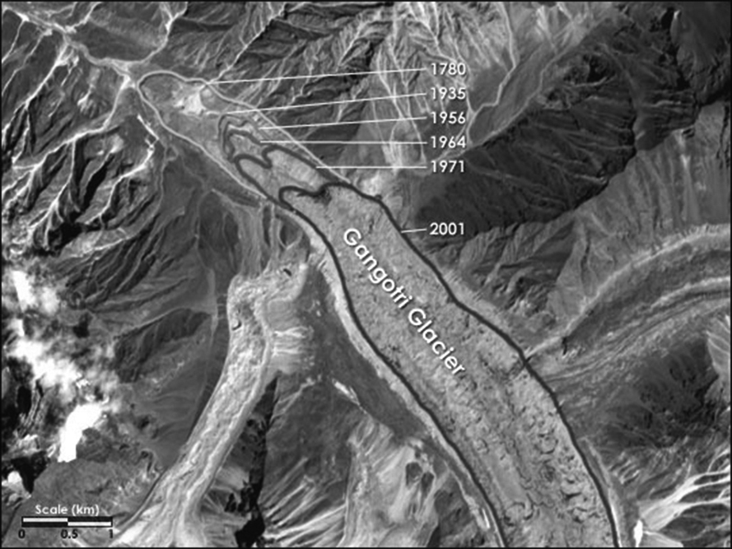  Credit: NASA Earth Observatory  Like the vast majority of glaciers, the Gangotri Glacier in the Himalayas has shown a consistent retreat. | 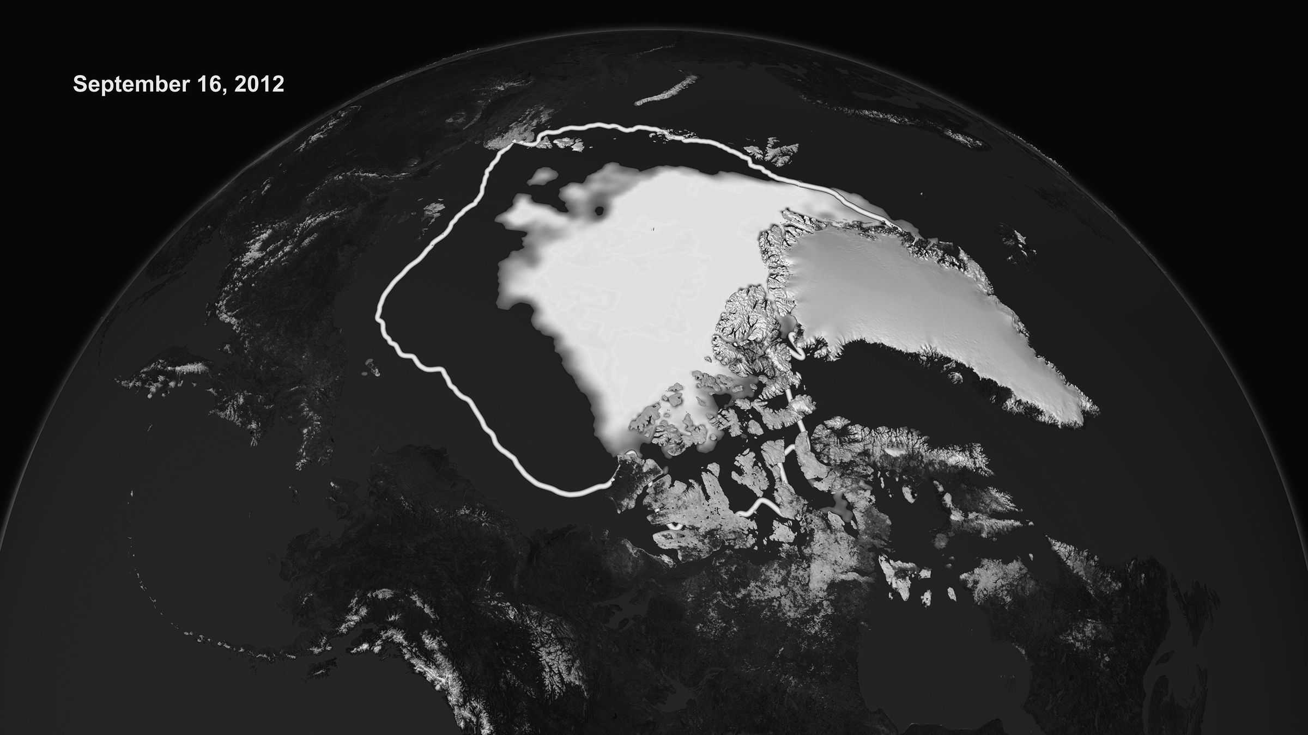  Credit: NASA/Goddard Space Flight Center Scientific Visualization Studio  The sea ice in the Canadian Arctic in 2012 has declined significantly compared with 30 years ago (yellow line).

5. Over 40% of the world’s population lives within 100 km of a coast. Scientists project that sea levels will rise by 0.50–1.65 m by the year 2100. Examine the flood risk map suggested by your teacher. Brainstorm consequences of sea level rise on populations and infrastructure.

6. Your friends in central Canada tell you they aren’t worried about sea level rise since they don’t live near an ocean. In what ways might populations living far from a coast be affected?

Table 1
1. Demonstration | 2. Predict and Explain | 3. Observe and Explain | 4. Sketch a Model | 5. Infer
Balloon with air and balloon with water  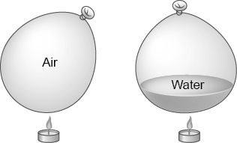 | Which balloon will pop first when held over a flame? Why? | Observations:  Explanation: |  | As the planet continues to warm, where will most of the additional heat be stored? In the atmosphere or in the ocean?
Water bottle with heat source  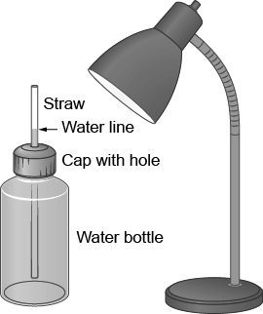 | What will happen to the water level in the straw as the water absorbs heat? Why? | Observations:  Explanation: |  | How will the volume of the ocean change if it absorbs heat?
Container with water and ice and container with water, rocks, and ice  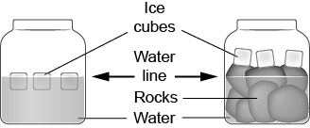 | What will happen to the water level in each container over time? Why? | Observations:  Explanation: |  | How will melting land ice and sea ice affect sea levels?

Consolidate Your Learning
Answer the following questions to check your understanding of concepts relating to the effects of climate change.
1. Some friends are discussing an article stating that the global average temperature has increased by less than a degree since 1880. They wonder whether the climate is really changing. How might you respond?

2. Examine this sketch of different types of ice. Circle the types that will contribute to sea level rise. Explain your answer in the space below.
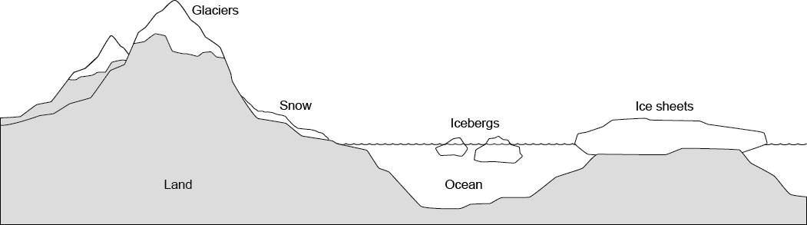

3. How might sea level change affect you and your community? Specifically consider the financial costs to individuals. What could your community do to lessen the effects?

4. How might decreasing sea ice and rising sea levels affect Inuit communities in the far North?

