Student Activity 5—Sheet 1
How Much Carbon Is in That Tree?
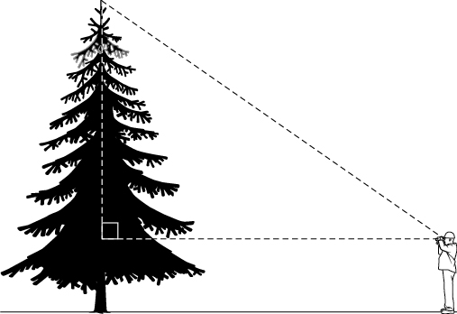
Part 1: Calculating the Height of the Tree
1. Measure the following:
(a) distance from observer to tree (in metres to two decimal places)
(b) angle of elevation of the top of the tree (to the nearest degree)
(c) distance from the ground to the observer’s eye (to two decimal places)
2. (a) Add your measurements to the illustration on the right.
(b) Calculate the height of the tree in metres (to one decimal place)
Part 2: Calculating the Size of the Tree
The shape of a tree changes with its height. Most of the mass of the tree is in its trunk, but some is in its branches and roots. To approximate the volume of a tree, we will treat it as a cylinder. The volume of a cylinder is given by the formula V  πr2h.
A tree trunk tapers, so measuring its circumference at the bottom will give a value that is too big. By convention, foresters use the circumference measured 1.30 m above the ground to provide a good approximation of the radius of the trunk (i.e., the cylinder).
- Measure the circumference of the tree trunk in centimetres at a height of 1.30 m up the trunk. Round to the nearest centimetre.
C 

2. Calculate the radius of the trunk of the tree at this height. Remember that C  2πr, where C is the circumference in centimetres, r is the radius in centimetres, and π is about 3.14. We can rearrange this equation to get
$$r=\frac{C}{2π}$$ 
3. Convert this to metres. Round your answer to two decimal places.
r 
Part 3: Calculating the Mass of Carbon Dioxide Trapped by the Tree
1. Calculate V, the volume of the tree (in cubic metres, m3) using the formula V  πr2h, where r is the radius of the tree in metres, h is the height of the tree in metres, and π is about 3.14.
V  πr2h
V 
2. Calculate the mass of the tree (in kilograms) using the following densities for wood:
• hardwood (e.g., oak, maple, poplar) is about 700 kg/m3
• softwood (e.g., pine, cedar) is about 400 kg/m3
mass 
Since about 20% of a tree’s mass is in its roots, multiply this by 1.25 to better approximate the mass.
mass 
3. About 65% of a tree is solid matter and about 50% of the solid matter is carbon. Calculate the mass of carbon in the tree (in kilograms) using the equation
mass of carbon  mass × 0.65 × 0.50
                          
4. Thus,
mass of CO2 trapped  mass of carbon × 3.67 (See below for explanation.)
                                   
Ratio of Mass of Carbon Dioxide to Mass of Carbon
Carbon has an atomic mass of 12 u (atomic mass units).
When one carbon atom is combined with two oxygen atoms (each with an atomic mass of 16 u), the carbon dioxide molecule has a mass of 12 u  (16 u × 2)  44 u.
Thus, the mass of carbon dioxide captured is actually $\frac{44 u}{12 u}$ or about 3.67 times the mass of carbon in the tree.

