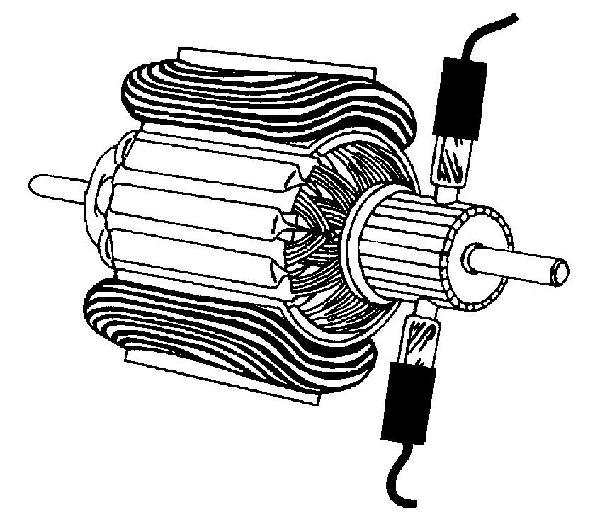
1995 Credit Paper

1. a.i. 800 kHz (from dial) (1)
ii. = 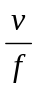 = 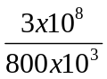 = 375 m [½,½,1]
b. i. simple wave, same shape a envelope of modulated wave.

(1)
ii. wave should have short wavelength, and amplitude should not change.

(1)
- Same envelope shape, longer wavelength than in question.

(2)
c. Long wave would be better because it has the longer wavelength, long wavelengths diffract better round obstacles [1,1]

2. a. i. If one bulb fails the others will remain on in parallel, but in series if one fails they all go out (1)
ii. 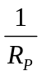 = 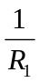 + 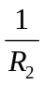 + 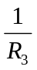
= 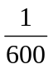 + + 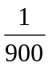
= 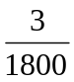 + + 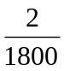 = 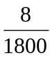
R_{P} = 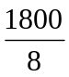 = 225  [½,½,1]
b. E_{p} = mgh = 70 x 10 x 900
= 630 000 J
= 630 kJ = 6.3 x 10⁵ J [1]
c. E_{p} = mgh = 70 x 10 x 900
= 630 000 J
= 630 kJ = 6.3 x 10⁵ J [1]

3. a.i. A –R (1)
B – 1. hair dryer is double insulated so it does not need an Earth wire [1]
2 - hair dryer uses 5A so 3A flex would not cope [1]
ii. R = 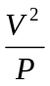 = 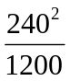 = 48
(1 for mains voltage, then ½,½,1)
iii.
field coils [1]
b. i. Permanent magnets (1)
ii.. The current is in opposite directions in both arms [1]
iii. The brush provides good electrical contact with the commutator. The commutator ensures that the current is always in the correct direction to provide the appropriate upward/downward force. [1,1]

4. a. Right kidney, it has not got rid of the radioactive material (1,1)
b. X (1)
c. 1. alpha radiation could not pass through the skin [1]
2. alpha radiation is highly ionising [1]

5. a. i. It concentrates the X-rays on the cancerous tissue, and has minimal effect on the healthy tissue surrounding it. (2)
ii. To target the cancerous tissue accurately (1)
b. i. ₄ [1]
ii. Normal [1]

6. a. power gain = 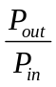 = 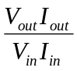
= 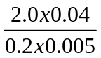 = 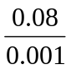 = 80 (3)
b. Frequency is unchanged 100 Hz [1]

7. a.i. V₁ = 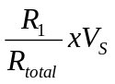 = 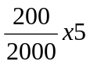
= 0.5 V [½,½,1]
ii. V₂ = V_{S} - V₁ = 5 – 0.5 = 4.5 V (1)
b. i. as brightness increases, resistance decreases [1]
ii. V₁ increases, V₂ decreases (2)
iii. as V₁ increases it will get to more than 0.7 V which switches on the transistor, allowing current to flow through the LED lighting it up. (2)

8. a. OR gate [1]
b.
X | Y | Z
0 | 0 | 0
0 | 1 | 1
1 | 0 | 1
1 | 1 | 1
[2]
c. It could switch on when master switch is on during the day (1)
d. Use an AND gate (1)

9. a. speed = 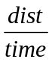
= 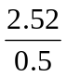 = 5.04 km/h [½,½,1]
b. distance was smaller, he should have measured step length from heel on floor to heel on floor. The length measured was greater than actual distance. (2)
c. he should have measured step length from heel on floor to heel on floor. (1)

10.a.i. 8 s (1)
ii. distance = area under graph
= lb + ½bh
= 8x35 + ½x7x35
= 280 + 122.5
= 402.5 m [3]
- a = 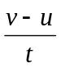 = 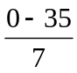
= - 5.04 m/s² [½,½,1]
iv. F = ma = 380 x 5
= 1 900 N = 1.9 kN [½,½,1]
b. i. 1. during AB there is twice the force applied as in BC (1)
2. during BC the mass is greater than in AB (1)
ii. The slope of the graph will reduce still further (or even become level) (1)

11. a.i. as field lines are cut a voltage is induced in the coil [1]
ii. 1 – more coils of wire [1]
2 – stronger magnet [1]
b.i. X – step up transformer – increases the voltage [1]
Y – step down transformer – decreases the voltage [1]
ii. total resistance = 100 x 2 = 200 (1)
P_{lost} = I²R = 200²x200
= 8 x 10⁶ W = 8 MW (½,½,1)

12. a. E_{H} = cmT
= 4 180 x 1.52 x (100 – 19.5)
= 4 180 x 1.52 x 80.5
= 5.11 x 10⁵ J
(1 for 4180 then ½,½,1)
b. P = 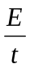 = 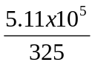
= 1.57 x 10³ W = 1.57 kW [½,½,1]
c. i. Some energy lost due to boiling for short time (1)
ii. Don’t allow it to boil (1)
d. E_{H} = mL = 0.1 x 22.6 x 10⁵
= 2.26 x 10⁵ J [½,½,1]

13.a.i. The image will be dimmer, but may well be sharper [2]
ii.

[3]
b. i. P – Ultraviolet, Q – Infra red [1]
ii. f = 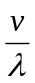 = 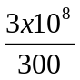 = 1x10⁶ Hz = 1 MHz
(1 for speed of light, then ½,½,1)
c. the radio waves are reflected by the reflector and focussed/concentrated onto the detector/aerial [2]

14. a. E_{K} = ½mv² = ½x2x70 000²
= 4.9 x 10⁹ J = 4.9 GJ [½,½,1]
b. Its kinetic energy is converted into heat due to air resistance and it will melt or burn up. (2)

Total marks KU [50]
PS (50)

KU & PS

Grade 1 - ≥ 35
Grade 2 - ≥ 25
Grade 7 - ≤ 24

(N.B. half marks are rounded up)

1996 Credit Paper

1. a. i. It is rotating at the same sate as the Earth, it remains above the same point on the Earth’s surface [1,1]

ii. = = 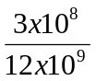 = 0.025 m (½,½,1)

b. time = 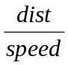 = 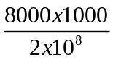

= 0.025 m (1 for speed in fibre, ½,½,1)

2. a. photographic film, skin, IR diode [1]

b. tuner (1)

c. the more electrons hitting the screen per second the brighter it will glow (2)

d. i. white : red, green and blue (1)

ii. yellow : red and green (1)

e. Vary the ratio of red to green [2]

3. a.i. sidelights (½)
ii. no lights (½)
b. i. P_{total} = 4xside + 2xhead
= 4x5 + 2x21
= 20 + 42 = 62 W (1)
I = 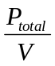 = 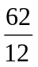 = 5.17 A (½,½,1)
ii. The headlight has the lower resistance because it has the greatest power, as they all operate from a 12 V supply it must have a larger current flowing throught it and as a result a lower resistance. (1,1)
c.

brakelights
battery

(1 or any connection that would work)

4. a. figure 2 – downwards
figure 3 – upwards (1,1)
b. i. A – WX – into the page
YZ – out of the page [1]

B – WX – upwards

YZ downwards [1]
C - clockwise [1]
ii. The brushes ensure good electrical contact with the commutator. The commutator ensures that the current is always flowing in the correct direction, i.e. into the page in the LH arm and out of the page in the RH arm [3]
c. i. It makes the motor more powerful OR makes the rotation smoother [1]
ii. Field coils are lighter than permanent magnets [1]

5. a.i. The X-ray receiver should be placed to the left of the knee in the diagram (1)
ii. Ultrasound works by reflection, X-rays works by transmission (1)
iii. t = 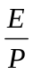 = 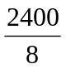 = 300 s [½,½,1]
b. i. 20 kHz OR 20 000 Hz (1)
ii. 1 500 m/s (1)
iii. absorbed (1)

6. a. The source could be /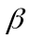 or / because the lead would stop both
and . (1,1)
b. Any one from : do not eat in lab, wear gloves, handle with tongs, do not point at body especially eyes etc. [1]
c. i. Radiactivity is a random process so many reading should be taken then averaged (1)
ii. Plot a graph of count rate against time. From the graph see how long it takes for the count rate to half. (1,1)
d. 4 half lives in 2 minutes [1]
80040020010050 kBq [1]

7. a.i. When hands come in the light level decreases, the resistance of the LDR increases, so the voltage across the LDR increases. The transistor switches on, and the relay closes switch 1. [3]
ii. V_{LDR} = 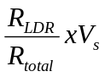
= 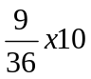 = 2.5 V [½,½,1]
- A capacitor should be placed between P and Q
(1)

8. a.i. OR gate [1]
ii. AND gate [1]
iii.
Input P | Input Q | Output 1 | Output 2
0 | 0 | 0 | 0
0 | 1 | 1 | 0
1 | 0 | 1 | 0
1 | 1 | 1 | 1
[2]
8 b. i. Output 1 means a car on either side of the road, out put 2 means a car on both sides of the road at the same time which is less likely (1,1)
ii. 2 (1)
iii. 8 (1)

9. a.i. a = = 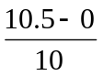
= 1.05 m/s² [½,½,1]
ii. distance = area under the graph
= ½bh + lb + ½bh
= ½x10x10.5 + 40x10.5 +
½x10x5.5
= 52.5 + 420 + 27.5
= 500 m [3]
b. i. A – push is greater than air friction (1)
B – push is equal to air friction (1)
ii. Small frontal area, streamlined suit, hat to stop drag from hair etc. (1)

10. a. E_{P} = mgh = 60x10x2 = 1 200 J [½,½,1]
b. P = 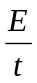 = 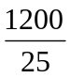 = 48 W [½,½,1]

11. a. Heat is a measure of how much energy an object has, temperature is a measure of how hot something is. [1,1]
b. i. The foam filled walls cut down heat loss by conduction and convection, because foam is a poor conductor of heat and it stops the movement of air within it. (1)
ii. The shiny outer casing reduces heat loss by radiation because any radiated heat will be reflected back towards the bottle (1)
c. E_{H} = cmT
= 4 180 x 0.5 x (40 – 25)
= 4 180 x 0.5 x 15
= 31 350 J [½,½,1]
t = = 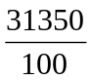 = 313.5 s [1]
d. There is also the bottle and the milk to heat up (1)

12. a.i. P = VI = 110 x 18 = 1 980 W [½,½,1]
ii. Transformer S (1)
b. 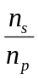 = 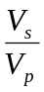 so 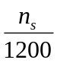 = 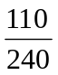
n_{s} = 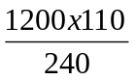 = 550 turns [½,½,1]
c. i. P_{in} = VI = 240 x 11 = 2 640 W [1]
Eff. = 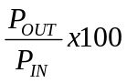
= 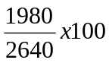 = 75 % [½,½,1]
ii. energy is lost through noise, vibration, heating up (2)

13. a. upwards – engine thrust
downwards – weight (1)
b. The thrust is greater in size than the weight (1)
c. a = = 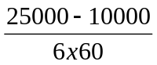
= 41.7 km/h/s (½,½,1)
d. w = mg = 83 x 1.6 = 132.8 N (½,½,1)
e. Kinetic energy is converted into heat energy [1]

Total marks KU [50]
PS (50)

KU & PS

Grade 1 - ≥ 35
Grade 2 - ≥ 25
Grade 7 - ≤ 24

(N.B. half marks are rounded up)

1997 Credit Paper

1. a. f = = 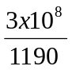 = 252 100 Hz
= 252.1 kHz [½,½,1]
so tuned to long wave (LW) (1)
b. i. FM is not received because it has a short wavelength, which diffract the least [2]
ii. Satellite broadcasts come from above and don’t have to diffract round the hills like terrestrial signals from the transmitter (2)

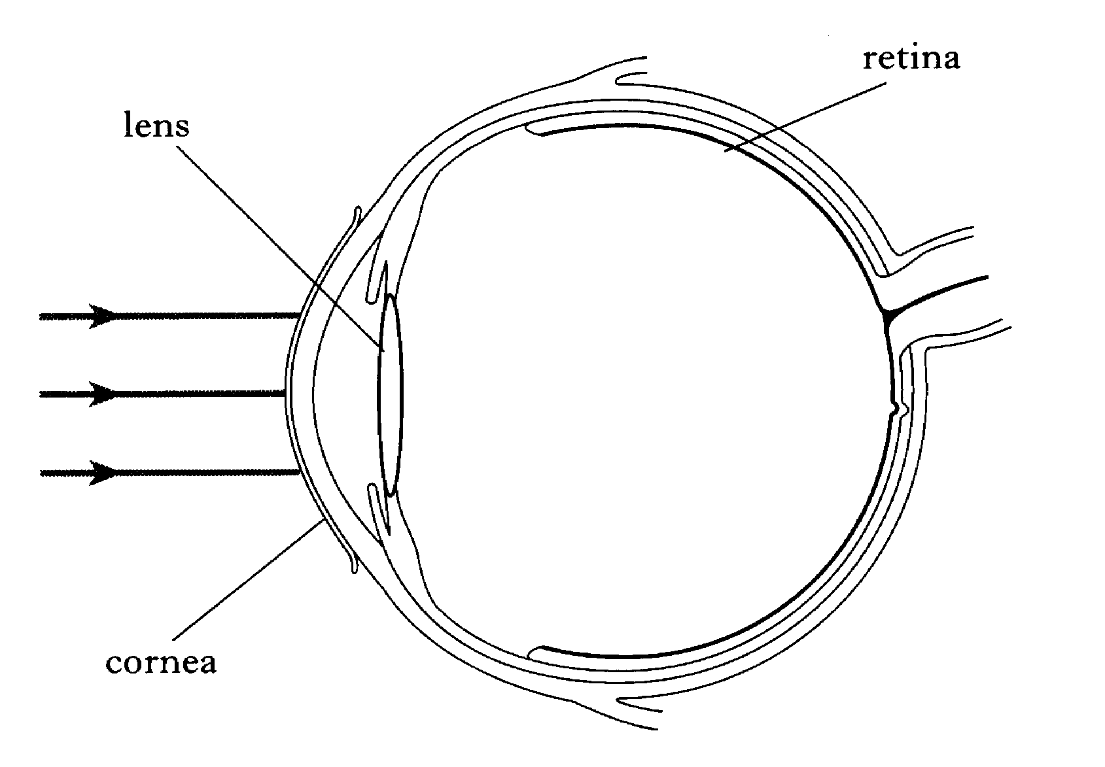
2. a. any 2 from – less repeaters required / less attenuation/signal loss OR cables less bulky, easier to install, cheaper OR more secure, not able to be tapped etc. [2x1]
b. The signal travels more quickly in electrical wires, but the optical signal would be quicker because the switching at the exchange is electronic not mechanical (1,1)
c. i. 4.0 kHz (twice the frequency of X) (1)
c. ii. 0.25 V (half the amplitude of X) (1)

3. a.
Switch S₁ | Switch S₂ | Motor | Lamp L₁ | Lamp L₂
Open | Open | OFF | OFF | OFF
Open | Closed | OFF | ON | ON
Closed | Open | ON | OFF | OFF
Closed | Closed | ON | ON | ON
(2)
- R = = 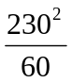
= 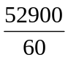 = 882 [1,1,1]
c. = + +
= 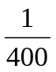 + 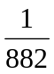 +
= 4.77 x 10⁻³
R_{P} = 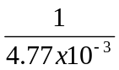 = 210 [½,½,1]

4. a. alternating (1)
- 4 V [1]
- The peak voltage will be bigger
(V_{rms} = 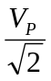 = 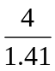 = 2.84 V) [1]

5. a. The resistance increases as the current increases. This is because the gradient of the graph (R = 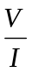) is steadily increasing
(3)
- When V = 12 V, I = 1.8 A (1)
P = VI = 12 x 1.8 = 21.6 W (½,½,1)

6. a.i.

[1 – refn. at lens, 1 – refn. at cornea]
ii. f = 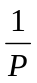 =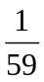 = 0.017 m
= 1.7 cm [½,½,1]
b. i. The rays of light coming from the bulb are not parallel (1)
ii. Put the bulb further away, or use a distant object to form the image (1)
c.
Lens part | Power
X | 4 D
Y | 2 D
(1)

7. a.i. Half life is the time taken for the activity of a source to drop to half its original value [1]
ii. So that the radioactivity dies away quickly so that no harm is done to the body following the diagnosis (1)
iii. 600 300 150 75 (2)
3 half lives, so it can be safely disposed of after 18 hrs (1)
b. any 2 from, distance, shielding, time of exposure, type of radiation, type of absorbing tissue [2x1]
c. i.
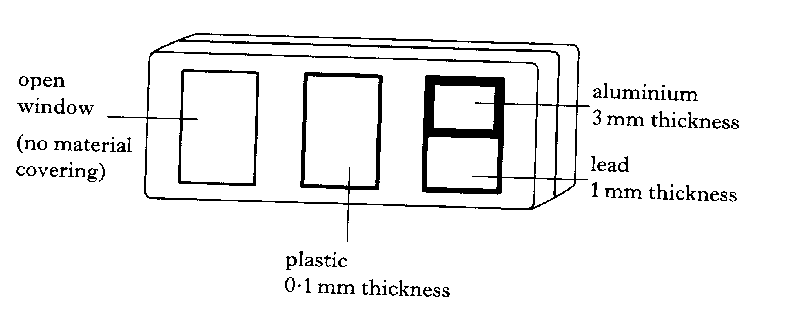

(1)
ii. The darker the film the greater the amount of radiation received. [1]

8. a. V₁₀₀₀ =
= 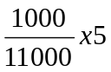 = 0.45 V [½,½,1]
- When package is in front of light sensor, the sensor is dark. This would mean the voltage would drop to below 0.7 V, therefore switching off the relay and switching off the motor (3)

9. a.
 | Logic level at X | Logic level at Y
Capacitor charged | HIGH | LOW
Capacitor uncharged | LOW | HIGH
[4x½]
b. 1 Hz (1)
c. Reduce the size of the capacitor OR reduce the size of the resistor, either will increase the frequency of the pulse generator [1,1]

10. a.i. speed = = 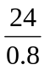 = 30 m/s [½,½,1]
ii. Reduce the distance between the arrows (1)
b. i. v = u + at = 30 + (-4.5x5)
= 30 – 22.5 = 7.5 m/s [½,½,1]
ii. F_{U} = ma = 72 x 4.5 = 324 N (½,½,1)
50 % from seat belt = 0.5 x 324
= 162 N (1)

11. a. E_{P} = mgh = 65x10x6
= 3 900 J [½,½,1]
b. i. Weight [1]
ii. w = mg= 65 x 10 = 650 N [½,½,1]
c. speed
(m/s)
7

Time (s) 0.7 (2)
d. distance = area under graph
= ½bh = ½x0.7x7
= 2.45 m (3)

12. a. As the magnet is turning field lines are being cut by the coil inducing a voltage in the coil (1,1)
b. voltage

time (1,1)

13. a.i. liquid gas (1)
ii. energy is required to change a liquid into a gas, this energy is taken away from the food keeping it cool [1]
b. E_{H} = mL = 0.2 x 3.34x10⁵ = 6.68x10⁵ J
= 66 800 J = 66.8 kJ [½,½,1]

14. a. = so 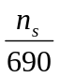 = 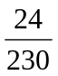
n_{s} = 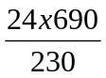 = 72 turns (½,½,1)
b. if 100% efficient P_{in} = P_{out} so
4.6 = V_{P}I_{P} = 230 x I_{P}
I_{P} = 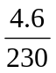 = 0.02 A = 20 mA (½,½,1)
c. energy is lost as heat, vibration and noise [1]

15. a. E_{K} = ½mv² = ½x16 000x2²
= 32 000 J [½,½,1]
b. It moves at const speed in straight line (1,1)
c. Fire thrusters rockets for same length of time in opposite direction (1,1)

16. a. weight of mirror on Moon is less than on Earth, g_{Earth} = 9.8, g_{Moon} = 1.6 (1,1)
b. d = vt = 3x10⁸ x 2.56 = 7.68x10⁸ m [½,½,1]
actual dist is half of this = 0.5 x 7.68x10⁸
= 3.84x10⁸ m [1]
c. time for laser light and radio are the same (1)
d. i. P – microwaves
Q – Infra red [1]
ii. S shows increasing wavelength
R shows increasing frequency [1]

Total marks KU [48]
PS (50)

KU PS

Grade 1 - ≥ 34 ≥ 35
Grade 2 - ≥ 24 ≥ 25
Grade 7 - ≤ 23 ≥ 24

(N.B. half marks are rounded up)

1998 Credit Paper

1. a.

[1]
b. t = 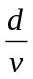 = 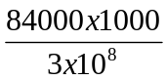 = 0.28 s (½,½,1) (1 for speed of microwaves)

2. a. i. Infra red (1)
ii. It detects heat given off by the body (1)
b. Green & blue (1)

3. a. E_{H} = cmT = 4 180x5x24 = 501 600 J
= 5.01 x 10⁵ J [½,½,1]
b. P = = 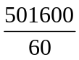 = 8 360 W
= 8.36 kW [½,½,1]
c. The flow rate would be less, because the water coming in would be colder than 16 ⁰C (1,1)

4. a. E_{H} = cmT = 4 180x5x24 = 501 600 J
= 5.01 x 10⁵ J (½,½,1)
b. R = 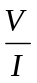 = 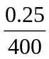 = 6.25 x 10⁻⁴ (½,½,1)
length = 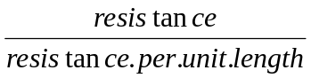
= 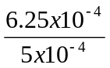 = 1.25m (1)
- X - commutator
Y – field coils [1]
d. t = 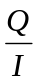 = 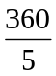 = 72 s [½,½,1]

5. a. P = 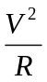 = 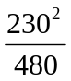 = 110 W [½,½,1]
b. = + +
= 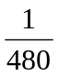 + 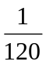 + 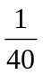
= + 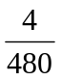 + 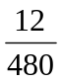 = 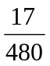
R_{P} = 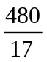 = 28.2 [½,½,1]
c. I = 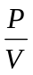 = 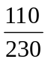 = 0.48 A [½,½,1]
6. a.

[1 – concave lens, 1 – divergence at lens,
1 – retinal focus]
- P = 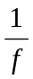 = 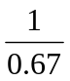 = 1.49 D [½,½,1]

7. a. Q – it cuts out UV but allows most radiation in the visible to pass through (1,1)
b. R – cuts out UV but reduces the amount of visible getting through, cutting down the amount of light from the Sun and reflected from the snow. (1,1)

8. a. The time taken for the activity of the source to drop to half is original value.
[1]
b. i. 800 400 200
2 half lives so time is 2 x 6 hours
= 12 hours (1,1)
ii. Lungs and thyroid as they need less than 200 MBq which is the value at 8 p.m. (1,1,1)
c. Dose equivalent, measured in sieverts [1,1]

9. a. P

Q [1]
b. i. V₁ = 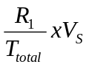 =
= 0.45 V [½,½,1]
ii. When dark the resistance of the LDR is high so the voltage across it is high and the input to the transistor is low. If it is less than 0.7 V the transistor is off and so no current will flow through the LED. (½,½,½,½)
c. Swop the LDR and 1K resistor OR put a NOT gate between resistor and the transistor (1)

10. a. 4 Hz (1)
b. i. NOT gate [1]
ii. R₂ has a lower resistance because it generates a higher frequency (1,1)
c. P, when switch is closed all the voltage is across the 1K resistor, so it would give a high (logic 1) output. (1,1)

11. a. W = Fd = 65 000 x 150 = 9 750 000 J
= 9.75 MJ = 9.75 x 10⁶ J [½,½,1]
b. E_{P} = mgh = 8 500 x 10 x 110
= 9 350 000 J = 9.35 MJ
= 9.35 x 10⁶ J [½,½,1]
c. dist = area under graph = ½bh + lb
= (½x4x40) + (4x5)
= 80 + 20 = 100 m [½,½,1]
d. The value would be less than 10 m/s², due to friction and air resistance. (1,1)
e. Set up a light gate, measure the length of the car,
use speed = 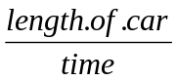 [1,1]

12. a. dist = speed x time, so speed is the same on each occasion and so is the thinking time (1,1)
b. a = 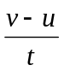 = 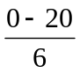
= - 3.33 m/s² (½,½,1)
c. F = ma = 1 500 x 3.33
= 5 000 N = 5 kN [½,½,1]
d. Greater mass with same force means the acceleration would be less, so the stopping distance would be greater. (1,1)

13. a. The maximum value for sunlight coincides with the minimum for average wind speed, guaranteeing all year round energy. (1,1)
b. Transformers will not work with direct current, so alternating current is needed. (1)
c. = so 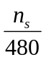 = 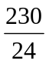
n_{s} = 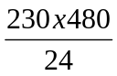 = 4 600 turns [½,½,1]
d. Line Y is high voltage so the current is less. Power loss is I²R, so lowering current lowers the power loss. (1,1)

14.a. i. X – thrust, Y - weight (1)
ii. w = mg = 2.05x10⁶x10
= 2.05x10⁷ m/s [½,½,1]
iii. F_{U} = 2.91x10⁷ - 2.05x10⁷
= 8.6x10⁶ N [1]
a = 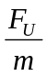 = 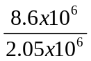
= 4.2 m/s² [½,½,1]
b. i. v = 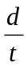 = 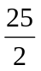 = 12.5 m/s [1]
ii. v = u + at = 0 + 1.6x2 = 3.2 m/s [1]

15. a.i. weight per unit mass [1]
ii. 1.6 m/s² [1]
b. i. v = = = 12.5 m/s [½,½,1]
ii. v = u + at = 0 + 1.6x2 = 3.2 m/s [½,½,1]
iii. the distance would be less, it would take less time to fall, so would have less time to travel horizontally. It would also be affected by air resistance (1,1,1)

Total marks KU [50]
PS (50)

KU PS

Grade 1 - ≥ 35 ≥ 35
Grade 2 - ≥ 25 ≥ 25
Grade 7 - ≤ 24 ≥ 24

(N.B. half marks are rounded up)

1999 Credit Paper

1. a. λ = = 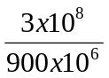 = 0.333 [½,½,1]
- T₂ is now closer, or T₁ is behind a hill (1)
c. i. The transmitter might be out of sight, might be broken or might be too far away (1)
- The telephone box transmits its signals by wire and does not need to rely on a radio signal. (1,1)

2. a. i. An electron gun scans across the screen, taking 625 horizontal lines to make one picture. Where the screen is black no electrons are fired at the screen, but where the screen is white, many electrons hit the screen causing the phosphors to glow. [1,1]
ii. We are used to seeing 25 pictures per second which gives the impression of continuous movement, but 3 pictures per second leaves too long a gap between pictures to achieve this. [1,1]
b. i. white (1)
ii. red (1)
- yellow (1)

3. a. The live wire is where the electricity enter the appliance [1]
b. Circuit 3 has two wires giving two routes for the current to follow (1,1)
c. To protect the wiring in the house [1]
d. Easily reset OR reusable [1]
e. Circuit 1 (lowest current) [1]

4. a. P = = 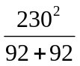 =287.5 W (½,½,1)
b. i. 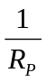 = 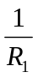 + 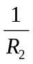 = 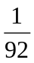 + = 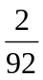
R_{P} = 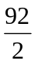 = 46 [½,½,1]
ii. I = 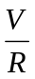 = 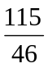 =2.5 A [½,½,1]
iii. The fuse will blow because the current will be 5A (twice the voltage, twice the current) (1,1)

5 a. A change in speed or direction of travel (normally caused by a change in medium) [1]
b. Lens 1 could be made more powerful so that it bends the light more than lens 2 (1,1)
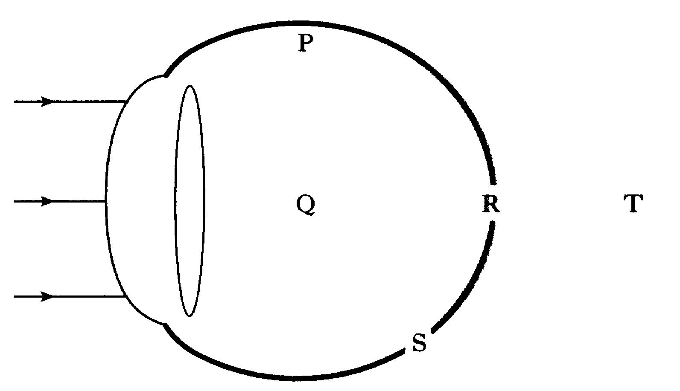
c. i.

[1]
ii. A concave (1)
B f = = 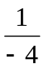 = - 0.25 m [½,½,1]
iii. Less curvature means the focal length would be longer (1)

6. a. 8 minutes (1)
b. The radioactivity does not drop off as quickly, so the blood must not be flowing out of the ankle as quickly (1)
c. i. Na-24 (1)
ii. Y-86, beta so not penetrating enough
Tc-96, half life too long (2x1)
d. 10 kBq5 kBq2.5 kBq1.25 kBq
Three half lives so 3 x 2.7 days
= 8.1 days [1]

7. a. 0 V (1)
b. i. It reduces the current through OR the voltage across OR protects the resistor [1]
ii. V_{R} = V_{S} – V_{LED} = 5 – 2 = 3 V [1]
R = = 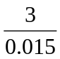 =200 [½,½,1]
c. i. NOT gate (inverter) (1)
ii. When one is OFF the other will be ON and vice versa (1)
d.
Capacitor condition | Voltage at P (V) | Voltage at Q (V)
Charged | 5 | 0
uncharged | 0 | 5
[2]

8. a. distance = area under graph
= ½bh + lb + ½bh
= ½x3x40 + 12x40 + ½x12x300
= 60 + 480 + 1 800
= 2 340 m [3]
b. i. a = = 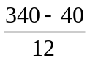
= 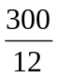 = 12.5 m/s² [½,½,1]
- F = ma = 10 000 x 25
= 250 000 N [½,½,1]
iii. F_{friction} = F_{engine} - F_{unbal}
= 276 000 – 250 000
= 26 000 N (½,½,1)
c. They increase the drag/make the car less streamlined, so increasing the friction force upon it. [1]

9.a. i. E_{P} = mgh = 80 x 10 x 12.8
= 10 240 J [½,½,1]
ii. A W = Fd = 40 x 112
= 4 480 J (½,½,1)
B E_{K} = E_{P} - W = 10 240 – 4 480
= 5 760 J [½,½,1]
b. i. It remains the same [1]
ii. It steadily increases
(by 10 m/s every sec) [1]
iii. d = vt = 6 x 0.4 = 2.4 m [½,½,1]

10. a. E_{H} = cmΔT = 4 180 x 0.5 x (100 – 20)
= 4 180 x 0.5 x 80 (1 for 80)
= 167 200 J (½,½,1)
b. i. E = Pt = 600 x 8 x 60
= 288 000 J [½,½,1]
ii. Excess = 288 000 – 167 000
= 120 800 J (1)
m = 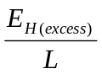 = 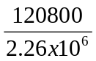
= 0.0535 kg = 53.5 g (½,½,1)
ii. heat, temperature (in that order) [1]

11.a. i. a.c. voltmeters because transformers only work with a.c. voltages [1,1]
ii.
 | Primary voltage (V) | Secondary voltage (V)
line X | 2 | 1
line Y | 2 | 2
line Z | 2 | 4
(3 x 1)
iii. line X (1)
iv. = so 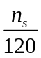 = 
n_{s} = 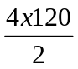 = 240 turns (½,½,1)
b. i. Eff. = 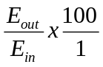 = 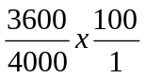
= 90 % (½,½,1)
ii. Energy is lost as heat to surroundings, by vibration, by noises [1]

12. a.
Radiation 1 | Radiation 2 | Radiation 3
X - rays | Ultra Violet | UHF radio
Shortest λ |  | Longest λ
(4 x ½)
b. i. P = 65 x 0.2 = 13 W/m² (1,1)
ii. Batteries would run out after a certain time, solar power is available most of the time OR solar panels are lighter than batteries [1]
c. w = mg = 10.5 x 4 = 42 N (½,½,1)

Total marks KU [50]
PS (50)

KU PS

Grade 1 - ≥ 35 ≥ 35
Grade 2 - ≥ 25 ≥ 25
Grade 7 - ≤ 24 ≥ 24

(N.B. half marks are rounded up)

