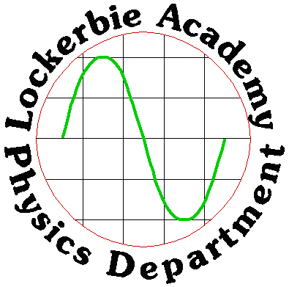
2018
J A Hargreaves
Lockerbie Academy
June 2018

HIGHER PHYSICS INTRODUCTION
Table of Contents
AIMS OF HIGHER PHYSICS COURSE 4
What do you need to be successful in Higher Physics? 4
How To Progress Through The Course 4
How To Get The Maximum Out Of The Course 4
CONTENT FOR UNITS PREFIXES AND SCIENTIFIC NOTATION 6
UNITS PREFIXES & SCIENTIFIC NOTATION NOTES 7
SI Units 7
Prefixes 7
Points to note 7
Using your calculator 8
Significant Figures 9
Rounding off 9
Tutorials 11
Units, Prefixes & Scientific Notation -Tutorial 1 11
Units, Prefixes & Scientific Notation - Tutorial 2 13
Answers to Units, Prefixes and Scientific Notation Tutorials 15
Tutorial 1 15
Tutorial 2 16
OPEN ENDED QUESTIONS 17
1. Rationale for the introduction of open ended questions 17
2. Types of open-ended question. 17
3. Marking open-ended questions 18
4. Student responses to sample questions. 19
5. Marks awarded to student responses to sample questions 20
6. Strategy for Solving Open-Ended Questions. 20
7. Exemplar questions. 23
Estimate - Tutorial 3 31
CONTENT ASSOCIATED WITH UNCERTAINTIES 32
UNCERTAINTIES NOTES 34
Systematic Effects 34
Random Uncertainties 34
Reading Uncertainties 34
Quantifying Uncertainties 35
Find the mean 35
Find the approximate random uncertainty in the mean (absolute uncertainty) 35
Find the percentage uncertainty. 35
Reducing Uncertainties 38
Scale Reading Uncertainty 38
Overall final Uncertainty 41
Uncertainties practicals 42
Practical (A):One Paper Clip with a systematic effect 42
Practical (B): Repeating measurements 42
Practical (C): signficant figures 43
Practical (D) Measuring: Uncertainties during an experiment 43
Tutorials 44
Uncertainty Tutorial 1 44
Uncertainties Tutorial 2 45
Uncertainties Tutorial 3 47
HSDU Tutorial 4 48
PRESCRIBED PRACTICAL 49
Aim 49
Uncertainties 49
Risk Assessment 49
Hazards 49
Risk 49
Control Measures 49
Results 49
Homework 50
Uncertainties Tutorial Answers 50
Answers to Tutorial 1 50
Answers to Tutorial 2: 51
Answers to Tutorial 3: 51
Answers to HSDU problems tutorial 4 52

CHAPTER 1 GET THE MOST FROM HIGHER PHYSICS

AIMS OF HIGHER PHYSICS COURSE

The aims of the Higher Physics Course are to enable you to:
♦ develop and apply knowledge and understanding of physics
♦ develop an understanding of the role of physics in scientific issues and relevant applications of physics, including the impact these could make in society and the environment
♦ develop scientific inquiry and investigative skills
♦ develop scientific analytical thinking skills, including scientific evaluation, in a physics context
♦ develop the use of technology, equipment and materials, safely, in practical scientific activities.
♦ develop planning skills
♦ develop problem solving skills in a physics context
♦ use and understand scientific literacy to communicate ideas and issues and to make scientifically informed choices
♦ develop the knowledge and skills for more advanced learning in physics
♦ develop skills of independent working

What do you need to be successful in Higher Physics?
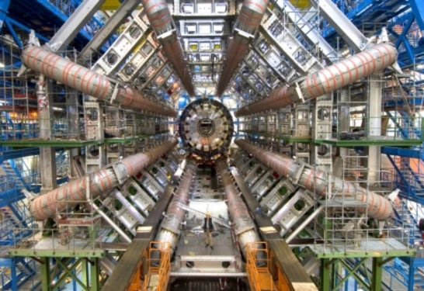
Alvaro de Rujula, theoretical physicist, CERN suggests;
- It pays not to know very much (no preconceived ideas!)
- Challenge what you do know (let go of your misconceptions)
- Be young (most big discoveries are made by scientists early in their careers)

How To Progress Through The Course
See the compendium and follow this process regularly.

How To Get The Maximum Out Of The Course

- Take responsibility for your own learning, and make sure that you give yourself every chance of success.
- Analyse your work and identify Areas for Improvement
- Use past papers along with the SQA website – use “marking instructions”, your teacher will show you how.
- Attend after-school Supported Study regularly.

- Consult teachers at interval/lunchtime, perhaps to get help with homework or to borrow other resources.
- Make sure you are part of the Edmodo or Glow group and log in regularly
- Refer to Syllabus/Content Statements/Arrangements Document/“Need to Know” sheets.
- Practise with “Basic Knowledge” or Tutorial Question.

- Make/obtain and use Flash Cards.
- Try mind-mapping/spider diagrams.
- Generate your own short notes/ summaries
- Familiarise with the equations on page 2, stick a copy in your jotter and add your own notes to these.
- Create and learn mnemonics (ROYGBIV – Richard of York Gave Battle in Vain, RMIVUXG but don’t overdo it)
- Plan weekly Revision timetable.
- Write and record mp3 files.
- Use Flash Learning , Scholar, Glesga Physics or other software
- Useful websites and departmental website.
- Post-it notes in your room/house (better ask first!)
- Remember to revise at the first opportunity after any lesson, asking yourself;
  - What were the main learning objectives of the lesson?
  - Do I understand these?
  - What can I do to improve?
Also, plan your revision and do not put things off to tomorrow when you could fix them today.


CHAPTER 2 UNITS PREFIXES & SCIENTIFIC NOTATION

CONTENT FOR UNITS PREFIXES AND SCIENTIFIC NOTATION
a) Units and prefixes
b) Significant figures
c) Scientific notation

- SI units should be used with all the physical quantities where appropriate. Prefixes should be used where appropriate. These include pico (p), nano (n), micro (μ), milli (m), kilo (k), mega (M), giga (G) and tera (T).

- In carrying out calculations and using relationships to solve problems, it is important to give answers to an appropriate number of significant figures. This means that the final answer can have no more significant figures than the value with least number of significant figures used in the calculation.

- Candidates should be familiar with the use of scientific notation and this may be used as appropriate when large and small numbers are used in calculations.

UNITS PREFIXES & SCIENTIFIC NOTATION NOTES

SI Units

There is an international standard for units called the Systeme International D’Unites, SI units for short.

These consist of seven basic units, two of which we do not use in this course (the unit of luminous intensity, the candela, and the amount of substance containing a certain number of elementary particles, the mole).

The 5 basic units we use are units of mass, length, time, temperature and current. Every other unit can be expressed using a combination of these seven basic units.
Quantity | Symbol | Units
Mass | m | kilogram, kg
Length | l | metre, m
Time | t | second, s
Temperature | T | degrees Celsius, Kelvin, K
Current | I | ampere, A

e.g. Velocity is measured in metres per second, ms⁻¹

Prefixes

Prefix | Symbol | Multiple | Multiple in full
Tera | T | x10¹² | x1 000 000 000 000
Giga | G | x10⁹ | x1 000 000 000
Mega | M | x10⁶ | x1 000 000
Kilo | K | x10³ | x1 000
Centi | C | x10⁻² | ÷100
Milli | M | x10⁻³ | ÷1 000
Micro | μ | x10⁻⁶ | ÷1 000 000
Nano | N | x10⁻⁹ | ÷1 000 000 000
Pico | P | x10⁻¹² | ÷1 000 000 000 000

Above is a table of prefixes, which you will commonly find in Higher Physics.
NB THE STANDARD UNIT FOR MASS IS THE KILOGRAM. Do not try changing it to grammes!
Watch out for ms which is not metres per second but milli seconds

Points to note
All multiples go down by 10³ each time with the exception of ‘centi’, which is highlighted.
When converting from a prefixed value to the ‘normal’ number you should always ask yourself whether you expect the ‘normal’ value to be larger or smaller than the prefixed value.
eg 12MHz = 12 × 10⁶Hz = 12 × 1000000 = 12000000Hz
You expect the ‘normal’ number to be greater than 12, you multiply by 1000000.
eg 500μA = 500 × 10⁻⁶A = 500/1000000 = 0.0005A
You expect the ‘normal’ number to be less than 500 by a factor of 1000000 hence you divide by 1000000.
It is common to show very large or very small numbers in scientific notation or use prefixes e.g. 0.00005A looks better if it is written as 50 μA or 5 × 10⁻⁵ A.

Using your calculator

There are various buttons on your calculator you can use when dealing with prefixes.

10^{X} /EXP/ EE Your scientific calculator will definitely have this button, from now on think of it as your “times ten to the power of” button.
eg 5 × 10³ is 5 ‘times ten to the power of ‘ 3
On you calculator this would be: 5 EXP 3 or 5 10^{X} 3
Pressing equals(=) should give you 5000

There is another button on your calculator that can produce the same result; y^{x} / x^{y}, this means “to the power of”
e.g. For 5 × 10³ (still 5 times ten to the power of) you would put into your calculator: 5×10 y^{x} 3
You should get the same answer, 5000.

Practise using these functions on your calculator. Find which button you prefer to use and always operate the same one all the time to avoid confusion.

ENG is another common button to use. Not all scientific calculator have this function but it can be useful, especially converting from one prefix to another or if you are dividing/ multiplying by a huge multiple of 10. On Sharp calculators you’ll find this under the FSE (fix, scientific notation, engineering) button
It takes the value shown on your calculator to the nearest multiple of 10³. If you keep pressing this button it keeps changing the multiple by a factor of 1000.

e.g. 6 × 10⁵ Ω
Put this number into you calculator as before (6 10^{X} 5) then press your ENG button. You should now see: 600 × 10³Ω
This is still the same number but it is easier to prefix now. We know that ×10³ is kilo hence:
6 × 10⁵Ω = 600kΩ

FIX allows you to fix how many figures after the decimal point should be displayed i.e. it fixes the number of decimal places you quote a value to. This is really useful if you suffer from calculator diarrhoea, but be careful, do not have this setting on when working out calculations for the mass defect (see the Radiation and Matter section). Also watch the most modern calculators have the recurring button at the end of the last digit, so this might mean that you incorrectly round up the number which would cost you a mark in the exam, eg 2.66 (dot above the 6) should be recorded at 2.67

SCI puts the number into scientific notation, i.e. a.b× 10^{c}

Significant Figures
Often when we use calculators we obtain answers with more decimal places than we need. But how do we decide where and when to round off these numbers? We need to round up our final answer so that it is as accurate as the least significant number that we measured.

Rounding off
Whenever we decide to round off we do so as follows:
Suppose we have the number 5.918504
Rounding to one decimal place we get 5.9 (the next decimal place was “1”)
Rounding to two decimal places we get 5.92 (the next decimal place was “8”)
Rounding to 3 decimal places we get 5.919 (the next decimal place was “5”)
In summary if the last digit is 0-4 Round down
5-9 Round up

But don’t round up too early in a calculation as errors can creep in.

e.g. A trolley is timed over a distance of 4.93m with a millisecond timer. The recorded time is 0.216s. The speed is to be calculated to 2 decimal places.
The correct calculation is
But if we round off to 2 decimal places too early we get

So don’t round off until the end in a calculation.

But how do you know how many places to round off too? When taking a measurement your apparatus can only give a reading that can be quoted to a reasonable number of places. For example it is unreasonable to take a school 10 Newton spring balance, place a 1 kilogram mass on the end and get a value of 9.81N. The Newton balance will not be marked off in 1/100th s of a Newton. It is only likely to be able to give your answer to one or maybe two significant figures.

eg You could measure piece of string and record it as;

Number | Number of significant figures
241.31mm | 5 significant figures which indicates that it is accurate to 1/100th mm
241.3mm | 4 significant figures i.e. to the nearest 10th of a mm
241mm | 3 significant figures.
24 × 10mm | 2 significant figures
0.24m | 2 significant figures
2.4 × 10²mm | 2 significant figures
2 × 10²mm | 1 significant figures

Obviously the number of significant figures you quote a value to gives a measure of the accuracy it was measured.
Supposing we take the reading of length as in (1) and the breadth of this piece of string was now measured as 2mm

If the student wanted to find the area that this piece of string takes up then the area can only be quoted to the accuracy of its least accurate component i.e. the breadth.
Despite the area value being 482.60mm² when calculated you must take into account the fact that the breadth is only quoted to 1 significant figure. Hence the value for area becomes 500.
SUMMARISING:
Measurement | Value | No. of sig fig
Length | 241.30 | 5
Breadth | 2 | 1
Area | 500 | 1

Good planning and experimentation normally avoids this mismatch of values and significant figures. Try not to choose apparatus where you can obtain too few or an unnecessarily high number of significant figures. Try to obtain all measurements to the same number of significant figures.
Marks will de deducted in the exam if you use too many significant figures. It could also result in failing your assessment.
SUMMARY
Be realistic about the number of significant figures you quote a value to.
DO NOT write down all the numbers you see on your calculator.
DO use the FIX or SCI button if you feel confident about using them.
Below is an extract from a lecture given by a professor at Yale University : This whole business of significant digits, I think, is badly distorted; by the way, it's taught in school. In school you often get situations where people give you a whole sheet of rules on how to figure out how many significant digits you have. This is nonsense. All you have to do is behave like a human being. We say to each other, I'll meet you in the dining hall in ten minutes. That doesn't mean something different from I'll meet you in the dining hall in eleven minutes and twenty-six seconds. Even if the person happens to show up in the dining hall in exactly eleven minutes and twenty-six seconds. Ten minutes means I'll meet you there in ten minutes, we all know what that means. I'll meet you there in eleven minutes and twenty-six seconds means you're a character in a bad spy novel who's just synchronized his watch. This shows up in science fiction too. I don't know how many of you are Star Trek fans? In all the different Star Trek movies there's always a second in command who isn't a human being, right? A Vulcan or an android, and to emphasize the non-humanness of these characters, they make them use too many significant digits. And so that makes them inhuman and so the captain will say, "When are we landing on omicron M?" The second in command will say, "Well, we should assume standard orbit in 2.6395 minutes," emphasizing somehow superior brain power or something. But it's nonsense because it takes the guy ten seconds to say that sentence, so what is this time calculated to a 100th of a second? Does it start from when he begins the sentence? From when he ends the sentence? What's the other end of that time interval? Can you say you assume standard orbit to the 100th of a second? What does that even mean? When you start beaming down? When you end beaming down? Also, keep in mind it takes more than a 100th of second for the sound to travel from his lips to the captain's ears, so the whole thing is just nonsense. And so, you don't need any special rules, just behave like a human being; don't behave like an android. So, no androids. And that's the only rule I'm going to give you about significant digits, just do the right thing, okay.”

Extract from: http://oyc.yale.edu/transcript/36/astr-160
Image: http://www.manofactionfigures.com/products/star-trek-mr-spock-16-scale-statue-hollywood-collectibles

Tutorials

Units, Prefixes & Scientific Notation -Tutorial 1

PREFIXES
- Use scientific notation to write the measurements in the units shown.
a. | 12 gigahertz | = | 12 GHz | = | Hz
b. | 4.7 megohms | = | 4.7 MΩ | = | Ω
c. | 46 kilometres | = | 46 km | = | M
d. | 3.6 millivolts | = | 3.6 mV | = | V
e. | 0.55 milliamps | = | 0.55 mA | = | A
f. | 25 microamps | = | 25 µA | = | A
g. | 630 nanometres | = | 630 nm | = | M
h. | 2200 picofarads | = | 2200 pF | = | F

- Rewrite the following quantities in the units shown. –
a. | 14 × 10³ m | = | km
b. | 2.3 × 10⁷ Ω | = | MΩ
c. | 5.6 × 10⁸ Hz | = | GHz | = | MHz
d. | 4.6 × 10⁻³ V | = | mV | = | µV
e. | 2.5 × 10⁻⁵ A | = | µA | = | mA
f. | 4.50 × 10⁻⁷ m | = | nm
g. | 4.70 × 10⁻⁹ F | = | pF | = | µF

- Express the following quantities in terms of the five base units (Hint think of equations linking the quantities)
  - acceleration, b) force and c) work .
- Express the unit of charge in terms of the base units.

- Put the following values into mA or μA
a) O.005A | b) 0.080A | c) 0.0000078A
d) 0.45A | e) 0.670A | f) 0.047A
g) 0.00003A | h) 1A

- Put the following into kΩ MΩ, GΩ or TΩ as required:
a) 5000 Ω | b) 10000 Ω | c) 3000000 Ω | d) 600000 Ω | e) 340 Ω
f) 3 x 10⁵ Ω | g) 4 x l0⁴ Ω | h) 9 x 10¹³ Ω | i) 8.4 x 1O⁷ Ω | j) 3.56 x 1O⁸ Ω
k) 98 x 1O⁵ Ω | l) 740 x l0¹¹ Ω

- Change the following distances into the prefix shown in brackets.
a) 500 mm (to m) | b) 50 cm (to mm) | c)5000000 mm (to km) | d) 68000 cm (to km)
e) 0.09 km (to cm) | f) 0.28 cm (to mm) | g) 9560 m (to cm) | h) 9220 m (to cm)
i) 0.78 Mm (to cm)

- Quote the following values to the number of significant figures shown in the brackets.
a) 242 cm (to 2 sig fig) | b) 273°C (to 2 sig. fig.) | c) 31.20 mm (to 3 sig. fig.)
d) 1786 (to 2 sig fig) | e) 74500 (to 3 sig. fig.) | f) 15600 (to 2 sig. fig.)
- A pupil measures the current through a resistor as 0.25A and the voltage across it is 2.0V. What is the resistance of the resistor?

- How much energy is released when 0.500kg of water (c=4180 Jkg^{-1 °}C⁻¹) lowers its temperature by 5°C?

- What distance is travelled if a boat travelling at 30kmh⁻¹ takes 1.50 hours to reach its destination?

- What is the power of a heater that uses 1200J of energy in 212.5 seconds?

- What is the acceleration of a car that changes its speed by 34.5ms^{-l} in a time of 5s?

- What is the volume of a cuboid with sides length 10cm, 5.5cm and 2.55cm respectively?

- What is the area of a triangle if its base is 25cm and its height 12cm?

Units, Prefixes & Scientific Notation - Tutorial 2

- What current flows through a loudspeaker of power 8W if a voltage of 12.0V is across it?
- Copy and complete the following table:
 | mass (kg) | gravitational field strength (N/kg) | height,  (m) | potential energy, (J) | no. of sig. fig.
a) | 2 | 10 | 3
b) | 2.35 | 10.00 | 3.05
c) |  | 2 | 4.5 | 1200
d) | 40.0 | 1.6 |  | 100.00
e) | 60 |  | 5 | 1000
f) | 2 | 8.8 |  | 300
g) |  | 10 | 9 | 9999

- What value for the speed of sound would you get if the results were:
Explain the difference in your values.
Distance (m) | Time(s) | Speed (ms⁻¹)
1000 | 3
1000.00 | 3
1000.00 | 3.00
1000 | 3.0

- A circle has a radius of 2.5cm, what is its area?

- A sphere has a radius of 2.500cm, what is its volume?

- From the graph below, what distance is travelled by the object in l0s?

- 68122500J of energy are used by a heater in 136245s. What is the power output of the heater?

Answers to Units, Prefixes and Scientific Notation Tutorials

Tutorial 1
1) 2)
a) | 12 × 10⁹ Hz | a) | 14 km
b) | 4.7 × 10⁶ N | b) | 23 MΩ
c) | 46 × 10³ m | c) | 0.56 GHz | 560 MHz
d) | 3.6 × 10⁻³ m | d) | 4.6 mV | 4600 μV
e) | 0.55 × 10⁻³ A | e) | 25 μA | 0.025 mA
f) | 25 × 10⁻⁶ A | f) | 450 nm
g) | 630 × 10⁻⁹ m | g) | 4.70 pF | 0.0047 μF
h) | 2200 × 10⁻¹² F

3 a) ms⁻² b) kgms⁻² c) kgm²s⁻²
4) As
5) 6) 7) 8)
a) | 5 | m | A |  | a) | 5 | k | Ω |  | a) | 0.5 m
b) | 80 | m | A |  | b) | 10 | k | Ω |  | b) | 500 mm
c) | 7.8 | μ | A |  | c) | 3 | M | Ω |  | c) | 5 km
d) | 450 | m | A |  | d) | 0.6 | M | Ω |  | d) | 0.68 km
e) | 670 | m | A |  | e) | 0.34 | k | Ω |  | e) | 900 cm
f) | 47 | m | A |  | f) | 0.3 | M | Ω |  | f) | 2.80 mm
g) | 30 | μ | A |  | g) | 40 | k | Ω |  | g) | 95.6 cm
h) | 1000 | m | A |  | h) | 90 | T | Ω |  | h) | 92.2 cm
 |  |  |  |  | i) | 84 | M | Ω
 |  |  |  |  | j) | 0.356 | G | Ω
 |  |  |  |  | k) | 9.8 | M | Ω
 |  |  |  |  | l) | 74 | T | Ω
a) | 240cm
b) | 270 °C
c) | 31.2 mm
d) | 1800
e) | 74500
f) | 16000
- 8.0Ω
- 1000J
- 50km
- 5.6W
- 7ms⁻²
- 100 cm³
- 150 cm²

Tutorial 2
- 0.7A

Mass | gravitational field strength | height, | potential energy, | no. of sig. fig.
(kg) | (N/kg) | (m) | (J)
2 | 10 | 3 | 60 | 1
2.35 | 10.00 | 3.05 | 71.68 | 1
100 | 2 | 4.5 | 1200 | 1
40 | 1.6 | 2 | 100 | 1
60 | 3 | 5 | 1000 | 1
2 | 8.8 | 20 | 300 | 1
100 | 10 | 9 | 9999 | 1

Speed
(ms⁻¹)
300
300
333
300

4) 20cm²
5) 65.45cm³
6) 300m
7) 500.000W

CHAPTER 3 OPEN-ENDED QUESTIONS

OPEN ENDED QUESTIONS
The purpose of this section is to give you advice and practice at open-ended .
- Rationale for the introduction of open ended questions.
- Types of open-ended question.
- Marking open-ended questions
- Student response to sample of open-ended questions
- Marks awarded to student responses to sample questions
- Strategy for solving open-ended questions.
- Exemplar questions.

1. Rationale for the introduction of open ended questions
An open-ended question is one where there is no fixed response. It is designed to encourage a full and meaningful answer using your knowledge of physics, therefore allowing you the opportunity to demonstrate a deeper understanding of physics principles than is usually assessed by the familiar numerical type problems. Such quantitative type problems usually require you to select appropriate relationships, manipulate these to fit the situation, identify the given and unknown quantities and solve for a numerical value. Open-ended type questions have previously been at the end of an extended question and you had the benefit from a lead-in. You will not benefit from a lead-in, you will have to identify the relevant area of physics and the physics principles in the situation presented in the problem.

2. Types of open-ended question.
a) A common type presents a written scenario which you are required to comment on, using physics principles. Typically the scenario takes the form of a quote from a book or the media. This question type is essentially assessing your ability to apply knowledge and problem skills to everyday situations.
velocity / m s⁻¹
An example of this type is:
In a book in which he describes his childhood experiences; an author describes how he used to drop peanuts down the stairwell of a department store. This would annoy the shop owner “who would come flying up the stairs at about the speed that the peanut had gone down, giving you less than five seconds to scramble away to freedom”.
Using physics principles, comment on the way the author has compared the speed of the peanut and the shop owner.

b) Information may be presented in formats such as diagrams, pictures, tables and graphs. The candidates will then be required to analyse these and come to a relevant conclusion.
An example of this type is:
A trolley is at rest on a slope. It is pushed then released. The velocity –time graph shows the resultant motion of the trolley.

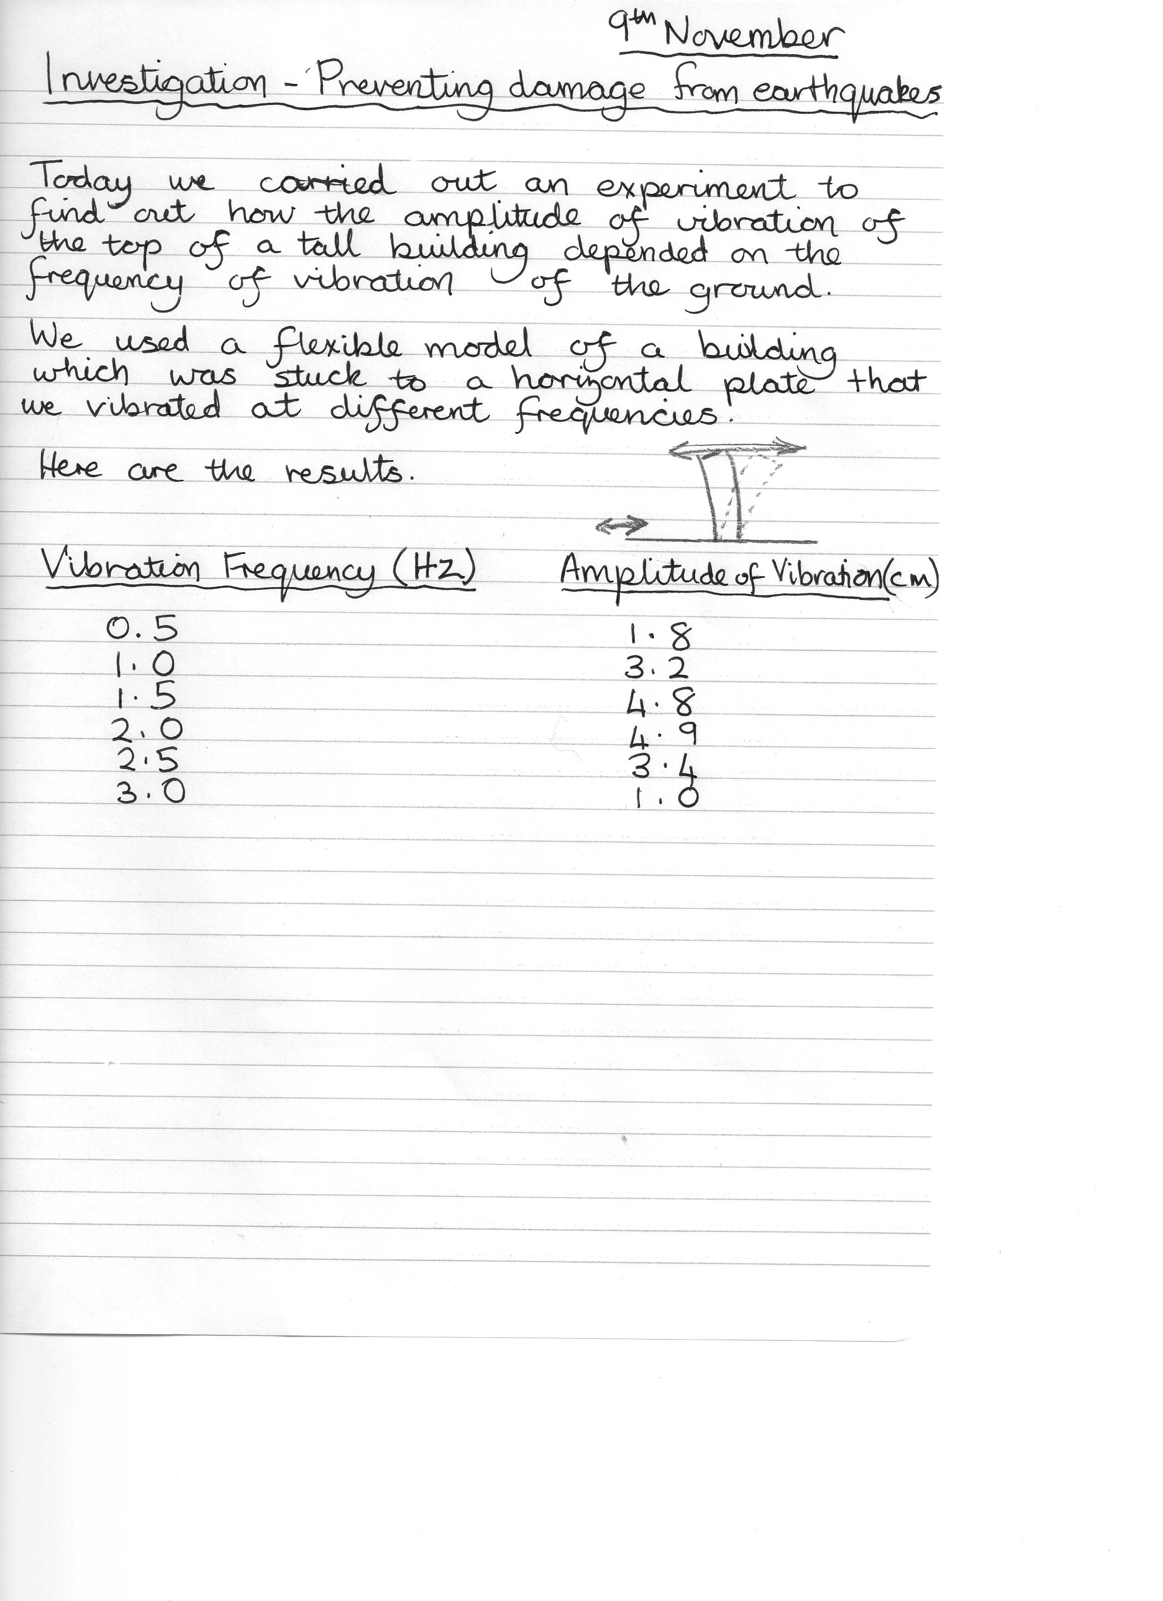
Use you knowledge of physics to comment on the shape of the graph.
- Another type of question could invite candidates to comment on the work of a peer. This may be in the form of a laboratory report or simply recorded results from an experiment.
An example of this type is:
An extract from a student’s investigation diary is shown.

The student has taken six sets of readings and used the results to draw a conclusion.

- Sketch a graph of the results.
- Write a conclusion based on the results and your sketch graph.
- Suggest two improvements that the student could have made to the collection of data for this experiment.

d) Numerical questions perhaps lend themselves to open-ended question types in less obvious ways.
One way to make a numerical question open-ended is to require you to estimate the value of one or more physical quantities needed in the problem. For example you might be required to estimate the mass, length or velocity of familiar objects.
An example of this type is:
Some cars are fitted with a system that stores the energy normally lost as heat in the brakes. Estimate the maximum energy that could be stored as a car is decelerated to rest. Clearly show your working for the calculation and any estimates you have made.

3. Marking open-ended questions
Open-ended questions have no fixed response. Any number of answers may be given which are equally correct (or incorrect). It is therefore not possible to predict likely responses and there can be no fixed marking scheme. Marking will be carried out by looking at the answer as a whole using holistic methods.
It is not necessary to produce an answer that is correct in all respects to be awarded full marks. (Partial marks for partial physics). A good answer will demonstrate a good understanding of physics and will attract full marks without necessarily being a model or complete answer.
0 marks. The candidate has not demonstrated any understanding of the physics of the situation.
There is no evidence that the candidate recognises the area of physics involved or has given any statement of a relevant physics principle.

1 mark. The candidate demonstrates a limited understanding of the physics of the situation.
The candidate makes some statement which is relevant to the situation showing that the problem is understood.
2 marks. The candidate demonstrates a reasonable understanding of the physics of the situation.
The candidate makes some statement which is relevant to the situation showing that the problem is understood. There might also be a statement of a physics principle such as conservation of momentum or a relevant relationship between the variables involved in the problem.

3 marks. This maximum available mark award would be a quality mark.
The candidate demonstrates a good understanding of the physics of the situation. This type of response might include a statement of the principles involved, a relationship and the application of these to respond to the problem.
This does not mean the answer has to be what might be termed an “excellent” answer or a complete one.

4. Student responses to sample questions.
1. In a book in which he describes his childhood experiences, an author describes how he used to drop peanuts down the stairwell of a department store. This would annoy the shop owner “who would come flying up the stairs at about the speed that the peanut had gone down, giving you less than five seconds to scramble away to freedom”.
Using physics principles, comment on the way the author has compared the speed of the peanut and the shop owner. 3 marks

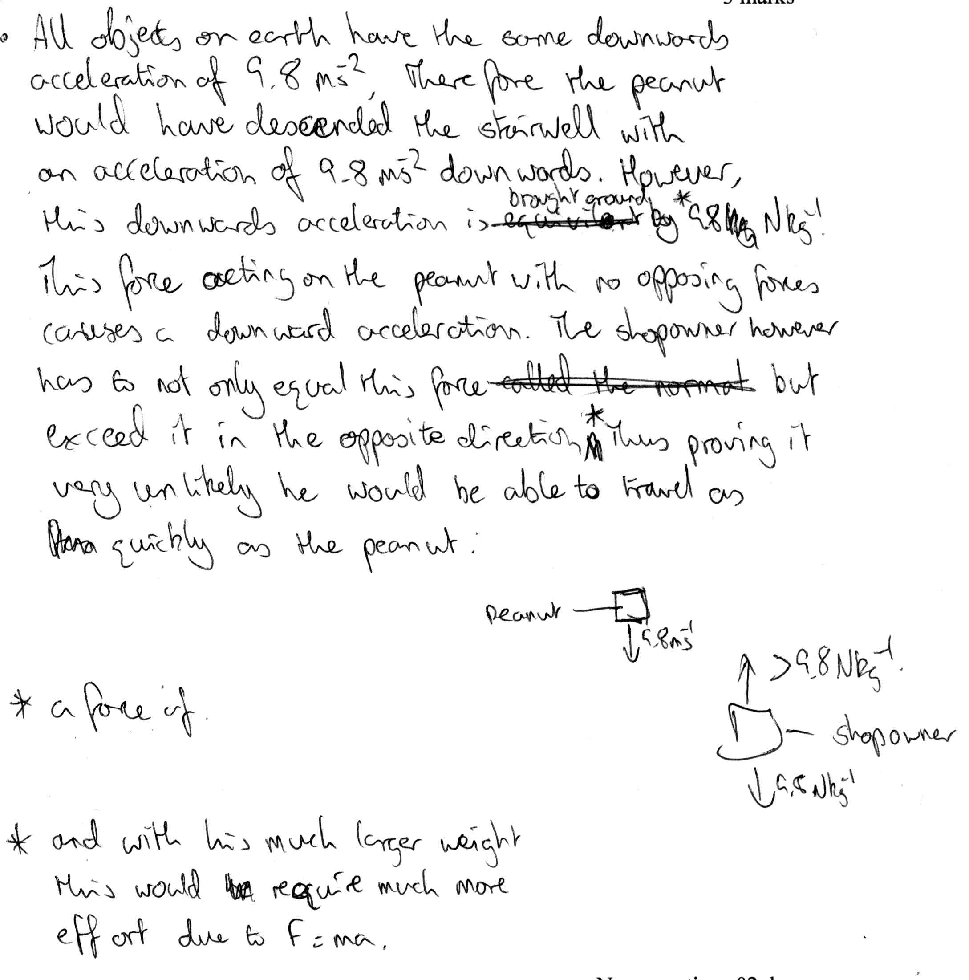
Response 1.1

5. Marks awarded to student responses to sample questions
In the example above the student correctly discusses the acceleration of the peanut and the relative forces or force/kg acting on the peanut and the shop owner. The student uses the wrong unit of acceleration in diagram and has not discussed speed of peanut and shop owner. Total 1 mark. There are further examples we will use in a separate lesson and in a separate booklet.

6. Strategy for Solving Open-Ended Questions.
Experience has shown that students generally find solving open-ended questions more difficult than the more familiar type of problem requiring a quantitative solution.
Deciding on the defining the problem is the part likely to cause most difficulty and will therefore require to be practised by the student.

In answering open ended questions you should:

- read the question - taking care not to skim read.
- reread the question.
- try to understand/define the problem situation and what is asked.
- visualise the situation.
- draw a diagram and include any relevant information such as speeds, velocities, forces, vector directions etc.
- determine and write down
  - relevant physics principles e.g. conservation of momentum
  - note area/topic of physics involved in problem e.g. internal resistance of supplies
  - relationship relevant to variables in the problem.
- use knowledge of familiar quantities such as body mass, body height, length of running track to create estimated values as required.
- with the information noted previously solve the problem or do what can be done.
- reread the response to see if it makes sense and answers the question.

Some helpful examples that might be worth noting
This table might give you an idea of speeds etc. I am just using v=u+at and assumes no air resistance
time (s) | a (m/s²) | u from t=0 (m/s) | v at end of time period (m/s) | u for 1s interval (m/s) | average speed over previous second (m/s) | v at end of time period mph | equivalent average speed in mph
0 | 9.8 | 0 |  | 0
1 | 9.8 | 0 | 9.8 | 0 | 4.9 | 22 | 11
2 | 9.8 | 0 | 19.6 | 9.8 | 14.7 | 44 | 33
3 | 9.8 | 0 | 29.4 | 19.6 | 24.5 | 66 | 55
4 | 9.8 | 0 | 39.2 | 29.4 | 34.3 | 88 | 77
5 | 9.8 | 0 | 49 | 39.2 | 44.1 | 110 | 99
6 | 9.8 | 0 | 58.8 | 49 | 53.9 | 132 | 121
7 | 9.8 | 0 | 68.6 | 58.8 | 63.7 | 153 | 143
8 | 9.8 | 0 | 78.4 | 68.6 | 73.5 | 175 | 164
9 | 9.8 | 0 | 88.2 | 78.4 | 83.3 | 197 | 186
10 | 9.8 | 0 | 98 | 88.2 | 93.1 | 219 | 208
11 | 9.8 | 0 | 107.8 | 98 | 102.9 | 241 | 230
This is what the table looks like for the moon as a comparison
time (s) | a (m/s²) | u from t=0 (m/s) | v at end of time period (m/s) | u for 1s interval (m/s) | average speed over previous second (m/s) | v at end of time period mph | equivalent average speed in mph
0 | 1.6 | 0
1 | 1.6 | 0 | 1.6 | 0 | 0.8 | 4 | 2
2 | 1.6 | 0 | 3.2 | 1.6 | 2.4 | 7 | 5
3 | 1.6 | 0 | 4.8 | 3.2 | 4 | 11 | 9
4 | 1.6 | 0 | 6.4 | 4.8 | 5.6 | 14 | 13
5 | 1.6 | 0 | 8 | 6.4 | 7.2 | 18 | 16
6 | 1.6 | 0 | 9.6 | 8 | 8.8 | 21 | 20
7 | 1.6 | 0 | 11.2 | 9.6 | 10.4 | 25 | 23
8 | 1.6 | 0 | 12.8 | 11.2 | 12 | 29 | 27
9 | 1.6 | 0 | 14.4 | 12.8 | 13.6 | 32 | 30
10 | 1.6 | 0 | 16 | 14.4 | 15.2 | 36 | 34
11 | 1.6 | 0 | 17.6 | 16 | 16.8 | 39 | 38

Now let’s look at a few other helpful points
Mass of a small car (kg) | 1000 | Could go up to 1800
Mass of man (kg) | 100 | Approx. 16 stone
Mass of boy (kg) | 30 | This is 4 ½ stone and would be about right for a boy about 10 (obviously depends on no. of burgers)
Max speed limit in UK (m/s) | 32 | Conversion factor speed in mph is /0.447 of speed in m/s
Fast car acceleration (m/s²) | 5.4 | (0-60mph in 5s)
30 mph in m/s | 13
1 light year |  | 9.5 × 10¹⁵ m
Length of student foot | 0.25-0.30m | With show on approx. 0.30m
Width of student foot | 0.05-0.10m
Atmospheric Pressure | 10⁵ Pa
Yellow Bunsen flame | ∼800°C
Blue Bunsen flame | ∼1100°C
Geostationary orbit | 36 000 km | 3.6 × 10⁷ m

7. Exemplar questions.
Some exampless of open-ended questions are given in this section. These will give you an idea of the type of questions which may be used in the exam. The examples can also be used to give you practice in answering this type of problem.
Typical “expected” answers are not given here as it might give the impression of a fixed marking scheme. You should be aware that when asked to use physics principles to comment on a particular statement the statement does not necessarily need to be correct.
Question 1
A student is watching the launch of a rocket.

The student states that the rocket takes off because the gas from the rocket engine pushes on the ground.

Using physics principles show that the student’s statement is untrue.

Question 2
In an experiment a ray of red light and a ray of blue light pass through a triangular glass prism as shown.

blue light

red light

red light

blue light

A student viewing this experiment makes the following statement about the refractive index of the glass and the frequency of the light.

“The refractive index of the glass depends on the frequency of light
but the frequency of the light does not depend on the refractive index of the glass.”

Use your knowledge of physics to comment on this statement.

Question3
A student holds a ball at rest then allows it to fall. The ball accelerates freely to the ground.
The student notes that before release the momentum of the ball is zero but after release it has a momentum.
The student concludes that this shows that the Law of Conservation of Momentum is not always obeyed.
Use your knowledge of physics to show that the student’s statement is untrue..

Question 4
X
Y
wall
A rubber ball X and a ball Y with a very sticky surface have the same mass. They are thrown, with the same speed, at a wall.
The ball X rebounds back along its original path. Ball Y sticks to the wall.
A student states “Ball X will always exert a greater force on the wall than that exerted by Y”.
Use your knowledge of physics to comment on this statement.

Question 5 A rubber ball X and a ball Y with a very sticky surface have the same mass. They are thrown, with the same speed, at a wall.
X
Y
wall

The ball X rebounds back along its original path. Ball Y sticks to the wall.
A student states “The change in momentum of ball X is greater than the change in momentum of ball Y. This means that ball X will always exert a greater force on the wall than that exerted by Y on the wall”.
Use your knowledge of physics to comment on this statement.
Y
X
Z
Question 6
A ball is thrown vertically into the air.

The ball starts from rest at point X.
It leaves the thrower’s hand at point Y and travels vertically upwards to point .Z
A student states “the magnitude of the acceleration of the ball is always greater when being thrown (from X to Y) from rest than when in the air from Y to Z.”
Use your knowledge of physics to comment on this statement.

Question 7
A comedian remarks that “when you fall it is not the falling which hurts but the coming to rest”.
Use your knowledge of physics to comment on this remark.

Question 8
When you jump from a height of 5 m into water it usually does not cause any damage. Jumping from the same height onto a concrete surface usually causes injury.
Use physics principles to comment on this statement.

Question 9
Monochromatic light is shown onto a diffraction grating to produce an interference pattern on a screen.
Describe the significance of “diffraction” on the production of an interference pattern.

Question 10
A student states “When a single force acts on an object the object can never remain stationary or move with constant speed”
Using physics principles comment this statement.
Question 11
A battery is charged using a 12V d.c.supply as shown in diagram I.
12 V
r
mp3
player
r
12 V
++
-+

diagram I
diagram II

When charged it is connected to an MP3 player as shown in diagram II..
A teacher states that “the energy used to charge the electrical battery is always greater than the energy which can be taken from it”.
Use your knowledge of physics to comment on this statement.
You may use calculations to aid your comment.

Question 12
A ball can be thrown into the air at all angles to the horizontal, including 0º and 90º.

A student states “the acceleration of the ball can never be parallel to the velocity of the ball”.

Use your knowledge of physics to comment on the truth or otherwise of this statement.
Question 13
A ball can be thrown into the air at all angles to the horizontal, including 0º and 90º.

A student states “the acceleration of the ball can never be perpendicular to the velocity of the ball”.

Use your knowledge of physics to comment on the truth or otherwise of this statement.
Question 14
A trolley is at rest on a slope. It is pushed up the slope then released as shown in the diagram.


Use your knowledge of physics to describe and explain the resultant motion of the trolley,

Question 15
A student observes a gardener pushing a wheelbarrow.

The student knows that the gardener exerts a force on the wheelbarrow and that the wheelbarrow exerts a force of equal size in the opposite direction on the gardener.
The student has difficulty explaining why the wheelbarrow moves forward.

Using physics principles give your explanation for the movement of the wheelbarrow.

Question 16
A student sees a diagram of a force acting on a combination of blocks as shown.
3 kg

2kg
A
B
10 N

The student reasons that block A exerts a force on block B and block B exerts an equal force in the opposite direction on block A. The student then cannot understand why the blocks move.
Use your knowledge of physics to give an explanation for the movement of the blocks.

Question 17
An iron bar is heated. As the temperature of the bar increases the colour of the bar changes from red to bluish white.
Use your knowledge of physics to explain this change in colour.

Question 18
The star Betelgeuse has a surface temperature of about 2400 K and appears red when viewed. The star Bellatrix has a surface temperature of about 25000 K and appears bluish white.
Using your knowledge of physics explain the reason for the difference in colour of these stars.

Question 19
A beam of blue light and a beam of red light are shone onto a screen.
A student states that a beam of blue light will always produce a greater irradiance on the screen than the beam of red light.
Use your knowledge of physics to comment on this statement.

Question 20
A trolley is at rest on a slope. It is pushed then released.
velocity / m s⁻¹

The velocity –time graph shows the resultant motion of the trolley.
Use you knowledge of physics to comment on the shape of the graph.

Question 21
A commentator at a skateboarding competition describes the movement of a competitor on a ramp as shown in the diagram.

“The skateboarder has gained enough force on the down- slope to let her reach the very top of the up- slope”.
Using physics principles, comment on the way the commentator has described the movement of this competitor.

Question 22
A ray of light of wavelength 5.0 x 10⁻⁷ m is shone onto a diffraction grating. The spacing between the lines of the grating is 5.8x 10⁻⁷ m. An interference pattern is observed on a screen.
A student observing the pattern states that there is no limit to the number of maxima of intensity produced on the screen.
Use your knowledge of physics to comment on this statement about the number of maxima.

Question 23
N
S
S
N
A book has a drawing of an “invention” which will provide a means of transport.

A magnet is attached to a trolley and a person on the trolley holds a second magnet in front of the first magnet.
The North pole N of a magnet is known to attract the South pole S of a magnet.
Using physics principles explain why this invention cannot work.
Question 24
A box is pulled along a floor by a force of 200 N as shown in the diagram.
80 kg
45º
200 N
Use your knowledge of physics to comment on why this is not the most efficient way to move the box.
Question 25
In a book in which he describes his childhood experiences, an author describes how he used to drop peanuts down the stairwell of a department store. This would annoy the shop owner,“who would come flying up the stairs at about the speed that the peanut had gone down, giving you less than five seconds to scramble away to freedom”. © The Life and Times of the Thunderbolt Kid: A Memoir by Bill Bryson, Random House, 2006
Using physics principles, comment on the way the author has compared the speed of the peanut and the shop owner.

Question 26
A ball is thrown vertically into the air.
Y
X
Z

The ball starts from rest at point X.
It leaves the thrower’s hand at point Y and travels vertically upwards to point .Z
A student states “the magnitude of the force on the ball is always greater when being thrown (from X to Y) from rest than when in the air from Y to Z.”

Use your knowledge of physics to comment on this statement.

Question 27
An extract from a student’s investigation diary is shown
The sudent has taken six sets of readings and used the results to draw a conclusion.

Sketch a graph of the results.
Write a conclusion based on the results and your sketch graph.
Suggest two improvements that the student could have made to the collection of data for this experiment.
How could the conclusion to the experiment inform the design of tall buildings in earthquake zones

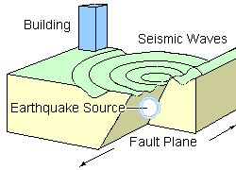
ALTERNATIVE
An extract from a student’s investigation diary is shown.
9th November
Investigation – Preventing damage from earthquakes.

We found on the web that most of the energy of seismic waves from earthquakes is from waves close to a certain frequency.
We carried out an experiment to find how the amplitude of vibration of the top of a building depended on the frequency of vibration of the ground.
We used a flexible model of a building which was stuck to a horizontal plate that we vibrated at different frequencies.

Vibration frequency (Hz) | Amplitude of Vibration (mm)
0.5 | 18
1.0 | 32
1.5 | 48
2.0 | 49
2.5 | 34
3.0 | 10
Here are the results.
___________________________________
The student has taken six sets of readings and used the results to reach a conclusion.
- Sketch a graph of the results
- Using the information from your sketch graph write a conclusion for the experiment.
- Suggest two improvements that the student could have made to the investigation.
- How could the conclusion to the experiment affect the design of tall buildings in earthquake zones?
OR How could the conclusion to the experiment determine the affect of an earthquake on buildings.

Question 28
A television commentator was heard to describe a free kick in a football match in the following way.
“It was a magnificent free kick. The ball flew into the net. Once it left his foot it positively accelerated into the goal.”

Using physics principles, comment on the way the television commentator has described the motion of the ball.
Question 29
On April 1st, a car manufacturer placed an advertisement for a new system which could be fitted to cars and was called “Magnetic Tow Technology”. It was of course an April Fool – the system does not exist.
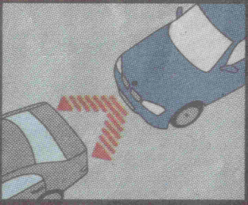
“The system locks on to the car in front using an enhanced magnetic beam. Once you are attached, you are free to turn off your engine. The vehicle in front will do the pulling without noticing any changes”

Using physics principles, suggest how you can tell that the advertisement is an April Fool.
Question 30
Some cars are fitted with a system that stores the energy normally lost as heat in the brakes. Estimate the maximum energy that could be stored as a car is decelerated to rest.
Clearly show your working for the calculation and any estimates you have made.

Question 31
A book describing a medieval battle includes the following description of the flight of an arrow.
“The arrow drew its curve in the sky, then fell fast, plunging, and losing its momentum.”
Using physics principles, comment on the way the author has described the flight of the arrow.
Question 32
“They don't make them like they used to," said old Uncle Willie as a breakdown truck
towing a crashed car drove past. "In my day, cars were built like tanks. They didn't crumple
up in crashes like that one has," he continued.

Use your knowledge of physics to explain why certain parts of cars are designed to crumple in collisions.

Estimate - Tutorial 3

These questions are about your thinking and working not the final answer.
- Estimate the number of atoms in a 1p coin.
- Estimate the number of visible photons leaving a 60W light bulb per second.
- Estimate the maximum power output of a reasonably fit human being. For example, imagine running up stairs or lifting a heavy weight as quickly as you can.
- Assuming that wind resistance limits the speed of a cyclist, estimate the wind force at maximum speed.
- Use the fact that wind resistance force is proportional to the square of the velocity to estimate the terminal velocity of a human in free fall through the air.
- Estimate the mass of food given to a tiger in a zoo each day.
- Estimate the number of piano tuners in London.
- Estimate the lowest frequency playable on a flute and a large church organ. (The speed of sound in air is 340ms⁻¹.)
- Estimate the number of air molecules in the entire atmosphere. (The radius of the Earth is about 6000km, atmospheric pressure at the Earth’s surface is about 10⁵Pa, the density of air at STP is about 1kgm⁻³).
- It has been suggested that every breath we take will, on average, contain one molecule from Isaac Newton’s dying exhalation. Is this a reasonable assertion?
- Estimate the length of the groove on an old LP. How small must the tip of the needle be to reproduce sounds in the upper region of the audible range?
- Estimate the length of a cassette tape. How small must the magnetic particles be in order to store music with frequencies up to the top end of the human hearing range?
- A mass driver is a horizontal accelerating rail used to launch space craft in an airless atmosphere. Estimate the angle subtended by one on the moon (ie the ratio of the length of the device to the radius of the moon), assuming it is for spacecraft carrying humans.
- Estimate the thickness of the layer of rubber left by a car during normal driving.
- I want to demonstrate the Doppler Effect using a ball which emits a constant tone. I swing it round my head. Estimate some of the important parameters.
- The time of sunrise varies through the year roughly sinusoidally (ignoring hour changes in the summer). Estimate the rate of change (i.e. how far sunrise moves each day) at the Autumn equinox.

CHAPTER 4- UNCERTAINTIES

CONTENT ASSOCIATED WITH UNCERTAINTIES

- Scale reading, random and systematic uncertainty
- Uncertainties and data analysis
- Quantifying Random uncertainties
- Quantifying analogue and digital scale reading uncertainties.

  - I know how to identify scale reading, random, and systematic uncertainties in a measured quantity and the causes of each of these I know all measurements of physical quantities are liable to uncertainty, which should be expressed in absolute or percentage form. Scale reading uncertainty is a measure of how precisely an instrument scale can be read Random uncertainties arise when an experiment is repeated and slight variations occur. Random uncertainties may be reduced by increasing the number of repeated measurements. Systematic uncertainties occur when readings taken are either all too small or all too large. They can arise due to measurement techniques or experimental design.

  - The mean of a set of readings is the best estimate of a ‘true’ value of the quantity being measured. When systematic uncertainties are present, the mean value of measurements will be offset. When mean values are used, the approximate random uncertainty should be calculated. When an experiment is being undertaken and more than one physical quantity is measured, the quantity with the largest percentage uncertainty should be identified and this may often be used as a good estimate of the percentage uncertainty in the final numerical result of an experiment. The numerical result of an experiment should be expressed in the form final value ±uncertainty.

  - I can quantify from appropriate relationships to determine the approximate random uncertainty in a value using repeated measurements.uncertainties using
or $$∆R=\frac{R_{max}-R_{min}}{n}$$
  - I can quantify analogue and digital scale reading uncertainties as
Analogue device = ±½ scale division
Digital device = ±1 in the last digit

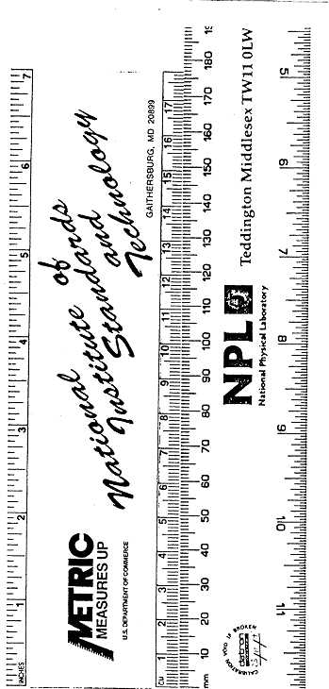
The National Physical Laboratory is the national measurement standards laboratory for the United Kingdom and NIST is the American equivalent, even they don’t get all their measurements perfect!

UNCERTAINTIES NOTES
Whenever you do an experiment there will be uncertainties.
There are three types of uncertainty and effects to look out for.

Systematic Effects
Here the problem lies with the design of the experiment or apparatus. It includes zero errors. Sometimes they show up when you plot a graph but they are not easy to recognise, as they are not deliberate. Systematic effects include slow running clocks, zero errors, warped metre sticks etc. The best way to ensure that these are spotted is to acknowledge their existence and go looking for them. Where accuracy is of the utmost importance, the apparatus would be calibrated against a known standard. Note that a systematic effect might also be present if the experimenter is making the same mistake each time in taking a reading.

Random Uncertainties
These uncertainties cannot be eliminated. They cannot be pinpointed. examples include fluctuating temperatures, pressure and friction. Their effect can be reduced by taking several readings and finding a mean.

Reading Uncertainties
These occur because we cannot be absolutely certain about our readings when taking measurements from scales. Use scales with mirrors where possible, good scales and repeat all measurements.

Repeat all experiments to reduce the reading and random uncertainties. Systematic effects are not improved by taking lots of results.

Which experiment has the best design?

x
x x x x x
x x x x x x x x x x
x x x x x
x xx x x x x x x x
x x x x x x x x x x
x x x x x
x xx xx x x x x
x x x x x
A

B

C

D

Explain your reasoning.

Quantifying Uncertainties

Find the mean
This is the best estimate of the “true” value but not necessary the “true” value

Find the approximate random uncertainty in the mean (absolute uncertainty)

This can be written as and it is sometimes referred to as average deviation or absolute uncertainty.
stop here and quote the result with an approx. random uncertainty

MEAN±approx. random uncertainty (UNITS)

Find the percentage uncertainty.
stop here and quote the result with a percentage uncertainty

MEAN (UNITS)± percerntage uncertainty (%) (

Or uncertainty in reading ÷reading × 100%
Questions
Tutorial 2 from the LA Physics Course and Higher Physics by Jardine page 18 q 1.2-1.5
Past papers 1991 P2 Q7
1992 P1 Q3
1993 P1 Q35
1994 P2 Q12
A student sets up the apparatus in the diagram to measure the average acceleration of a model car as it travels between P and Q  For one run, the following measurements were recorded along with their estimated uncertainty.  clock 1 reading = 0.23 s ± 0.01 s  clock 2 reading = 0.12 s ± 0.01 s  stopwatch reading = 0.95 s ± 0.20 s  length of car = 0.050 m ± 0.002 m  distance PQ = 0.30 m ± 0.01 m | During an experiment to measure the specific heat capacity of a liquid the relationship $VIt=mc∆T$ is used  The following quantities are measured  V= 12.0 ± 0.1 V  I = 4.2 ± 0.1 A  t=300 ± 1s  m=500± 2 g  ΔT = 15 ± 1 °C  Which quantity will contribute the largest uncertainty to the final answer for the specific heat capacity, c?  A Voltage  B Current  C Time  D mass  E temperature difference
The measurement which gives the largest percentage uncertainty is the
  - reading on clock 1
  - reading on clock 2
  - reading on the stopwatch
  - length of the car
  - distance PQ.

35. A pupil wishes to measure the amount of energy stored in a 5μF capacitor which is charged to a p.d. of 10 V. He discharges the capacitor through the heating coil which is immersed in a small quantity of oil. The energy stored in the capacitor is calculated using the equation
$$E=cm∆T$$
$$E stored in the capacitor=c \left(oil\right)×mass (oil)×∆T$$
- State the assumption made by the pupil in using this equation
- By considering the energy stored in the capacitor, explain why the measurement of the rise in temperature of the oil is likely to be extremely inaccurate.

31.Measurements are made of the time taken for 5 similar stones to drop down a well. The recorded times are as follows
2.57 s 2.61 s 2.47 s 2.46 s 2.49 s
Calculate
  - The mean value of the time of fall;
  - The random error in the mean value

The apparatus shown below is set up to determine the wavelenngth of light from a laser
The wavelength of the light is calculated using the equations
$$λ=dsinθ and\sin{θ=\frac{x}{L}}$$
Where angle θ and distances x and L are shown in the diagram.
  - Seven students measure the distance L with a tape measure. Their results are as follows
2.402 m | 2.399 m | 2.412 m | 2.408 m
2.388 m | 2.383 m | 2.415 m
Calculate the mean value for L and the approximate random error in the mean.
  - The best estimate of the distance x is 91± 1 mm
Show by calculation whether L or x has the largest percentage error
  - Calculate the wavelength, in nanometers of the laser light. You must give your answer in the form
Final value ±error
  - Suggest an improvement which could be made so that a more accurate estimate of the wavelength could be made. You must use only the same equipment and make the same number of measurements

Reducing Uncertainties
Always try to get the most accurate piece of apparatus to do the job.
Analogue scales can be read to the nearest 0.5 of a scale division.
Repeat measurements to reduce the random uncertainty in an experiment. You must repeat measurements in your Assignments.

Scale Reading Uncertainty
This value indicates how well an instrument scale can be read.

An estimate of reading uncertainty for an analogue scale is generally taken as:

± half the least division of the scale.

Note: for widely spaced scales, this can be a little pessimistic and a reasonable estimate should be made.

For a digital scale it is taken as

± 1 in the least significant digit displayed.
Examples

accurate to ½ a scale division,
so uncertainty =0.25/2.5 cm
or % uncertainty=(0.25×100)/2.5%
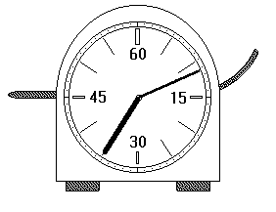
accurate to ½ a scale division, Each scale division is 1 second (look around the edge)
so uncertainty =0.5seconds/35min 12second
or % uncertainty=(0.5×100)/((35×60)+12)%

Watch out for different scales on a device. Make sure you know which scale you should be using!
accurate to ½ a scale division,
for the measuring cylinder ½ a scale division= 1ml
a) so uncertainty =1/46 ml
or % uncertainty=(1×100)/46%
b) so uncertainty =1/62 ml
or % uncertainty=(1×100)/62%
Here there is the same absolute uncertainty (1ml) but the % uncertainty of the second cylinder is less than the percentage uncertainty of the first.
eg. 2 people are underpaid at the end of a week by £1. Tom only gets £10 per week, Martin gets £100. The absolute error is the same (I have underpaid both £1) Who should scream about it most and why?

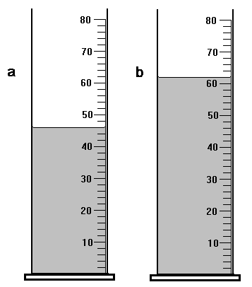

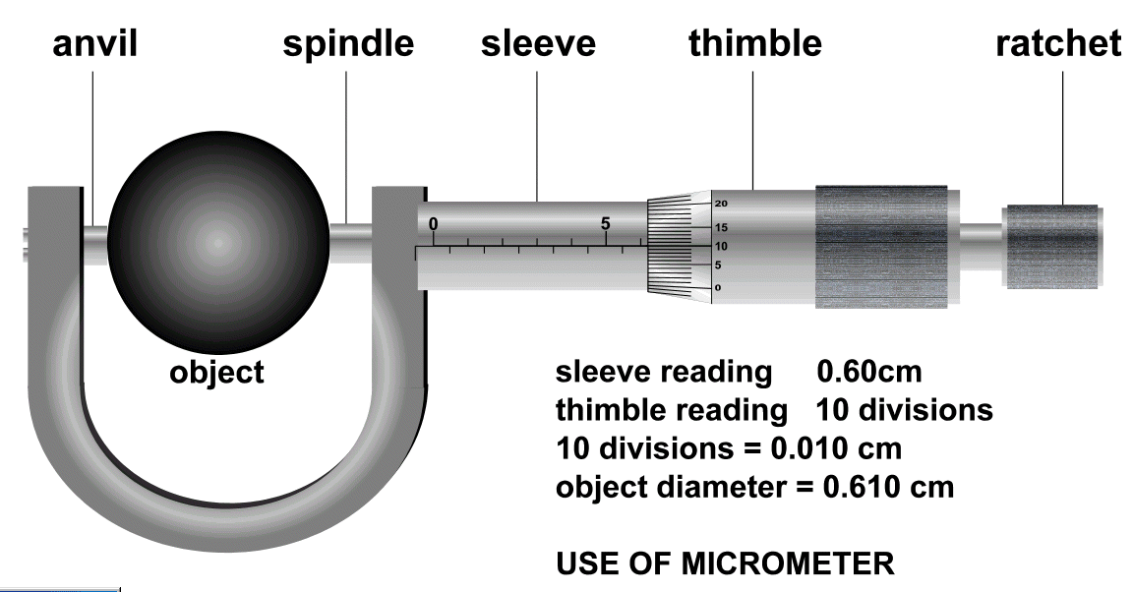

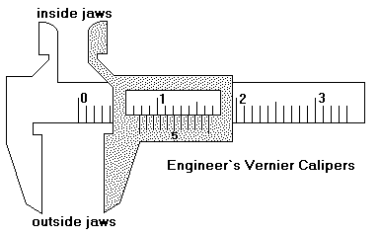

Try taking readings from these vernier scales. A must for all engineers!

Figure 1 WHAT IS THE READING AND UNCERTAINTY ON THE CALLIPERS ANDTHERMOMETER?
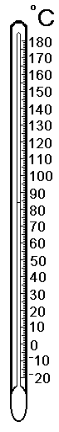

DIGITAL SCALES CAN BE READ TO ONE UNIT IN THE LAST SIGNIFICANT FIGURE
0.00KΩ
36.9°C
0.32A
% uncertainty % uncertainty % uncertainty
0.01/reading × 100% 0.1/reading × 100% 0.01/reading × 100%
% uncertainty % uncertainty % uncertainty
89.8784A
0382 KΩ
3.21m
0.0001/reading × 100% 1/reading × 100% 0.01/reading × 100%

Find the percentage uncertainty in each of the digital readings above. Now try some of your own.

Overall final Uncertainty
When comparing uncertainties, it is important to take the percentage in each.
In an experiment, where more than one physical quantity has been measured, spot the quantity with the largest percentage uncertainty. This percentage uncertainty is often a good estimate of the percentage uncertainty in the final numerical result of the experiment.
eg if one measurement has an uncertainty of 3% and another has an uncertainty of 5%, then the overall percentage uncertainty in this experiment should be taken as 5%

Example 1
The times for 10 swings of a pendulum are: 1.1, 1.4, 1.2, 1.3 and 1.1 s
Mean value = 1.2 s
Time for 10 swings = (1.2 ± 0.1) s = 1.2 s ± 5 %

Note: when the uncertainty is expressed in units then it is known as the
absolute uncertainty. In this case this is + 0.06 s, or ± 0.1 s.

Example 2
Suppose in an experiment the following uncertainties were found.
Systematic | = | 0.1 %
Scale Reading | = | 2 %
Random | = | 0.5 %
The overall uncertainty should be taken as the highest percentage uncertainty.
In this case, this would be the reading uncertainty at 2 %.

Note: since accuracy is now being quantified, it is essential when using a calculator that all the figures are not taken down, since every number stated indicates the degree of accuracy.

As a general rule, your answer should contain the same number of significant figures as the least accurate reading.
Examples
Refer to the example at the top of the page. The mean value is 1.22 s and the random uncertainty 0.06 s. However, all the readings are to two significant figures hence the final answer must be written as (1.2 ± 0.1)s as shown.

Calculate the average speed and absolute uncertainty from the following readings.

s = (1.54 ± 0.02) m | t = (1.69 ± 0.01) s
% uncertainty in s =  = 1.3 % | % uncertainty in t =  = 0.6 %
Highest uncertainty taken = 1.3 %
1.3 % of 0.911 m s⁻¹ = 0.012 m s⁻¹ (converts % to absolute uncertainty)

v = (0.91 ± 0.01) m s⁻¹

Uncertainties practicals

Practical (A):One Paper Clip with a systematic effect
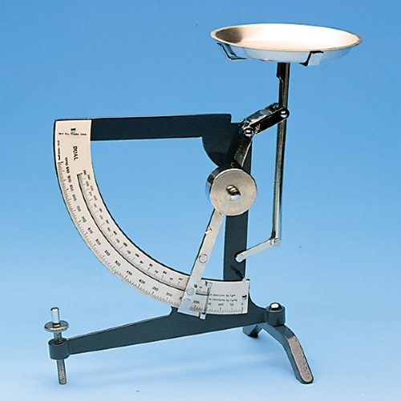
Obtain a supply of identical marbles of paper clips and a Butchart balance. Set up the balance but make sure its zero setting is incorrect before you start to use it. Do not take note of the amount of this error.
Now take a handful marbles or paper clips and find the total mass. Take note of the number of marbles and their mass. Record your results in a table.
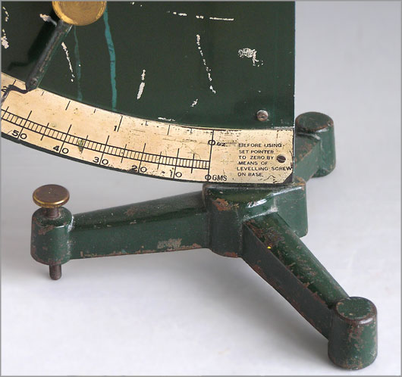
Repeat this for different sized handfuls and then make a graph of mass against number of marbles.
Work out from the graph the mass of one marble and the size of the zero error on your machine.
Check this against the uncertainty from the Butchart Balance.

Practical (B): Repeating measurements
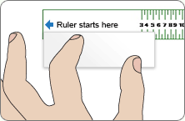
This experiment shows how the average measurement and the actual measurement compare as we increase the number of measuring attempts.
- Select two marks on a nearby desk. Put the forefinger of your left hand on one mark and the forefinger of your right hand on the other.
- Return to your desk while trying hard to keep your fingers the same distance apart.
- Have the distance between your fingers measured when you arrive.
- Repeat the process ten times at the very least and then find the average of the measurements.
- Compare this with the actual measurement of the distance between the two marks.
- Find the mean and approximate random uncertainty and the percentage uncertainty in your measurements.
- Comment on your results and compare your results to the true measurements.

Practical (C): signficant figures
- Draw two horizontal lines on graph paper each 3 units long
- Now add a vertical line to each, one 3 units tall, the other 4 units:
- Now measure and calculate the lengths of the two diagonals.

Your measurements on each of these drawings are of nearly identical accuracy and give 4.2 units ± a little bit and 5.0 ± a little bit. Your calculations on the other hand give 4.24264068712 units and 5 units exactly.

DISCUSSION OPPORTUNITY: Which set of answers do we choose; the calculation which looks as if it gives one accurate answer and one totally uncertain, or the measuring answer which gives two equally inaccurate results.

Practical (D) Measuring: Uncertainties during an experiment

Aim: To find the average speed of a trolley moving down a slope, estimating the uncertainty in the final value.
Apparatus: 1 ramp, 1 metre stick, 1 trolley, 1 stop clock.
Instructions:
- Set up a slope and mark two points 85 cm apart.
- Note the scale reading uncertainty.
- Calculate the percentage uncertainty in the distance.
- Ensuring the trolley starts from the same point each time, measure how
long it takes the trolley to pass between the two points.
- Repeat 5 times, calculate the mean time and estimate the random uncertainty.
- Note the scale reading uncertainty in the time.
- Calculate the percentage uncertainty in the time.
- Calculate the average speed and associated uncertainty.
- Express your result in the form:
(speed ± absolute uncertainty) m s⁻¹

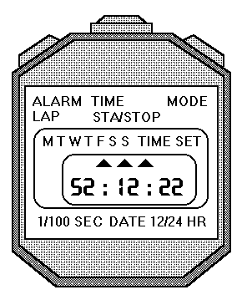

Tutorials

Uncertainty Tutorial 1
The two questions that follow set the scene for the type of problem we need to be able to handle.
NAME | No. of Marbles | Mass /g
FRED | 5 | 6.5
 | 17 | 22.1
 | 9 | 11.7
 | 11 | 14.3
 | 20 | 26
MICKEY | 13 | 17.5
 | 15 | 20.1
 | 4 | 5.8
 | 8 | 11
 | 18 | 24
JANE | 8 | 10.4
 | 19 | 24.7
 | 4 | 5.2
 | 12 | 15.6
 | 3 | 3.9
- Some first year pupils have completed a practical work in which they weighed handfuls of equal sized marbles. The results they presented to their teacher are shown below.

(a) What is the mass of a single marble according to either Fred or Jane?
(b) What is the mass of a marble according to Mickey?
(c)Show that Mickey’s balance has not been adjusted to zero at the start and is reading 0.6 g too much.

2. Here are two measurements of the circumference of a ball made by tying a string round it and then measuring the length of the string.
44.6cm, 39cm.
(a)What is the average measurement?
(b)What would you calculate as the average error if the actual circumference of the ball were known to be 42cm?
(c) Here are two more results: 40cm, 44.2cm
(i) What is the new average measurement of the circumference?
(ii) What is your new average for the error in its measurement?
(d) Here are five more results. Just using these results calculate the new average circumference and the average error in its measurement.
43.5cm, 41.2cm, 42.8cm, 39.6cm, 42.9cm

Uncertainties Tutorial 2
Now try the following six questions. They should be used to make you think of the consequences of uncertainties in experiments
- In an experiment to measure the speed of a trolley as it runs down a ramp, the timing gate at the top of the ramp takes 0.05s to switch the clock on. The gate at the bottom takes 0.08s to switch the clock off. Explain whether the calculated value of the speed is too low or too high.

- A pupil boils some water for a time and calculates the amount of heat delivered in the process. He then measures the amount of water turned into steam and calculates the specific latent heat of vaporisation of the water, l, using the relationship E _{h} = m l, where m is the mass in kilogrammes.

Results: power of the heater = 500.00 W
boiling time = 5 min 16.4 s
Find E _{h} =
initial mass of water = 800.0 g
final mass of water = 720.0 g
Find mass of water evaporated =

        - What does the pupil calculate as the value of l?
        - Suggest a reason why his answer is lower than the accepted value of 2.26 × 10 ⁶ Jkg⁻¹.

3). Three groups in a class are trying to measure the velocity of water waves by noting down the frequency on the generator and measuring the wavelength in the tank.
Results:
Group | Number of Waves | Length (cm)
1 | 4  6  3  5 | 21.2  31.8  15.9  26.5
2 | 12  13  17  15 | 63.6  68.6  90.1  79.5
3 | 9  11  7  8 | 48.6  59.4  37.8  43.2

        - Which group has the short metre stick?
        - If they use the formula v = f × λ to calculate the velocity, does this make their calculated result slower or faster than the other two groups?

4). A pupil has been measuring the resistance of a length of wire using this circuit:

She knows that the battery provided 6V at the start of her experiment, but when she tested it afterwards it had fallen to an output of only 4V. She thinks that this makes an experimental error.
Explain why she should not worry.

5). A Standard Grade pupil is investigating the relationship between the length of a wire and its resistance using the following arrangement:
The graph of her results shows the expected straight line but it does not pass through the origin:

  - What is the resistance of zero centimetres of any wire?
  - Why do you think the graph does not pass through the origin?
  - What do these results give as the resistance of one metre of wire

6). A pupil uses an electronic thermometer to measure the temperature of water in a thermos flask after fixed amounts of energy have been added. Her results are:
Energy added  ( x 10 ⁴ J) | Temperature of water (ºC)
5 | 9.9
10 | 24.8
15 | 39.6
20 | 54.5
25 | 69.4

  - Plot a graph of temperature against energy added.
  - Calculate the temperature actually reached when 200,000 J of energy are added.
  - Describe the experimental error you think she has made in this experiment.

Uncertainties Tutorial 3
1. Look at the two result lists shown below then simply state (that means without doing any written calculation) which has the higher percentage error.
(A) 2.3s, 2.2s, 2.3s, 2.4s, 2.3s
(B) 12.3s, 12.2s, 12.3s, 12.4s, 12.3s
2. Calculate the percentage uncertainties in each of the following sets of results:
(A) 52.5cm, 51.8cm, 47.5cm, 53.2cm, 48.2cm, 46.8cm
(B) 47.3cm, 52.6cm, 52.2cm, 47.8cm, 52.7cm, 47.4cm
3.
DISTANCE TRAVELLED | TIME TAKEN
72.82cm | 1.94s
72.85cm | 1.91s
72.83cm | 1.85s
72.81cm | 1.89s
72.86cm | 1.93s
72.81cm | 1.94s

(a) Use these two sets of results to calculate the set of speed results.
(b) Calculate the percentage error in the speed.
(c) How does the percentage error in the speed compare with the percentage errors in the distance travelled and the time taken?

4. The following are some of the results obtained using an electromagnetic arrangement which released a metal ball and time its fall automatically.
TIME /s | 1.58 | 1.55 | 1.59 | 1.56 | 1.56 | 1.58

  - Calculate the absolute uncertainty of these results.
  - As a backup arrangement, a pupil of excellent reflexes is chosen to time the ball falling using a hand-held mechanical stopwatch which ticks ten time per second.
These results are shown below:
TIME /s | 1.56 | 1.56 | 1.56 | 1.56 | 1.56 | 1.56

Explain why these results are not as good as the previous ones but have a lower absolute uncertainty.
Assuming we can always estimate to the nearest half of a scale division, on an analogue scale.

5.(a) What is the percentage uncertainty on the reading shown below?

(b) What is the approximate percentage uncertainty if a pupil quotes a measurement of 83.25cm when using a metre-stick?

When using digital meters, the last figure is always uncertain because these devices have to round off their displays to the nearest whole last digit.
e.g. A reading of 1.57mA on a display means a current between 1.56mA and 1.58mA so it is really giving a measurement of
Calculate the percentage errors in each of the following displays:
(i) 2.01A (ii) 25.5V (iii) 5.2×103Ω.

HSDU Tutorial 4
1)Calculate the percentage uncertainties for the following absolute readings:
a) (4.65 ± 0.05) V | b) (892 ± 5) cm | c) (1.8 ± 0.4) A
d) (2.87 ± 0.02) s | e) (13.8 ± 0.5) Hz | f) (5.2 ± 0.1) m.

- State the three types of uncertainty, explaining the difference between them.

- Manufacturers of resistors state the uncertainty in their products by using colour codes.
Gold - 5 % accuracy. | Silver - 10 % accuracy.
Calculate the possible ranges for the following resistors for each colour.
a) 1 k Ω | b) 10 k Ω | c) 22 Ω

- For each of the following scales, write down the reading and estimate the uncertainty.
f)
e)
d)

- Calculate the mean time and random uncertainty for the following readings:
0.8 s, 0.6 s, 0.5 s, 0.6 s and 0.4 s.

- A student uses light gates and suitably interfaced computer to measure the
acceleration of a trolley as it moves down a slope. The following results were obtained.

a / m s² | 5.16 | 5.24 | 5.21 | 5.19 | 5.12 | 5.20 | 5.17 | 5.19

Calculate the mean acceleration and the corresponding random uncertainty.

7). AB is measured using a metre stick.A trolley is timed between AB.
The following results were obtained.
AB = (60.0 + 0.1) cm

t/s | 1.21 | 1.21 | 1.26 | 1.27 | 1.24 | 1.28

Express the average speed in the form (value ± absolute uncertainty)

PRESCRIBED PRACTICAL

You can work in up to 3 groups, everyone must be actively involved or you can fail this assessment
By the end of this lesson (2 periods) I need

Aim
To find out how the steepness of the slope affects the acceleration down the slope.
You can use a single or double mask, one or two lightgates

Uncertainties
Think about where and how you are getting uncertainties in your results. I will want you to quantify them tomorrow

Risk Assessment
I want you to think about

Hazards
What are your hazards?
What could go wrong and how?

Risk
How likely is it that each thing goes wrong?
How serious would it be if the above did go wrong (these two are called the risk)

Control Measures
How can you reduce the risk (seriousness and likelihood) of something going wrong?

Results
Remember it is best if you can plot your results and graph them as you go along and then you can tell if you have got a dodgy point.
- How many repeats?
- How many different points?
- How close should they be? Evenly spaced or more at a certain point?
- What do you need to measure?
- What are the best measuring instruments?

Homework
Hand in from everyone an individual piece
- An excel table and graph of your results!
- Uncertainties quantified
- Results and Conclusion
- Evaluation, did you plan well enough or launch in and make mistakes (hint don’t!)
References: For more info go into Assignment and look at the Intro to Risk Assessment, Look in your notes on how to do the practical
!TI DEEN THGIM UOY!KCUL DOOG

Uncertainties Tutorial Answers

Answers to Tutorial 1
1 (a) 1.3g.
(b) Mickey’s 1.36g from the graph (see below) 1.35g if taken from the mean
(c) all other mass readings will be 0.5 g / 0.6g too high.

  - 42cm
  - 42 ± 3 cm (2.8cm)

    - 42cm
    - 42 ± 1 cm (1.4cm)
  - 42.0 ± 0.8 cm

Answers to Tutorial 2:
1. the calculated speed is too low.
2. (a) L = 1.9775 x 10⁶ J kg⁻¹
(b) Its low value, for example, might be due to water that has bubbled over rather than just escaped as steam.
3. (a) Group 3 has the shortest metre stick.
(b) velocity which is too large.
4. Her calculated value stays correct regardless of how V changes.
5. (a) Zero ohms
(b) The graph shows that there is resistance in the circuit when the length of wire being measured is zero.
(c) resistance of 100 cm as 50 Ω.
6 (a)

(b) 59.6 ºC.
(c) the electronic thermometer has not had it’s zero checked

Answers to Tutorial 3:
1. Set (A) has the larger percentage error.
2. (a) Set (A) 2.2%
set (B) 1.8%

3. The calculated speeds are:
(a)
37.54 cms-1
38.14 cms-1
39.37 cms-1
38.52 cms-1
37.75 cms-1
37.53 cms-1
        - speed as ±0.8%
        - A separate calculation for the percentage uncertainties of distance and time gives ±0.01% and 0.8% respectively. Combininig these two measurements to give the speed of the object does nothing to improve on the certainty and we usually quote the highest percentage uncertainty in each measurement as our overall uncertainty Therefore the uncertainty in the object’s speed is 0.8%
4. ±1.57 s
The second set of results has no measured error but is not much use because of the clock used. Since it ticks only 10 times per second, any times that fall between one tick and the rest cannot be recorded. Thus any variations in the hundredths of a second are “invisible” in the results
5. (a) 0.06%
(c) (i) 0.5%
(ii) 0.4%
(ii) 1.9%

Answers to HSDU problems tutorial 4
1. | (a) 1.1% | (b) 0.6 % | (c) 22 %
 | (d) 0.7 % | (e) 3.6 % | (f) 1.9 %
2. Systematic effect: affects all readings in the same way. Can be due to apparatus limitations or fault in experimental approach.
Reading uncertainty: accuracy limited by quality of scale
± half the least division (analogue) or good estimate.
± 1 in the least significant digit (digital).
Random uncertainty: random fluctuations between readings.
Effect is minimised by repeating readings.
3. | a)Gold 5 % of 1kΩ = 0.05 kΩ  Silver 10 % of 1kΩ = 0.1kΩ |  | Range is (0.95 - 1.05) kΩ  Range is (0.9 -1.1) kΩ |  | = (950 - 1050) Ω  = (900 - 1100) Ω
 | b) Silver (9000 - 11000) Ω |  | Gold (9500 - 10500) Ω
 | c) Silver (19.8 - 24.2) Ω |  | Gold (20.9 - 23.1) Ω
4. | (a)( 3.2 ± 0.1) mm | (b)(2.30 ± 0.05) cm |  | (c) (0.250 ± 0.005) ⁰C
 | (d) (7.84 ± 0.01) s | (e) (1.005 ± 0.001) s |  | (f) (195 ± 1) mA
5. | t = (0.6 ± 0.1) s
6. | a = (5.19 ± 0.02) m s⁻²
7. | 48.0 cm s⁻¹ ± 0.8% = (48.0 ± 0.4) m s⁻¹

It is really important that you don’t forget this material as you go through the course!

