2021
J. A. Hargreaves
Mostly Harmless
2021

Higher Compendium Questions



Much of this material is taken from the SQA Higher Physics Course Specifications

Data Sheet

Relationships Required For Higher Physics
 |  | $$V_{rms}=\frac{V_{peak}}{\sqrt{2}}$$
 |  | $$I_{rms}=\frac{I_{peak}}{\sqrt{2}}$$
 | $$I=\frac{P}{A}$$
 | $$I_{1}d_{1}^{2}=I_{2}d_{2}^{2}$$
 |  | $$E=V+Ir$$
 | $E_{2}-E_{1}=hf$
 | $$dsinθ=mλ$$ | $$\text{Q=It}$$
 |  | $$E=\frac{1}{2}QV=\frac{1}{2}CV^{2}=\frac{1}{2}\frac{Q^{2}}{C}$$
$$t^{'}=\frac{t}{\sqrt{1-\frac{v^{2}}{c^{2}}}}$$
 | Path difference= mλ or (m+ ½)λ where m = 0,1,2 …..
 | $$∆R=\frac{R_{max}-R_{min}}{n}$$

Periodic Table

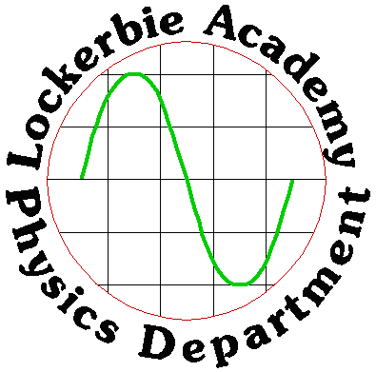
Uncertainties
No. | CONTENT
1. | Uncertainties
1a) | I can identify that all measurements of physical quantities are liable to uncertainty which I can express in absolute or percentage form.
i | State what you must be aware of, whenever you are making a measurement.
ii | Is there any measurement that you can make that is not liable to uncertainties? Explain your answer.
iii | State any uncertainties that can arise when using a stopwatch to time 10 swings of a pendulum.
iv | Explain why a ruler should not be used to measure the width of a tennis ball.
v | State the difference between accuracy and precision and give an example of each.
vi | An experiment is carried out to measure the wavelength of red light from a laser.  The following values for the wavelength are obtained.  Calculate the mean value for the wavelength and the approximate random uncertainty in the mean.
  650 nm | 640 nm | 635 nm | 648 nm | 655 nm
1b) | I can quantify and recognise scale reading, random and systematic uncertainties in a measured quantity.
i | Explain the terms:  - Scale reading uncertainty  - Random uncertainty  - Systematic uncertainty
ii | Calculate the percentage uncertainty in the following measurement.  0 10 20 30 40 50
iii | State an example of a  - random uncertainty b) systematic uncertainty.
Iv | SQA Higher Paper 1994  During an experiment to measure the specific heat capacity of a liquid the relationship $VIt=mc∆T$ is used
  The following quantities are measured  V= 12.0 ± 0.1 V  I = 4.2 ± 0.1 A  t =300 ± 1s  m=500± 2 g  ΔT = 15 ± 1 °C | Which quantity will contribute the largest uncertainty to the final answer for the specific heat capacity, c?  A Voltage  B Current  C Time  D mass  E temperature difference
V | 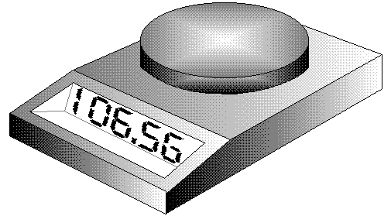  Calculate the scale reading uncertainty in the top pan balance measurement shown in the diagram.
vi | Calculate the scale reading and percentage uncertainty in each of the thermometers readings.  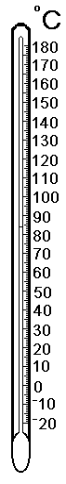
vii | A group of students was measuring the mass of paperclips using a butchart balance in order to find the mass of one paper clip.  The results have been plotted on the graph below:  - Explain how this graph indicates a likely systematic effect in these readings.  - State a likely cause of this systematic uncertainty.  - Estimate the systematic effect in these readings.  - Determine the mass of one paperclip.
1c) | I can express uncertainties in absolute or percentage form
i | A pupil uses light gates and a suitably interfaced computer to measure the acceleration of a trolley as it moves down an inclined plane.  The following results were obtained:  Calculate the mean valve of the acceleration and the corresponding random uncertainty.
  acceleration (m s⁻²) | 5.16 | 5.24 | 5.21 | 5.19 | 5.20 | 5.20 | 5.17 | 5.19.
ii | Calculate the percentage uncertainties for the following absolute readings:  a) (4.65 ± 0.05) V b) (892 ± 5) cm c) (1.8 ± 0.4) A  d) (2.87 ± 0.02) s e) (13.8 ± 0.5) Hz f) (5.2 ± 0.1) m.
iii | Calculate the mean time, random uncertainty and percentage uncertainty for the following readings:  0.8 s, 0.6 s, 0.5 s, 0.6 s, 0.4 s.
1d) | I know how random uncertainties arise.
i | State how random uncertainties arise.
ii | State the units for the approximate random uncertainty.
1e) | I can explain scale reading.
i | Explain the term scale reading uncertainty.
ii | State the usual scale reading uncertainty in an analogue device.
iii | State the usual scale reading uncertainty in a digital device.
iv | Calculate the scale reading uncertainties in each of the measurements above.
V | 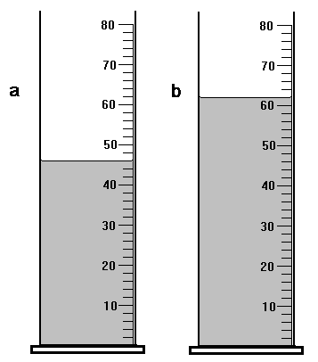  Calculate the scale reading uncertainties in each of the measuring cylinder volumes.  Quote your answer as reading ± uncertainty.
vi | For each of the following scales, write down the reading and estimate the uncertainty.  s
Vii | 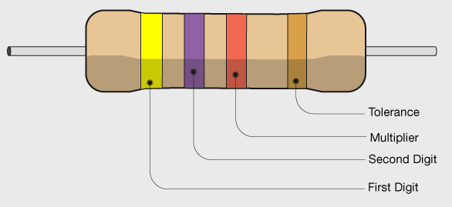  Figure 1 https://byjus.com/physics/resistor-colour-codes/  Manufacturers of resistors state the uncertainty in their products by using colour codes.  Gold - 5 % accuracy.  Silver - 10 % accuracy.  Calculate the possible ranges for the following resistors for each colour.  a) 1 k Ω b) 10 k Ω c) 22 Ω
viii | 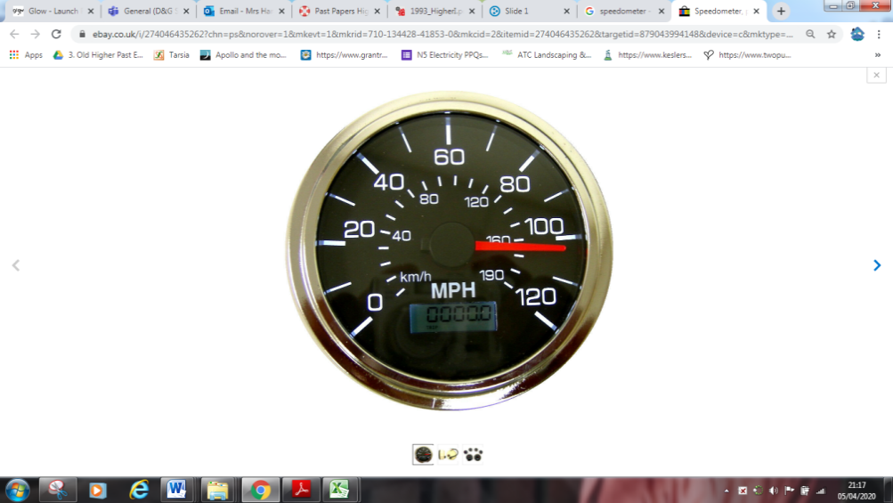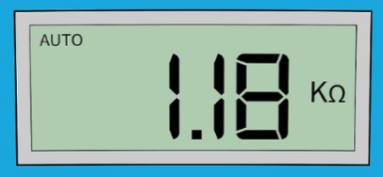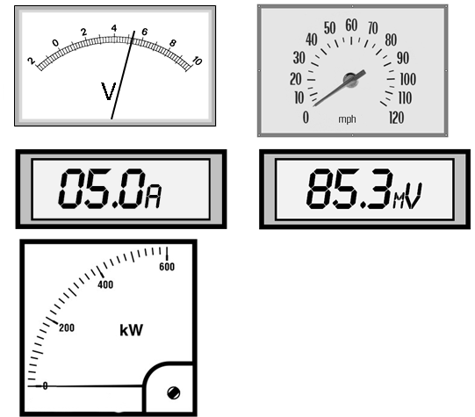  Determine the scale reading uncertainty and the percentage uncertainty in these measurements.  0  Figure 1 obviously not from UK roads!
1f) | I can state how random uncertainties can be reduced.
i | Give examples on how random uncertainties can be reduced.
ii | State what you must do to mitigate random uncertainties arising from your experiment.
1g) | I can explain how systematic uncertainties occur
i | Explain how systematic uncertainties occur
ii | Give examples of how systematic uncertainties occur
1h) | I can recognise possible causes of systematic uncertainties.
i | State the effect systematic uncertainties have on experimental results.
ii | 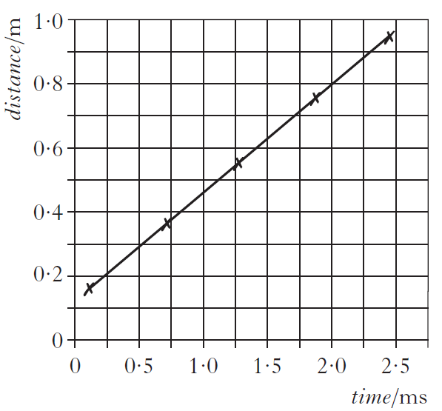  A student makes measurements of the time taken for sound to travel various distances in air.  The measurements are used to produce the following graph.  The student makes the following statements.  I The graph proves that the distance travelled is directly proportional to the time taken.  II The graph indicates that there is a systematic uncertainty in the measurements.  III The speed of sound can be calculated from the gradient of the graph.  Sketch the graph and copy out the correct statement(s)
iii | A National 5 pupil is investigating the relationship between the length of a wire and its resistance using the following arrangement:  The graph of her results shows the expected straight line but it d  oes not pass through the origin:  - State the resistance of zero centimetres of any wire  - State why the graph does not pass through the origin  - State what these results in the graph give as the resistance of one metre of wire.
iv | Some first year pupils have completed a practical work in which they weighed handfuls of equal sized marbles. The results they presented to their teacher are shown below.  (a) What is the mass of a single marble according to either Fred or Jane?  (b) What is the mass of a marble according to Mickey?  (c) Show that Mickey’s balance has not been adjusted to zero at the start and is reading 0.6 g too much.
  NAME | FRED |  |  |  |  | MICKEY |  |  |  |  | JANE
  No. of Marbles | 5 | 17 | 9 | 11 | 20 | 13 | 15 | 4 | 8 | 18 | 8 | 19 | 4 | 12 | 3
  Mass /g | 6.5 | 22.1 | 11.7 | 14.3 | 26 | 17.5 | 20.1 | 5.8 | 11 | 24 | 10.4 | 24.7 | 5.2 | 15.6 | 3.9
v | A pupil uses an electronic thermometer to measure the temperature of water in a thermos flask after fixed amounts of energy have been added. Her results are:  - Plot a graph of temperature against energy added.  - Calculate the temperature actually reached when 200,000 J of energy are added.  - Describe the experimental error you think she has made in this experiment.
  Energy added  ( x 10 ⁴ J) | Temperature of water (ºC)
  5 | 9.9
  10 | 24.8
  15 | 39.6
  20 | 54.5
  25 | 69.4
1i) | I know the mean of a set of repeated measurements is the best estimate of the ‘true’ value of the quantity being measured.
i | Find the absolute uncertainty in the following readings.
  Speed /ms ^{–1} | 0.97 | 0.92 | 1.07 | 1
- State the error made when recording the above results.
- Correct this error by re-writing out the table.
- Find the mean in these measurements and the approximate random uncertainty in the mean value.
ii | State the best measurement we can hope for when making measurements.
1j) | I know that when systematic uncertainties are present they offset the mean value
i | Draw a diagram illustrating the effects of a systematic error in a set of results.
ii | State the effect of systematic uncertainties on the mean value.
iii | State any way(s) to identify systematic uncertainties arising in experiments.
1k) | I know when mean values are used; the approximate random uncertainty should be calculated.
i | Explain why repeat measurements should be taken when taking measurements.
ii | Explain how to find the approximate random uncertainty in a set of measurements.
iii | State how you should express your final answer for this measurement.
1l) | I can correctly calculate, use and identify uncertainties during data analysis.
i | Calculate the percentage uncertainty in these results.
  Time/s | 1.58 | 1.55 | 1.59 | 1.56 | 1.56 | 1.58
ii | A set of temperature measurements are made by a student as shown below.  80·5 °C, 80·3 °C, 80·4 °C, 81·7 °C, 81·3 °C, 80·1 °C, 81·4 °C, 80·8 °C  Calculate the mean value of the readings and the random uncertainty in the mean.
iii | A student sets up the apparatus in the diagram to measure the average acceleration of a model car as it travels between P and Q.  For one run, the following measurements were recorded along with their estimated uncertainty.  clock 1 reading = 0.23 s ± 0.01 s  clock 2 reading = 0.12 s ± 0.01 s  stopwatch reading = 0.95 s ± 0.20 s  length of car = 0.050 m ± 0.002 m  distance PQ = 0.30 m ± 0.01 m  The measurement which gives the largest percentage uncertainty is the  - reading on clock 1  - reading on clock 2  - reading on the stopwatch  - length of the car  - distance PQ.
iv | Measurements are made of the time taken for 5 similar stones to drop down a well. The recorded times are as follows  2.57 s 2.61 s 2.47 s 2.46 s 2.49 s  Calculate  - The mean value of the time of fall;  - The random error in the mean value
v | A student makes five separate measurements of the diameter of a lens.  These measurements are shown in the table.  The approximate random uncertainty in the mean value of the diameter is  - 0.1mm  - 0.2mm  - 0.3mm  - 0.4mm  - 0.5mm.
  Diameter of lens/mm | 22.5 | 22.6 | 22.4 | 22.6 | 22.9
vi | SQA Revised Higher 2012  A group of students carries out an experiment to find how the horizontal range of a ball depends on the angle of launch, θ.  They use a projectile launcher as shown.  The results are shown in the table.  - Draw a graph of these results.  - Use your graph to estimate the angle of launch that produces the maximum range of the ball.  - Using the same apparatus, the students now wish to determine more precisely the angle of launch that produces the maximum range. Suggest two improvements to the experimental procedure that would achieve this.  - Describe further experimental work that could be carried out to investigate another factor that may affect the horizontal range of a projectile.
  Angle of launch, θ (°) | Range (m)
  20 | 1·55
  30 | 1·64
  40 | 1·63
  50 | 1·43
  60 | 1·18
  70 | 0·95
1m) | I can correctly calculate, use and identify uncertainties during data analysis.
i | A student is using an electronic top pan balance to measure mass during an experiment. She discovers that the readings are all consistently too high. State the name of this type of uncertainty and suggest a reason for the uncertainty.
Ii | Calculate the percentage scale reading uncertainty in this line.
iii | The manufacturer of a resistor claims that it is accurate to ± 0·5 Ω. State the name applied to this type of uncertainty.
iv | Eight students in a class measure the temperature of the room. They obtain the following results.  21·9 °C 21·8 °C 21·4 °C 22·3 °C 22·1 °C 22·1 °C 21·5 °C 22·3 °C  (a) State the type of uncertainty represented by a range of results.  (b) (i) Calculate the mean value for these results.  (ii) Calculate the random uncertainty in the mean.
v | The following results were obtained from an experiment.  distance = 1.00 ± 0.01 m, time = 0.16 ± 0.02 s  Calculate the speed from these results and express it in the form final value ± uncertainty.
vi | SQA Higher 2010  An experiment is carried out to measure the time taken for a steel ball to fall vertically through a fixed distance using an electronic timer.  (a) The experiment is repeated and the following values for time recorded.  Calculate:  (i) the mean value of the time;  (ii) the approximate random uncertainty in the mean value of the time.
  0·49 s | 0·53 s | 0·50 s | 0·50 s | 0·55 s | 0·51 s.
vii | A pupil wishes to measure the amount of energy stored in a 5 μF capacitor which is charged to a p.d. of 10 V. She discharges the capacitor through the heating coil which is immersed in a small quantity of oil. The energy stored in the capacitor is calculated using the equation  $$E=cm∆T$$  $$E stored in the capacitor=c \left(oil\right)×mass (oil)×∆T$$  - State the assumption made by the pupil in using this equation  - By considering the energy stored in the capacitor, explain why the measurement of the rise in temperature of the oil is likely to be extremely inaccurate.
viii | SQA 2016  A student uses the apparatus shown to investigate the force of friction between the wheels of a toy car and a carpet.  The toy car is released from rest, from a height h. It then travels down the ramp and along the carpet before coming to rest. The student measures the distance d that the car travels along the carpet. The student repeats the procedure several times and records the following measurements and uncertainties.  Mass of car, m : (0·20 ± 0·01) kg  Height, h : (0·40 ± 0·005) m  (a) (i) Calculate the mean distance d travelled by the car.  (ii) Calculate the approximate random uncertainty in this value.
  Distance, d : | 1·31 m | 1·40 m | 1·38 m | 1·35 m | 1·41 m
ix | SQA Higher 2009  Golf clubs are tested to ensure they meet certain standards.  In one test, a securely held clubhead is hit by a small steel pendulum. The time of contact between the clubhead and the pendulum is recorded.  The experiment is repeated several times.  The results are shown.  (i) Calculate:  (A) the mean contact time between the clubhead and the pendulum;  (B) the approximate absolute random uncertainty in this value.  (ii) In this test, the standard required is that the maximum value of the mean contact time must not be greater than 257 μs. Does the club meet this standard? You must justify your answer.
  248 μs | 259 μs | 251 μs | 263 μs | 254 μs
X | SQA Higher 2005  A student uses the apparatus shown to measure the average acceleration of a trolley travelling down a track.  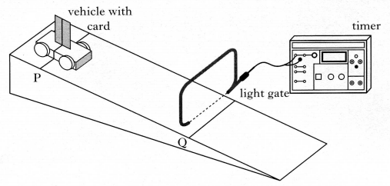  The line on the trolley is aligned with line P on the track. The trolley is released from rest and allowed to run down the track. The timer measures the time for the card to pass through the light gate.  The procedure is repeated a number of times and the results shown below.  - Calculate:  - the mean time for the card to pass through the light gate.  - The approximate absolute random uncertainty in this value.  - The length of the card is 0.020 m and the distance PQ is 0.60 m. Calculate the acceleration of the trolley (a uncertainty in this value is not required).
  0.015 s | 0.013 s | 0.014 s | 0.019 s | 0.017 s | 0.018 s
1n) | I know that when an experiment is being undertaken and more than one physical quantity is measured, the quantity with the largest percentage uncertainty should be identified and this may often be used as a good estimate of the percentage uncertainty in the final numerical result of an experiment.
I | The experimental arrangement shown below is used to measure the speed of an air rifle pellet.  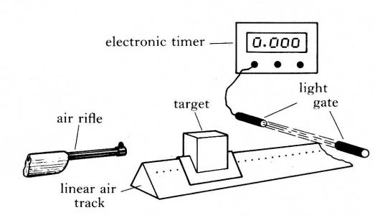  The speed of the pellet is calculated from the equation  $$speed of pellet=\frac{final mass of target ×speed of target}{mass of pellet}$$  The results from one experiment are  Final mass of the target = (2.00 ± 0.02) kg  Mass of pellet = (10.0 ± 0.5) g  Speed of target = (0.50 ± 0.01) ms⁻¹  Which of the following gives a good estimate of the percentage error in the calculated speed of the pellet?  1 %  2 %  3 %  5 %  8 %
ii | A vehicle runs down a slope as shown.  The following results are obtained.  angle of slope, θ = 15.0 ± 0.5°  length of card on top of vehicle,  d = 0.020 ± 0.001 m  time for card to pass light gate 1,  t₁ = 0.40 ± 0.01 s  time for card to pass light gate 2,  t₂ = 0.25 ± 0.01 s  time for vehicle to travel between the light gates,t₃ = 0.50 ± 0.01 s  - Which quantity has the largest percentage uncertainty?  - State the overall uncertainty is finding the relationship between acceleration and angle of the slope.
iii | A ball is dropped several times from the same height.  A student records the following times for the ball to reach the ground.  Calculate the mean time for the ball to reach the ground and the approximate random uncertainty in this mean.
  1·15 s | 1·13 s | 1·09 s | 1·13 s | 1·05 s
1o) | I can express the numerical result of an experiment in the form final value ±uncertainty.
i | Here are two measurements of the circumference of a ball made by tying a string round it and then measuring the length of the string.  44.6cm, 39cm.  (a)What is the average measurement?  (b)What would you calculate as the average error if the actual circumference of the ball were known to be 42cm?  (c) Here are two more results: 40cm, 44.2cm  (i) What is the new average measurement of the circumference?  (ii) What is your new average for the error in its measurement?  (d) Here are five more results. Just using these results calculate the new average circumference and the average error in its measurement.  43.5cm, 41.2cm, 42.8cm, 39.6cm, 42.9cm
Ii | SQA Higher 2002  A basketball is dropped several times from the same height. The following values are obtained for the acceleration of the basketball  Calculate:  - the mean of these values;  - the approximate random uncertainty in the mean.
  8.9 ms⁻² | 9.1 ms⁻² | 8.4 ms⁻² | 8.5 ms⁻² | 9.0 ms⁻²
iii | SQA 2007 Higher  An experiment to determine the wavelength of light from a laser is shown.  A second order maximum is observed at point B.  (b) Distance AB is measured six times.  The results are shown.  (i) Calculate:  (A) the mean value for distance AB;  (B) the approximate random uncertainty in this value.  (ii) Distance BC is measured as (270 ± 10)mm.  Show whether AB or BC has the larger percentage uncertainty.  (iii) The spacing between the lines on the grating is 4.00 × 10⁻⁶ m.  Calculate the wavelength of the light from the laser.  $$mλ = d sinθ$$  Where m=no. of order of maxima, λ = wavelength, d= distance between the  Express your answer in the form  wavelength ± absolute uncertainty
  1.11m | 1.08m | 1.10m | 1.13m | 1.11m | 1.07m

Units Prefixes and Scientific Notation
No | CONTENT
2. | Units, prefixes and scientific notation
2a) | I know the units for all of the physical quantities used in this course.
i | State the 7 base quantities from which all other quantities are derived.
ii | State the SI units for the following physical quantities  a) length, b) mass, c) acceleration, d) velocity, e) energy, f) charge.
2b) | I can use the prefixes: pico (p), nano (n), micro (μ), milli (m), kilo (k), mega (M), giga (G) and tera (T).
i | Express the following in scientific notation.  a) 50 mA, b) 0.3 nF, c) 200 s d) 45 μF e) 5000 GJ f) 0.0000217 A
ii | Express the following in scientific notation in SI units.  - 12 gigahertz 12 GHz  - 4.7 megohms 4.7 MΩ  - 46 kilometres 46 km  - 3.6 millivolts 3.6 mV  - 0.55 milliamps 0.55 mA  - 25 microamps 25 µA  - 630 nanometres 630 nm  - 2200 picofarads 2200 pF
iii | Calculate the volume in cubic metres of a cuboid with sides of length 10.0 cm, 5.50 cm and 2.55 cm respectively.
iv | A leaf of mass 0.10g feels a frictional force of 948 μN as it falls from a tree. Determine its acceleration as it falls. Include a free body diagram of the leaf.
2c) | I can give an appropriate number of significant figures when carrying out calculations. (This means that the final answer can have no more significant figures than the value with least number of significant figures used in the calculation).
i | 68122500 J of energy are used by a heater in 136245 s. Calculate the power output of the heater.
ii | From the graph determine the distance travelled
iii | A force of 1N is applied to a 3 kg mass determine the acceleration this produces
iv | A pupil measures the current through a resistor as 0.250 A and the voltage across it is 2.00 V. Calculate the resistance of the resistor.
v | Calculate the energy released when 0.500 kg of water (c = 4180 Jkg⁻¹ °C⁻¹) lowers its temperature by 5.0 °C.
vi | Calculate the power of a heater that uses 1200J of energy in 212.5 seconds?
vii | Calculate the area of a triangle in square metres if its base is 25 cm and its height 12 cm.
viii | Calculate the acceleration of a car that changes its speed by 34.5ms⁻¹ in a time of 5 s.
ix | Calculate the speed of sound from the results below:  Explain the difference in your values.
  Distance (m) | Time(s) | Speed (ms⁻¹)
  1000 | 3
  1000.00 | 3
  1000.00 | 3.00
  1000 | 3.0
x | How much work must be done to increase the potential of a charge of  6·4 × 10 ⁻⁷ C by 560 V (W = QV).
2d) | I can use scientific notation when large and small numbers are used in calculations.
i | Show by calculation the magnitude of a light year.
ii | put the following into kΩ MΩ, GΩ or TΩ as required:
  a) 5000 Ω | b) 10000 Ω |  | c) 3000000 Ω |  | d) 600000 Ω | e) 340 Ω
  f) 3 x 10⁵ Ω | g) 4 x l0⁴ Ω |  | h) 9 x 10¹³ Ω |  | i) 8.4 x 10⁷ Ω | j) 3.56 x 10⁸ Ω
  k) 98 x 10⁵ Ω |  | l) 740 x l0¹¹ Ω
iii | Astronomers use the following relationship to determine the distance, d, to a star.  For a particular star the following measurements are recorded:  apparent brightness, F = 4·4 × 10⁻¹⁰ W m⁻²  luminosity, L = 6·1 × 10³⁰ W  Based on this information, the distance to this star is  A 3·3 × 10¹⁹ m  B 1·5 × 10²¹ m  C 3·7 × 10³⁶ m  D 1·1 × 10³⁹ m  E 3·9 × 10³⁹ m.

Our Dynamic Universe
No | CONTENT
3. | Equations of Motion
Eq | $d=\overline{v}t, s=\overline{vt} ; s=\frac{1}{2}\left(u+v\right)t;$
3 a) | I can use the equations of motion to find distance, displacement, speed, velocity, and acceleration for objects with constant acceleration in a straight line.
Acceleration is the change in
…. distance per unit time
…. displacement per unit time
…. velocity per unit distance
…. speed per unit time
…. velocity per unit time.
Copy and complete the statement with the correct ending.
 | State if it is possible for an object to be accelerating but have a constant speed. You must justify your answer.
 | State if it is possible for an object to move with a constant speed for 5 seconds and have a displacement of 0 metres. You must justify your answer.
 | State if it is possible for an object to move with a constant velocity for 5 seconds and have a displacement of 0 metres. You must justify your answer.
 | An athlete ran a 1500 metres race in 3 minutes 40 seconds. Calculate his average speed for the race.
 | Calculate the distance between the sun and the Earth if it takes light 8 minutes to reach Earth.
 | A ground-to-air guided missile accelerates from rest at 150 m s⁻² for 5 seconds. Calculate the speed reached.
 | An Aston Martin accelerated from rest at 6 m s⁻². Calculate the time it takes to reach a speed of 30 m s⁻¹.
 | A family car is travelling well over the speed limit. The brakes are applied when travelling at its top speed of 68 m s⁻¹, and decelerates at 17 m s⁻², calculate the time it takes to reduce its speed 34 m s⁻¹.
A skateboard running from rest down a concrete path of uniform slope reaches a speed of 8ms⁻¹ in 4 s.
  - Determine the acceleration of the skateboard.
  - Calculate the time after it started when the skateboard take to reach a speed of 12 m s⁻¹.
In the Tour de France a cyclist is travelling at 20 m s⁻¹. When she reaches a downhill stretch her speed increases to 40 m s⁻¹. It takes 4 s for her to reach this point on the hill.
- Determine the acceleration of the cyclist on the hill.
- Assuming he maintains this acceleration, calculate the speed she will be travelling after a further 2.0 s.
- Calculate the time it takes the cyclist to reach a speed of 55 m s⁻¹.
 | An armour-piercing shell, travelling at 2000 ms⁻¹, buries itself in the concrete wall of a bunker. If it decelerates at 20000 ms⁻², what time does it take to come to rest after striking the wall?
 | An object moving with velocity 15 m s⁻¹ is accelerated for 8 s so that its new velocity is 27 m s⁻¹ in the same direction as before. Calculate its acceleration.
 | A feather is hit by a gust of wind, which accelerates it at 20 m s⁻² for 0.5 s. Calculate its new velocity if it was moving in the same direction as the wind at 2 ms⁻¹ to begin with.
 | Determine the time taken for a sports car to reach 30 ms⁻¹ from a standing start if it can accelerate at 15 ms⁻².
 | A car accelerates uniformly at 6 m s⁻², its initial speed is 15 m s⁻¹ and it covers a distance of 200 m. Calculate its final velocity
 | A ball is thrown to a height of 40 m above its starting point, determine the velocity with which it was thrown.
 | A car travelling at 30 m s⁻¹ slows down at 1.8 m s⁻² over a distance of 250 m. Calculate the time it takes to stop.
 | If a stone is thrown vertically down a well at 5 m s⁻¹. Calculate the time taken for the stone to reach the water surface 60 m below.
A tennis ball launcher is 0.6 m long and the velocity of a tennis ball leaving the launcher is 30 m s⁻¹. Calculate:
a) the average acceleration of a tennis ball
b) the time of transit in the launcher.

 | In an experiment to find “g” a steel ball falls from rest through 0.40 m. The time taken is 0.29 s. Determine the value for “g”.
A trolley accelerates down a slope. Two photo-cells spaced 0.5 m apart measure the velocities to be 20 cm s⁻¹ and 50 cm s⁻¹.
Calculate
a) the acceleration of the trolley
b) the time taken to cover the 0.5 m.

A helicopter is rising vertically at 10 m s⁻¹ when a wheel falls off.
The wheel hits the ground 8 s later. Calculate at what height the helicopter was flying when the wheel came off.

To test the braking system of cars, a test track is set up as shown.

The sensors are connected to a datalogger which records the speed of a car at both P and Q.

A car is driven at a constant speed of 30 ms^{–1} until it reaches the start of the braking zone at P. The brakes are then applied.
(a) In one test, the datalogger records the speed at P as 30 ms^{–1} and the speed at Q as 12 ms^{–1}. The car slows down at a constant rate of 9.0 s^{–2} between P and Q.
Calculate the length of the braking zone.
(b) The test is repeated. The same car is used but now with passengers in the car. The speed at P is again recorded as 30 m s^{–1}.
The same braking force is applied to the car as in part (a).
How does the speed of the car at Q compare with its speed at Q in part (a)?
Justify your answer.
a) A child's ball rolls down a pavement and passes a mark at 1.5ms⁻¹ . If its velocity is 6.6ms-1 three seconds later, what is its acceleration?
b) The same ball rolls round a corner at 7ms-1 onto a new slope which gives it an acceleration of 2ms-2. How long does it take for its velocity to rise to 10ms-1?
 | A water chute has a constant slope which gives the sliders an acceleration of 4ms-2. If a girl jumps on the chute at a velocity of 3ms⁻¹ , how far will she slide in 5s?
 | An air-gun pellet has an initial velocity of zero and a muzzle velocity of 225ms-1. If the barrel of the rifle is 0.5m long, what is the pellet's acceleration?
 | A football player catches up on a ball rolling at 3ms-1 and kicks it ahead along the same line with an acceleration of 200ms-2 while his foot is in contact with it. If his boot moves with the ball over a distance of 13.75cm, how fast is the ball moving after the kick?
 | A ball is thrown upwards out of a window at 15ms-1 and strikes the ground with a velocity of 30ms-1. How high is the window?
A balloon is released with an initial upwards velocity of 1ms-1 and accelerates at 2ms-2 for the first 12s of its climb.
(a) What is its average velocity during these 12s?
(b) What is its displacement during this time?

A golf ball is driven from a tee and reaches a velocity of 50ms-1 in a time of 3ms.
(a) What is the ball's acceleration?
(b) How far does the ball travel during the first 3s after it is struck assuming there is no air resistance during its flight?

A stone is thrown horizontally off a cliff and lands 2s later 45m out from the spot vertically below the thrower.
(a) How high is the cliff?
(b) What is the stone's initial velocity?

 | A meteroid strikes the Moon's surface and the impact ejects a 5kg rock with a velocity of 200ms-1 at 60o to the horizontal. If the rock lands 21.6 km away, what is the gravitational acceleration at the Moon's surface?
 | A person holds a golf ball at arms length so that the ball is 2m above the ground. How long does it take the reach the ground if he drops it?
 | An angler is standing on a bridge reeling in a hooked fish, which is rising vertically at 1.5ms-1 when it manages to wriggle off. If the fish hits the water 1.2s later, how far above the surface was it when it escaped?
A ball is thrown upwards from the side of a cliff as shown below.
a) Calculate:
i) the height of the ball above sea level after 2 s
I i) the ball’s velocity after 2 s.
b) Determine the total distance travelled by the ball from launch to landing in the sea.

A trolley is fitted with a mechanism which fires a ball bearing vertically upwards 5 seconds after the trolley is released. The trolley itself is fitted with a propeller that accelerates it along a horizontal track:
(a) If the ball-bearing is released when the vehicle reaches a velocity of 2.5ms-1, calculate how far the trolley has moved along the track to this point.
(b) If the ball-bearing starts with a vertical velocity of 4.8ms-1, find the maximum height it reaches.
(c) How far from the trolley does the ball-bearing land assuming that the trolley keeps at the same acceleration?

3b) | I can interpret and draw motion-time graphs for motion with constant acceleration in a straight line, including graphs for bouncing objects and objects thrown vertically upwards.
A ball is thrown vertically upwards and returns to the thrower 3 seconds later. Which velocity-time graph represents the motion of the ball
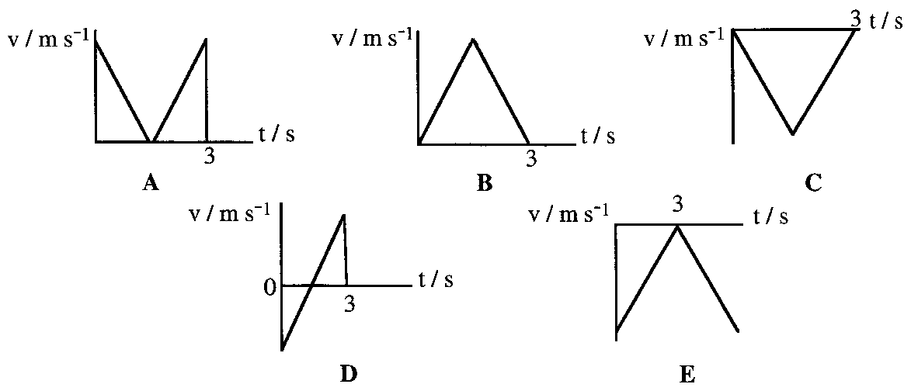
Sketch the acceleration-time graphs for each of the following velocity-time graphs.
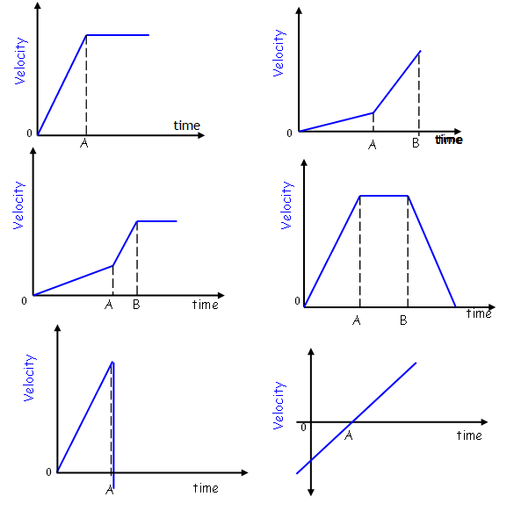

 | Copy the velocity time graph and the corresponding displacement time graph
Here is a velocity time graph for a vehicle travelling along a long straight road.
(a) Determine the average velocity for the vehicle.
(b) State the time this occurs.
(c) Calculate the displacement from the start up to the time recorded in part (b)
(d) Determine the total displacement.
(e) Sketch an acceleration-time graph that corresponds to the velocity-time graph above.
The velocity of a trolley on a slope is investigated using a motion sensor linked to a computer that prints out the velocity-time graph of the trolley's motion.
One such graph for a trolley, which is given an initial push up the slope, is shown here: -
- If the position marked P corresponds to the instant the experimenter lets the trolley go, determine the time the trolley at its maximum displacement from P.
- Draw the acceleration-time graph of this motion including the initial push.

A cockroach travels along a straight section of skirting board at a constant speed of 50 cm s⁻¹. A cat with tired legs and a reaction time of 0.2 s sees the 'roach at the instant it passes the end of its nose. The cat accelerates after the 'roach at a constant rate for 1.5 s until it reaches a velocity of 60 cm s⁻¹. It keeps this velocity up for 3.5 s after which it decelerates at 20 cm s⁻² until it reaches 50 cm s⁻¹ at which point it bumps into the door as the cockroach runs under it.
- Calculate the distance covered by the cat.
- At the instant the cat hits the door, how far is the 'roach on the far side assuming it kept at the same velocity?
- Draw an accurate acceleration-time graph for the cat from the time the cockroach passed its nose until its nose hits the door.

The graph below shows how the acceleration of an object varies with time.
The object started from rest.
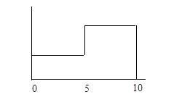
a / m s⁻²
4
2
t / s
Draw a velocity time graph for the first 10 s of the motion.

The velocity time graph for an object is shown below.
Draw the corresponding acceleration-time graph. (Put numerical values on time axis).

The graph shows the velocity of a ball which is dropped and bounces from a floor. A downwards direction is taken as being positive.

  - During section OB of the graph
    - in which direction is the ball travelling?
    - what can you say about the speed of the ball?
  - uring section CD of the graph
    - in which direction is the ball travelling?
    - what can you say about the speed of the ball?
  - During section DE of the graph
    - in which direction is the ball travelling?
    - State what can you say about the speed of the ball.
  - State what happened to the ball at point B on the graph.
  - What happened to the ball at point C on the graph?
  - What happened to the ball at point D on the graph?
State how the speed of the ball immediately after rebound compare with the speed immediately before.
A ball is dropped from a height and bounces up and down on a horizontal surface. Assuming that there is no loss of kinetic energy at each bounce, select the velocity-time graph which represents the motion of the ball from the moment it is released
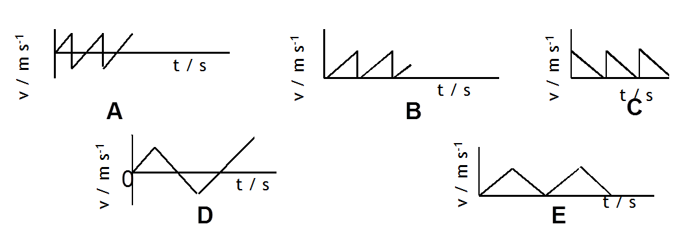
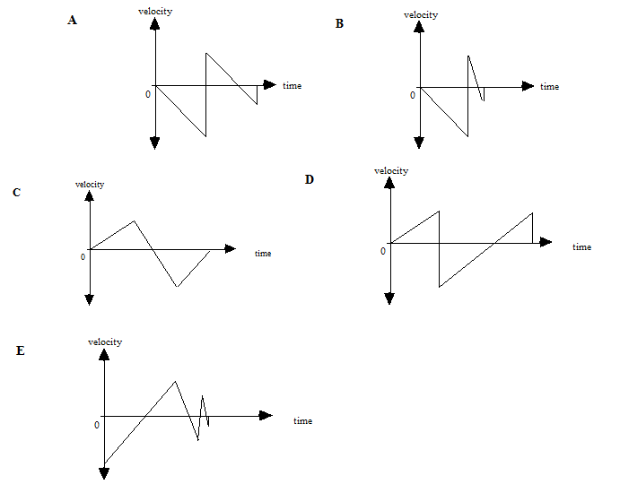
A ball is dropped from rest and bounces several times, losing some kinetic energy at each bounce. Copy out the correct velocity - time graph for this motion labelling it with the description.
0
0
0

A ball is dropped from rest and bounces several times, losing some kinetic energy at each bounce. Copy out the correct velocity - time graph for this motion.
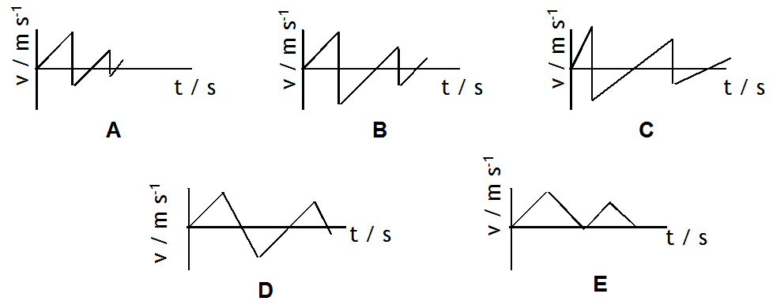
3c) | I know the interrelationship of displacement-time, velocity-time and acceleration- time graphs.
Copy and complete the table below.
Type of graph | Y axis | X axis | Gradient | Area under graph
s-t |  |  |  | -----
v-t | Velocity | time
a-t |  |  | ----- | Change in velocity (v-u)

The figure below represents the velocity of a particle moving in a straight line.

Draw the corresponding acceleration time graph for the velocity time graph shown above.
The graph shows how the acceleration, a, of an object varies with time, t.

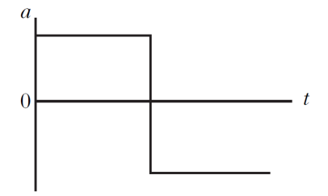
Which graph shows how the velocity, v, of the object varies with time, t?

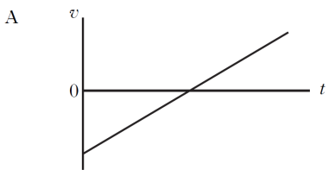
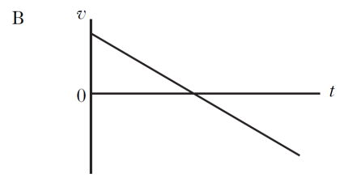
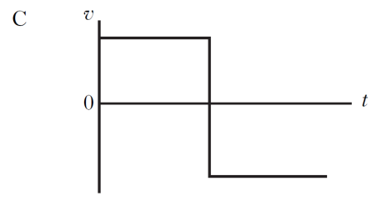
3d) | I can calculate distance, displacement, speed, velocity, and acceleration from appropriate graphs (graphs restricted to constant acceleration in one dimension, inclusive of change of direction).
The graph shows how the downward speed of a lift varies with time.
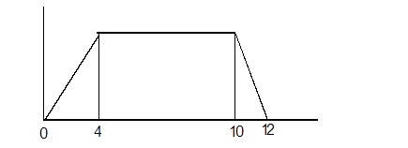
V /ms⁻¹
t(s)
      - Draw the corresponding acceleration/time graph.
      - A 4 kg mass is suspended from a spring balance inside the lift. Determine the reading on the balance at each stage of the motion.

Here is a typical velocity-time graph
(a) Determine the average velocity.
(b) State the time this occurs.
(c) Calculate the displacement from the start up to the time recorded in part (b).
(d) Determine the total displacement.
(e) Sketch an acceleration-time graph that corresponds to the velocity-time graph above.

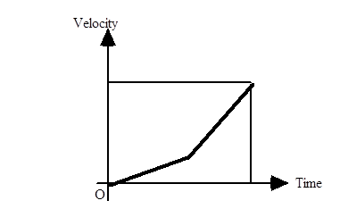
(a) Describe the motion of the object whose velocity-time graph is shown here.
(b) Sketch the corresponding acceleration-time graph.

Explain what the figures below tell us about the acceleration of the object that produced them.

Time / s | 0 | 10 | 20 | 30 | 40
Velocity / m s-1 | 0 | 25 | 55 | 90 | 130

If the object described in the graph travels in a straight line;
(a) State the time at which the speed is zero on this graph.
(b) State the time at which the acceleration is zero on this graph.

 | Sketch a velocity -time graph that corresponds to the acceleration-time graph shown here:
Here is a set of results taken from a strobe photograph whose frequency is 10 Hz, i.e. a photograph is taken every 0.1s.
Displacement between exposures /m | 0 | 0.2 | 0.6 | 1.0 | 1.4 | 1.8
Time from start /s | 0 | 0.1 | 0.2 | 0.3 | 0.4 | 0.5
        - Calculate the displacement measurements when measured from the start.
        - State whether these results show constant acceleration or constant velocity. You must justify your answer.
An object is dropped out of a balloon and the graph below made from observations of its motion. Suggest what is plotted on the Y-axis and give your reasons.
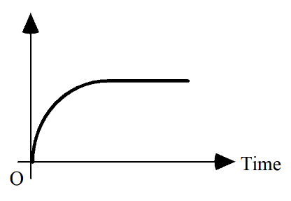
Exam Question
The velocity of a trolley on a slope is investigated using a motion sensor linked to a computer that prints out the velocity-time graph of the trolley's motion.
One such graph for a trolley, which is given an initial push up the slope, is shown here: -
- If the position marked P corresponds to the instant the experimenter lets the trolley go, determine the time the trolley at its maximum displacement from P.
- Draw the acceleration-time graph of this motion including the initial push.

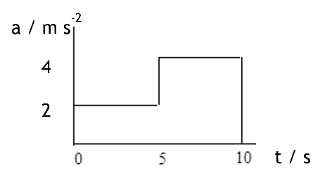
The graph below shows how the acceleration of an object varies with time.
The object started from rest.

Draw a velocity time graph for the first 10 s of the motion.

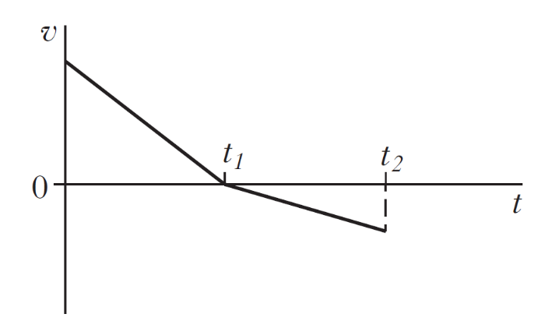
A ball rolls along a long straight track as shown in the diagram. The graph shows how the velocity, v of the trolley varies with time
- Describe the motion of the vehicle.
- Explain why the graph goes below the zero line
- Draw the corresponding acceleration time graph.

The following velocity-time graph represents the vertical motion of a ball.

Copy the acceleration-time graph that represents the same motion.

3e) | I can give a description of an experiment to measure the acceleration of an object down a slope
Use the information given below to calculate the acceleration of the trolley.

Length of card = 5 cm
Time on clock 1 = 0.10 s (time taken for card to interrupt top light gate)
Time on clock 2 = 0.05 s (time taken for card to interrupt bottom light gate)
Time on clock 3 = 2.50 s (time taken for trolley to travel between top and bottom light gate)
Describe two methods for measuring the acceleration of a vehicle along a straight level track. For each method state

- the measurements that must be taken,
- the equipment required
- the method to calculate the acceleration.
State how you would reduce the uncertainties in your measurements.
 | State whether you could measure the acceleration of a vehicle down a slope with a single mask and a single light gate. You must justify your answer.
- v | The acceleration of a trolley running down a slope can be measured in two ways.  1 – single mask and two light gates connected to a computer set to calculate acceleration  2– double mask and single light gate connected to a computer set to calculate acceleration  mask  light gate  mask  light gate  The light gates and masks are used to calculate two different velocities of the trolley. These velocities are then used to calculate the acceleration of the trolley. Using your knowledge of physics, comment on the reliability of the two methods used to calculate the acceleration of the trolley down the slope.
4. | Forces, energy and power
Eq | W = mg F = ma E_{W} or W = Fd Ep = mgh Ek = ½ mv² E = Pt
4a) | I can use vector addition and appropriate relationships to solve problems involving balanced and unbalanced forces, mass, acceleration and gravitational field strength.
 | Determine the minimum force required to lift a helicopter of mass 2000 kg upwards with an initial acceleration of 4 m s⁻². Air resistance is 1000 N.
A crate of mass 200.0 kg is placed on a balance in a lift.
- Determine the reading on the balance, in newtons, when the lift was stationary.
- The lift now accelerates upwards at 1.50 m s⁻². Determine the new reading on the balance.
- The lift then travels up at a constant speed of 5.00 m s⁻¹. Determine the reading on the balance.
- For the last stage of the journey calculate the reading on the balance when the lift decelerates at 1.50 m s⁻² while moving up
A small lift in a hotel is fully loaded and has a mass of 250.0 kg. For safety reasons the tension in the pulling cable must never be greater than 3500.0 N.
- Determine the tension in the cable when the lift is:
    - at rest
    - moving up at a constant 1.00 m s⁻¹
    - accelerating upwards at 2.00 m s⁻²
    - accelerating downwards at 2.00 m s⁻²?
- Calculate the maximum permitted upward acceleration of the fully loaded lift.
Describe a situation where the lift could have an upward acceleration greater than the value in (b) without breaching safety regulations.
 | A 150 g bird drops straight from a tree towards the garden with a steady frictional force of 0.970 N acting on it. Determine the acceleration of the bird.
 | A snowball is given an acceleration of 1000 ms ^{–2} by the thrower’s arm which exerts a 100 N force. If the jersey of her coat causes a constant retarding force of 20 N when it is being moved, Determine the mass of the snowball
A roller skate starts to roll down a hill and takes 5.00 s to reach a velocity of
7.50 ms^{–1}. If the roller skate has a weight of 7.84 N, Determine the force causing the acceleration.
 | A falling feather of mass 0.010 g feels a frictional force of 95.5 μN as it falls. Determine the acceleration during this time.
 | Two forces of 6.0 N and 8.0 N are at right angles to each other and both act on a 2.50 kg mass at the same time. Calculate the acceleration they cause.
 | A boy on a skateboard rides up a slope. The total mass of the boy and the skateboard is 90.0 kg. He decelerates uniformly from 12.0 m s⁻¹ to 2.0 m s⁻¹ in 6.0 seconds. Calculate the resultant force acting on him.
A box is pulled along a rough surface with a constant force of 140 N. If the mass of the box is 30.0 kg and it accelerates at 4.0 m s⁻² calculate:
- the unbalanced force causing the acceleration.
the force of friction between the box and the surface.
(a) A rocket of mass 40000 kg is launched vertically upwards. Its engines produce a constant thrust of 700000 N.
(i) Draw a diagram showing all the forces acting on the rocket.
(ii) Calculate the initial acceleration of the rocket.
(b) As the rocket rises its acceleration is found to increase. Give three reasons for this.
(c) Calculate the acceleration of the same rocket from the surface of the Moon if the Moon’s gravitational field strength is 1.6 N kg-1.
(d) Explain in terms of Newton’s laws of motion why a rocket can travel from the Earth to the Moon and for most of the journey not burn up any fuel.
A rocket takes off and accelerates to 90 m s⁻¹ in 4 s. The resultant force acting on it is 40 kN upwards.
              - Calculate the mass of the rocket.
              - Calculate the force produced by the rocket’s engines if the average force of friction is 5000 N.
A force of 60 N pushes three blocks as shown. If each block has a mass of 8 kg and the force of friction on each block is 4 N
Calculate:

    - the acceleration of the blocks
    - the force block A exerts on block B
    - the force block B exerts on block C.
  - The pushing force is then reduced until the blocks move at constant speed. Calculate the value of this pushing force.
  - State whether the force block A exerts on block B now equals the force block B exerts on block C. You must justify your answer.
30°
231N
200N

Determine the acceleration of a 1.5kg ball kicked by two players simultaneously as shown on this free-body diagram.
Determine the acceleration of a 100kg astronaut acted on by the forces shown in this free-body diagram.
32N
39N
35N
26°
90°

If the block shown in the diagram accelerates down the plane at 2.5ms ^{–2},
Determine the frictional force acting up the plane.
F
686N
30º

- i | If the block starts from rest and reaches a velocity of 6ms ^{–1} in 2s, Determine the frictional force acting up the plane.  F  735N  30º
- i | Two masses are pulled along a flat surface as shown below.  Find the  - acceleration of the masses  - , T between the masses.
A car of mass 1200 kg tows a caravan of mass 1000 kg. The frictional force on the car and caravan is 200 N and 500 N respectively. The car accelerates at 2.0 ms⁻².
- Calculate the force exerted by the engine of the car.
- Calculate the force the tow bar exerts on the caravan.
- e car then travels at a constant speed of 10 m s⁻¹. Assuming the frictional forces to be unchanged calculate the new engine force and the force exerted by the tow bar on the caravan.
The car brakes and decelerates at 5 m s⁻². Calculate the force exerted by the brakes (assume the other frictional forces remain constant).
 | A package of mass 4.0 kg is hung from a spring balance attached to the ceiling of a lift which is accelerating upwards at 3.0 m s⁻². Determine the reading on the spring balance?
 | A tractor of mass 1200 kg pulls a log of mass 400.0 kg. The tension in the tow rope is 2000 N and the frictional force on the log is 800.0 N. How far will the log move in 4.00 s assuming it was stationary to begin with?
 | A force of 800 N is applied to a narrowboat by means of a rope angled at 40° to the direction of the canal. If the mass of the barge is 1000 kg and the force of friction between the barge and the water is 100 N find the acceleration of the barge.
- i | A 500 g trolley runs down a runway which is 2 m long and raised 30 cm at one end. If its speed remains constant throughout calculate the force of friction acting up the slope.
The brakes on a car fail while it is parked at the top of a hill. It runs down the hill for a distance of 50m until it crashes into a hedge. The mass of the car is 900 kg and the hill makes an angle of 15° to the horizontal. If the average force of friction is 300 N. Calculate:
- the component of weight acting down the slope
- the acceleration of the car
- the speed of the car as it hits the hedge
the force acting perpendicular to the car (the reaction) when it is on the hill.
SQA Higher 2010
A helicopter is flying at a constant height above the ground. The helicopter is carrying a crate suspended from a cable as shown.
(a) The helicopter flies 20 km on a bearing of 180 (due South). It then turns on to a bearing of 140 (50 º South of East) and travels a further 30 km.
The helicopter takes 15 minutes to travel the 50 km.
(i) By scale drawing (or otherwise) find the resultant displacement of the helicopter.
(ii) Calculate the average velocity of the helicopter during the 15 minutes.
(b) The helicopter reaches its destination and hovers above a drop zone.
(i) The total mass of the helicopter and crate is 1·21 × 10⁴ kg.
Show that the helicopter produces a lift force of 119 kN.
(ii) The helicopter now drops the crate which has a mass of 2·30 × 10³ kg.
The lift force remains constant. Describe the vertical motion of the helicopter immediately after the crate is dropped. Justify your answer in terms of the forces acting on the helicopter.
- i | Two blocks are linked by a newton balance of negligible mass.  The blocks are placed on a level, frictionless surface. A force of 18·0 N is applied to the blocks as shown. Calculate the reading on the newton balance.
4b) | I know the effects of friction on a moving object (static and dynamic friction are not required)
 | A 2 kg block of wood is placed on the slope shown. It remains stationary. Determine the size of the frictional force acting up the slope.
 | A 500 g trolley runs down a runway which is 2.00 m long and raised 300.0 mm at one end. If its speed remains constant throughout calculate the force of friction acting up the slope.
The brakes on a car fail while it is parked at the top of a hill. It runs down the hill for a distance of 50.0 m until it crashes into a hedge. The mass of the car is 900.0 kg and the hill makes an angle of 15° to the horizontal. If the average force of friction is 300.0 N. Calculate:
  - the component of weight acting down the slope
  - the acceleration of the car
  - the speed of the car as it hits the hedge
the force acting perpendicular to the car (the reaction) when it is on the hill.
A crate of mass 100 kg is pulled along a rough surface by two ropes at the angles shown.
- If the crate is moving at a constant speed of 1 m s⁻¹. Determine the force of friction.
- If the forces were increased to 140 N at the same angle calculate the acceleration of the crate.
 | A block of wood slides with a constant velocity down a slope. The slope makes an angle of 30·0° with the horizontal as shown. The mass of the block is 2·0 kg. Calculate the magnitude of the force of friction acting on the block
4c) | I can identify and explain the effects of friction on moving objects. I do not need to use reference to static and dynamic friction.
 | State the effect of friction on moving objects.
 | State any energy conversions that occur when a ball moves through the air.
A golfer hits a ball from point P. The ball leaves the club with a velocity v at an angle of q to the horizontal. The ball travels through the air and lands at point R. Midway between P and R there is a tree of height 10·0 m.

The horizontal and vertical components of the ball’s velocity during its flight are shown. The effects of air resistance can be ignored
        - . Calculate:
          - the horizontal distance d;
          - the maximum height of the ball above the ground.
(b) When the effects of air resistance are not ignored, the golf ball follows a different path. Is the ball more or less likely to hit the tree? You must justify your answer.
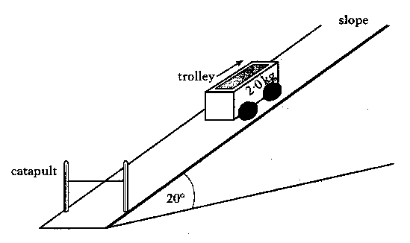
A trolley of mass 2.0 kg is catapulted up a slope. The slope is at an angle of 20º to the horizontal as shown in the diagram below. The speed of the trolley when it loses contact with the catapult is 3.0 m s⁻¹.
The size of the force of friction acting on the trolley as it moves up the slope is 1.3 N.
The magnitude of the acceleration of the trolley is -4.0 m s⁻² as it moves up the slope. Explain why the magnitude of the acceleration is not 4.0 m s⁻² when the trolley moves down the slope. 1
From my notes
A car of mass 1800 kg is towing a caravan of mass 600 kg there are frictional forces of 400 N on the car and frictional forces on the caravan of 400 N. State the tension in the towbar between the car and caravan when the vehicles travel at a constant speed of 3 m s⁻¹.
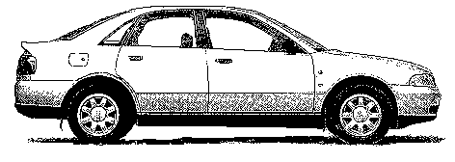
v =3 m s⁻¹

m = 1800 kg
m = 600 kg
Friction force
Engine force

A car of mass 1800 kg is towing a caravan of mass 600 kg they accelerate at 3 m s⁻². There are frictional forces of 400 N on the car and frictional forces on the caravan of 400 N. State the tension in the towbar between the car and caravan.

a =3 m s⁻²
m = 1800 kg
m = 600 kg
Friction force
Engine force

4d) | I can identify and explain, in terms of forces an object moving with terminal velocity
- I | Explain the meaning of the term balanced forces.
- Ii | State the effect of balanced forces on an moving object.
- Iii | Copy and complete the passage using the correct ending.  A person stands on a weighing machine in a lift. When the lift is at rest, the reading on the machine is 700N. The lift now descends and its speed increases at a constant rate. The reading on the machine  …. is a constant value higher than 700N  …. is a constant value lower than 700N  …. continually increases from 700N  …. continually decreases from 700N  …. remains constant at 700N.
- Iv | Explain why a sky diver does not continue to accelerate throughout the whole fall, even before the parachute is open.
- v | Explain why a sky diver can have balanced forces on them of the same magnitude when the parachute has been opened and just before it is opened.
4e) | I can interpret and produce velocity-time graphs for a falling object when air resistance is taken into account.
 | A ball is thrown vertically upwards and falls back to Earth. Neglecting air resistance, which velocity-time graph represents its motion?
Label the parts of the velocity time graph showing the velocity of a falling sky diver from the time they jump from the plane until they land

V/m s⁻¹
t (s)
0

4f) | I can analyse motion using Newton’s first and second laws.
. | A fully loaded oil tanker has a mass of 2.0 × 10³ kg.  As the speed of the tanker increases from zero to a steady maximum speed of 8.0 m s⁻¹ the force from the propellers remains constant at 3.0 × 10⁶ N
(a)  (b) | Calculate the acceleration of the tanker just as it starts from rest  Determine the size of the force of friction acting on the tanker when it is travelling at the steady speed of 8.0 m s⁻¹?
(c) | When its engines are stopped, the tanker takes 50 minutes to come to rest from a speed of 8.0 m s⁻¹. Calculate its average deceleration.

 | A 150 g bird drops straight from a tree towards the garden with a steady frictional force of 0.97 N acting on it. Determine the acceleration of the bird.
 | A snowball is given an acceleration of 1000 m s ^{–2} by the thrower’s arm which exerts a 100 N force. If the jersey of her coat causes a constant retarding force of 20 N when it is being moved, Determine the mass of the snowball.
 | A roller skate starts to roll down a hill and takes 5 s to reach a velocity of 7.5 m s ^{–1}. If the roller skate has a weight of 7.84 N, Determine the force causing the acceleration?
 | A falling feather of mass 0.01 g feels a frictional force of 95.5 μN as it falls. Determine the acceleration during this time?
 | State Newton’s 1st Law of Motion.
 | State Newton’s 2nd Law of Motion.
 | A lift of mass 500 kg travels upwards at a constant speed. Calculate the tension in the lifting table.
A fully loaded oil tanker has a mass of 2.0 × 10³ kg.
As the speed of the tanker increases from zero to a steady maximum speed of 8.0 m s⁻¹ the force from the propellers remains constant at 3.0 × 10⁶ N
a) Calculate the acceleration of the tanker just as it starts from rest.
b) Determine the size of the force of friction acting on the tanker when it is travelling at the steady speed of 8.0 m s⁻¹.
c) When its engines are stopped, the tanker takes 50 minutes to come to rest from a speed of 8.0 m s⁻¹. Calculate its average deceleration.
 | A boy on a skateboard rides up a slope. The total mass of the boy and the skateboard is 90 kg. He decelerates uniformly from 12 m s⁻¹ to 2 m s⁻¹ in 6 seconds. Calculate the resultant force acting on him.
A box is pulled along a rough surface with a constant force of 140 N. If the mass of the box is 30 kg and it accelerates at 4 m s⁻² calculate:
- the unbalanced force causing the acceleration.
- the force of friction between the box and the surf.
(a) A rocket of mass 40 000 kg is launched vertically upwards. Its engines produce a constant thrust of 700 000 N.
(i) Draw a diagram showing all the forces acting on the rocket.
(ii) Calculate the initial acceleration of the rocket.
(b) As the rocket rises its acceleration is found to increase. Give three reasons for this.
(c) Calculate the acceleration of the same rocket from the surface of the Moon if the Moon’s gravitational field strength is 1.6 N kg-1.
(d) Explain in terms of Newton’s laws of motion why a rocket can travel from the Earth to the Moon and for most of the journey not burn up any fuel.
4g) | I can use free body diagrams and appropriate relationships to solve problems involving friction and tension.
Two masses are pulled along a flat surface as shown below.

Find the
  - acceleration of the masses
  - tension, T between the masses.

 | A crate of mass 100 kg is pulled along a rough surface by two ropes at the angles shown. If the crate is moving at a constant speed of 1 m s⁻¹ Determine the force of friction.
A car of mass 1200 kg tows a caravan of mass 1000 kg. The frictional force on the car and caravan is 200 N and 500 N respectively. The car accelerates at 2 ms⁻².
  - Calculate the force exerted by the engine of the car.
  - Calculate the force the tow bar exerts on the caravan.
  - The car then travels at a constant speed of 10 m s⁻¹. Assuming the frictional forces to be unchanged calculate the new engine force and the force exerted by the tow bar on the caravan.

A force of 60 N pushes three blocks as shown. If each block has a mass of 8 kg and the force of friction on each block is 4 N
      - Calculate:
- the acceleration of the blocks
- the force block A exerts on block B
- the force block B exerts on block C.
- The pushing force is then reduced until the blocks move at constant speed. i. Calculate the value of this pushing force.
ii. State whether the force block A exerts on block B now equals the

A 2 kg trolley is connected by string to a 1 kg mass as shown. The bench and pulley are frictionless.
- Calculate the acceleration of the trolley.
- Calculate the tension in the string.

4h) | I can resolve a vector into two perpendicular components.
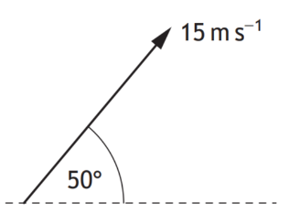
A stone is thrown at 50° to the horizontal with a speed of 15 m s -1 .
Calculate the in the horizontal component and the vertical component of the initial velocity of the stone

A force of 25 N acts on a shopping trolley handle as shown: -
 | Horizontal component | Vertical component
A | 25 sin50° | 25 sin40°
B | 25 cos50° | 25 sin40°
C | 25 sin50° | 25 cos50°
D | 25 cos40° | 25 sin40°
E | 25 cos50° | 25 sin50°
Which entry in the table below correctly shows the horizontal and vertical components of the force?
vertical
horizontal
25 N
40°
50°

The fairway on a golf course is in two horizontal parts separated by a steep bank as shown below.
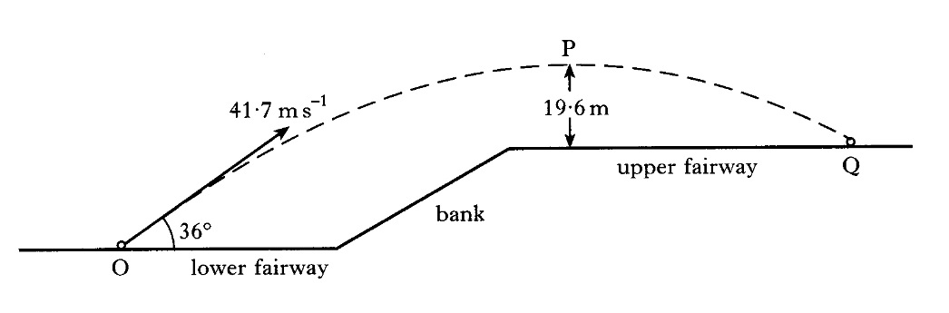
A golf ball at point O is given an initial velocity of 41·7 m s⁻¹ at 36° to the horizontal.
The ball reaches a maximum vertical height at point P above the upper fairway. Point P is 19·6 m above the upper fairway as shown. The ball hits the ground at point Q.
The effect of air resistance on the ball may be neglected.
(a) Calculate:
(i) the horizontal component of the initial velocity of the ball;
(ii) the vertical component of the initial velocity of the ball.

    - Determine the vertical' component of this tension.
    - Determine the weight of the spider.

 | An object is located at a distance of 20.616 from the origin at an angle of 14.036o to the X-axis. Determine the x and y component.
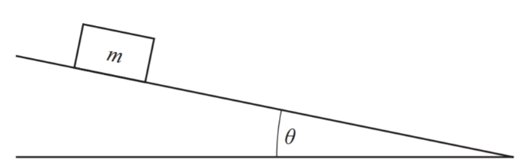
A box of mass m rests on a slope as shown.
Which row in the table shows the component of the weight acting down the slope and the component of the weight acting normal to the slope?
 | Component of weight acting down the slope | Component of weight acting normal to the slope
A | mg sinθ | mg cosθ
B | mg tanθ | mg sinθ
C | mg cosθ | mg sinθ
D | mg cosθ | mg tanθ
E | mg sinθ | mg tanθ

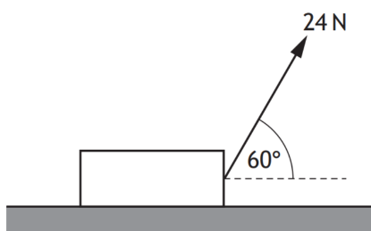
A block is resting on a horizontal surface. A force of 24N is now applied as shown and the block slides along the surface.
Calculate the component of the force responsible for pulling the block along the surface.
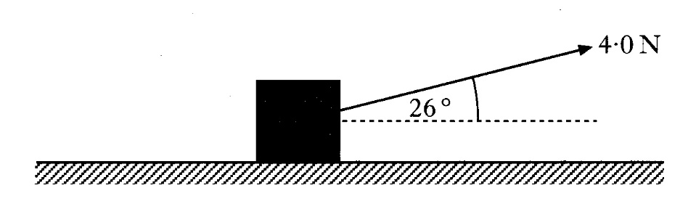
a) A box of mass 18 kg is at rest on a horizontal frictionless surface. A force of 4·0 N is applied to the box at an angle of 26° to the horizontal.

(i) Show that the horizontal component of the force is 3·6 N. 1
(ii) Calculate the acceleration of the box along the horizontal surface. 2
(iii) Calculate the horizontal distance travelled by the box in a time of 7·0 s. 2

(b) The box is replaced at rest at its starting position.
The force of 4·0 N is now applied to the box at an angle of less than 26° to the horizontal.

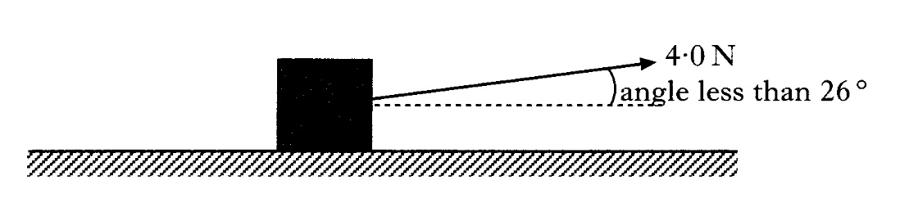
The force is applied for a time of 7·0 s as before.
How does the distance travelled by the box compare with your answer to part (a)(iii)? You must justify your answer. 2

4i) | I can resolve the weight of an object on a slope into a component acting parallel (down the slope) and a component acting normal to the slope.
- ???? | a) Determine the mass of the block shown.  b) Determine the resultant force on the block.  c) Determine the acceleration of the block shown.  d) If the block shown in the diagram accelerates down the plane at 2.5ms ^{–2}, determine the frictional force acting up the plane of the slope.  121N  200N  54º
 | 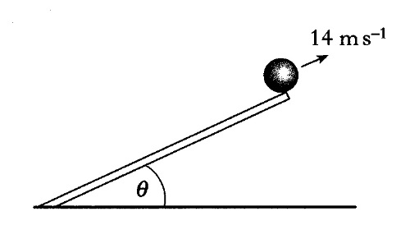 | The slope is set so that the angle to the horizontal,θ is 30°.  - Calculate the vertical component of the velocity of the ball as it leaves the slope.  - The slope is now tilted so that the angle to the horizontal, θ, is increased. The ball is rolled so that it still leaves the end of the slope at 14 m s⁻¹. Describe and explain what happens to the maximum height reached by the ball.
An archer fires an arrow at a target which is 30 m away.
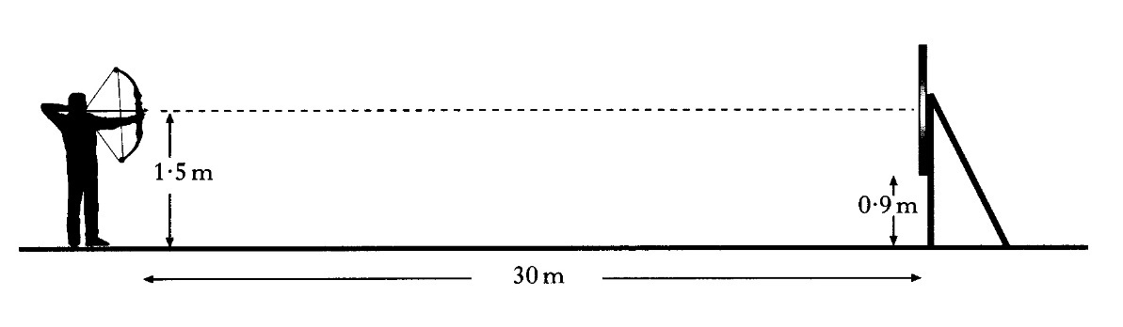
The arrow is fired horizontally from a height of 1·5 m and leaves the bow with a velocity of 100 m s⁻¹.
The bottom of the target is 0·90 m above the ground.
Show by calculation that the arrow hits the target.

The fairway on a golf course is in two horizontal parts separated by a steep bank as shown below.
A golf ball at point O is given an initial velocity of 41·7 m s⁻¹ at 36° to the horizontal.
The ball reaches a maximum vertical height at point P above the upper fairway. Point P is 19·6 m above the upper fairway as shown. The ball hits the ground at point Q.
The effect of air resistance on the ball may be neglected.
(a) Calculate:
(i) the horizontal component of the initial velocity of the ball;
(ii) the vertical component of the initial velocity of the ball.
(b) Show that the time taken for the ball to travel from point O to point Q is 4·5 s.
(c) Calculate the horizontal distance travelled by the ball.
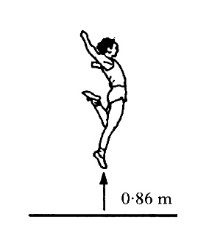
(a) A long jumper devises a method for estimating the horizontal component of his velocity during a jump.
His method involves first finding out how high he can jump vertically.
He finds that the maximum height he can jump is 0·86 m.
          - Show that his initial vertical velocity is 4·1 m s⁻¹.

          - He now assumes that when he is long jumping, the initial vertical component of his velocity at take-off is 4·1 m s⁻¹.
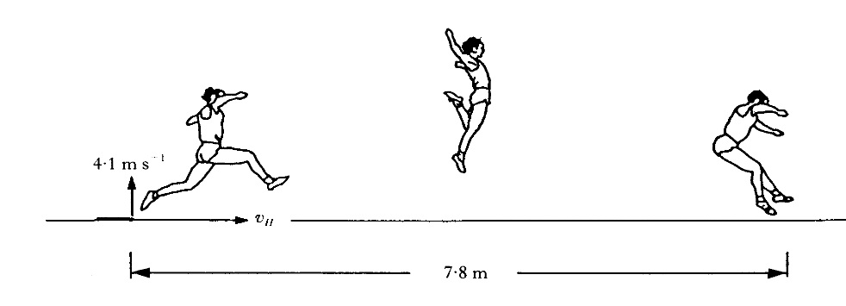
The length of his long jump is 7·8 m.
Calculate the value that he should obtain for the horizontal component of his velocity, v_{H}.
  - His coach tells him that, during his 7·8 m jump, his maximum height above the ground was less than 0·86 m. Ignoring air resistance, state whether his actual horizontal component of velocity was greater or less than the value calculated in part (a) (ii). You must justify your answer.

4j) | I can use the principle of conservation of energy and appropriate relationships to solve problems involving work done, potential energy, kinetic energy and power.
- I | Water flows at a rate of 6.25 × 10⁸ kg per minute over a waterfall. The height of the waterfall is 108 m. Calculate the power delivered by the water falling through 108 m.
- Ii | A man mows a lawn in 10 minutes by exerting an average force of 100 N over a distance of 100 m. Calculate his average power.
- Iii | In a low orbit the space shuttle has a mass of 75000 kg and a payload mass of 25000 kg. It travels at a speed of 8 kms ^{– 1}.  - Find the shuttles kinetic energy in orbit.  - Calculate the work done bringing the shuttle to rest on the ground.  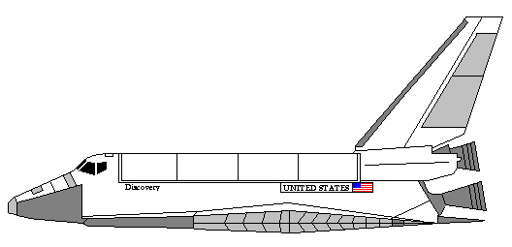  If the shuttle takes 53 minutes and twenty seconds to come to rest after the re-entry engines are fired  - Find the total distance travelled,  - Find the frictional force of the air.  - Determine the average power dissipated during the journey.
- Iv | A large packing case of mass 500 kg rests on the ground. A fork-lift truck raises it 1.5 m, transports it at a steady speed of 2.0 ms ^{–1} and deposits it on a loading platform of a lorry.  - Determine the minimum upward force exerted by the fork-lift truck.  - Calculate the potential energy gained by the packing case.  - Calculate the kinetic energy of the packing case while it is being transported at steady speed.  - State what happens to the kinetic energy when the fork-lift truck stops.  - If the fork-lift truck uses energy at the rate of 25 kW and the lifting operation takes 3.0 seconds, calculate the apparent efficiency of the operation.
5. | Collisions and explosions
Eq | p = mv Ft = mv − mu ${E_{k}=\frac{1}{2}mv}^{2}$
5a) | I can use the principle of conservation of momentum and an appropriate relationship to solve problems involving the momentum, mass and velocity of objects interacting in one dimension.
In an inelastic collision,
….. some momentum is changed into kinetic energy.
….. some momentum is destroyed.
….. some momentum is changed into heat.
….. some kinetic energy is changed into heat.
….. some kinetic energy is changed into momentum.
 | A cannon of mass 2000 kg fires a cannonball of mass 5.00 kg. The cannonball leaves the cannon with a speed of 50.0 ms⁻¹. Calculate the speed of the cannon immediately after firing
Two students Angus and Ryan are investigating collisions between ‘curling stones’ at an ice rink. Ryan releases his stone, of mass 15 kg, so that it collides head on with Angus’s stone, of mass 12 kg, which is travelling in the opposite direction. The speeds of the stones before and after collision are given in the table below.
 | speed before  collision/ms⁻¹ | speed after  collision/ms⁻¹
Angus’ stone | 0.6 | v
Ryan’s stone | 0.8 | 0
(a) Calculate the speed, v, of Angus’s stone after the collision.
(b) Show by calculation whether the collision is elastic or inelastic.
(c) (i) During the collision the stones are in contact for 0.05 s. Calculate the average force exerted by Ryan’s stone on Angus’s stone during the collision.
(ii) Determine the average force exerted by Angus’s stone on Ryan’s stone during the collision?

5b) | I can explain the role in kinetic energy in determining whether a collision is described as elastic and inelastic collisions or in explosions.
 | Explain the term inelastic collision
 | Explain that term elastic collision
 | State how to determine whether a collision is elastic or inelastic
 | s
5c) | I can use appropriate relationships to solve problems involving the total kinetic energy of systems of interacting objects.
 | A 200 kg bobsleigh hits the incline of the slow-down area at a speed of 20.0 m s-¹. If the sledge stops after rising a vertical height of 15.0 m, determine the energy turned to heat by the friction between the runners and the snow.
 | A 20.0 g pellet strikes a 380.0 g block horizontally at 50.0 ms⁻¹. The pellet sticks in the block which now slides across the table top before coming to rest after travelling 0.125 m. Determine the force of friction between the block and the table's surface.
The
diagram shows the masses and velocities of two trolleys just before they collide on a
level bench.
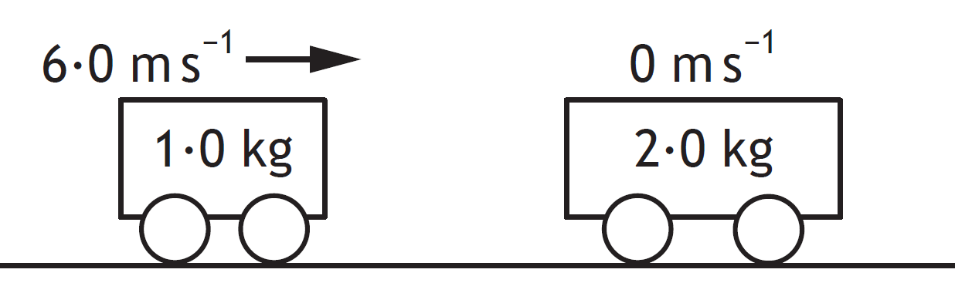1
After the collision, the trolleys move along the bench joined together.
Calculate the kinetic energy lost in this collision is.
5d) | I can use Newton’s third law to explain the motion of objects involved in interactions.
5e) | I can draw and interpret force-time graphs involving interacting objects.
 | State the quantity represented by the area under a force time graph.
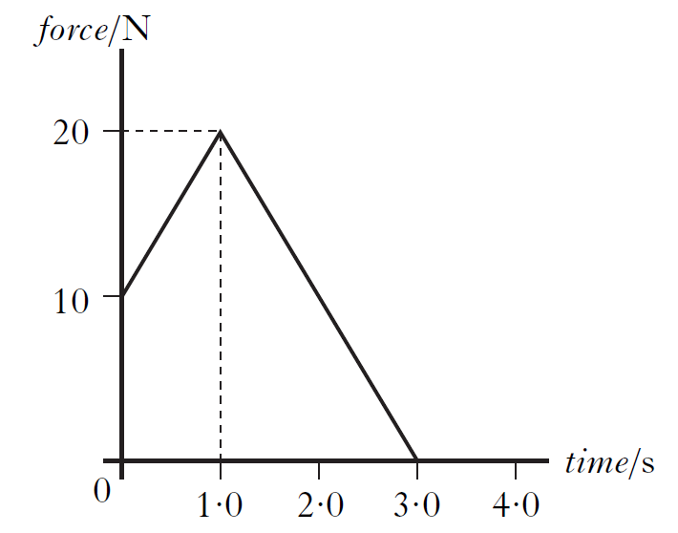
The graph shows the force acting on an object of mass 5.0 kg. Calculate the change in the momentum of the
object.
SQA Higher 2010
The apparatus shown is set up to investigate collisions between two vehicles on a track.
The mass of vehicle A is 0·22 kg and the mass of vehicle B is 0·16 kg.
The effects of friction are negligible.

        - During one experiment the vehicles collide and stick together. The computer connected to the motion sensor displays the velocity-time graph for vehicle A.
(ii) Calculate the velocity of vehicle B before the collision.
(b) The same apparatus is used to carry out a second experiment.
In this experiment, vehicle B is stationary before the collision.
Vehicle A has the same velocity before the collision as in the first experiment.
After the collision, the two vehicles stick together.
Is their combined velocity less than, equal to, or greater than that in the first collision?
Justify your answer.
5f) | I know that the impulse of a force is equal to the area under a force-time graph and is equal to the change in momentum of an object involved in the interaction.
Impulse is the product of a force and
…..the mass on which it acts
…..the time for which it acts
…..the distance through which it moves
…..the acceleration it causes
…..the change it momentum it causes.
An object is given a varying force over a 5.0 s period of time this is shown in the graph of force against time.
Determine the impulse delivered to the object from the graph shown.
t /s
F /N
5
12
0

5g) | I can use data from a force-time graph to solve problems involving the impulse of a force, the average force and its duration.
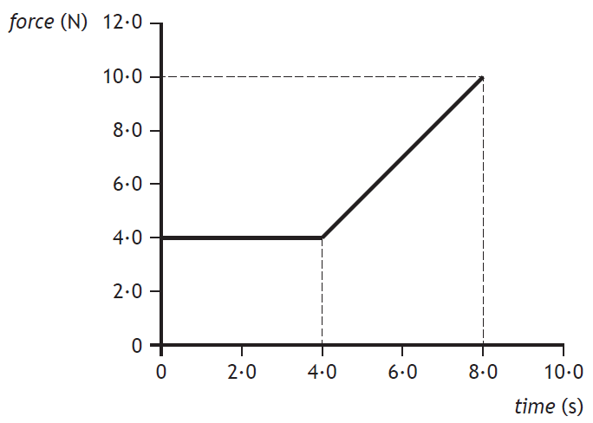
The graph shows the force that acts on an object over a time interval of 8·0 seconds.
Calculate the momentum gained by the object during the 8·0 seconds

F /N
t
5
4
3
2
1
15
3
5
10
0

An object is given a varying force over a 5.0 s period of time this is shown in the graph of force against time.

Determine from the graph
        - The impulse
        - The change in momentum of the object

5h) | I can use appropriate relationships to solve problems involving mass, change in velocity, average force and duration of the force for an object involved in an interaction.
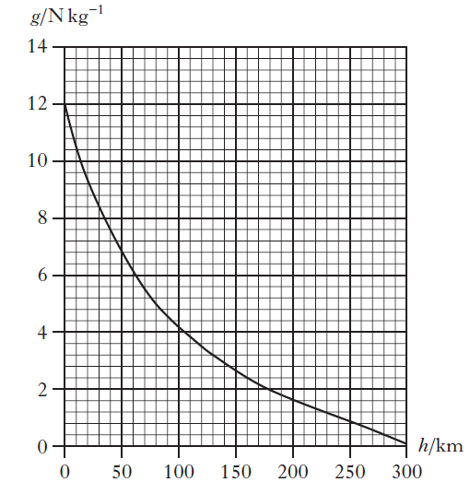
A rock of mass 0·80 kg falls towards the surface of a planet.
The graph shows how the gravitational field strength, g, of the planet varies with height, h, above the surface of the planet. At one point during its fall the weight of the rock is 4·0 N. Determine the height of this point above the surface of the planet is

 | A 0.2kg ball travelling at 15ms⁻¹ is stopped by a hockey stick. Calculate the impulse the stick receive from this action.
An 80kg rugby player moving at 8 ms⁻¹ receives an impulse of 520 kgms⁻¹ from another player he accidentally runs into.
  - Determine the change in momentum involved in this collision.
  - Determine the new momentum of the runner.

A 2.0 kg bowling ball is moving at 3.5 ms⁻¹ before it strikes the skittles, and at 0.5 ms⁻¹ afterwards.
- Determine its momentum change.
If the collisions with the skittles lasted for 1.5 s, Determine the average force acting on the ball during the strike.
 | A 90 kg football player slides into a tackle at 5 ms⁻¹. If the grass slows him with an average force of 180 N, calculate the time taken to stop.
 | Calculate the impulse needed to change the velocity of a 2000 kg car from 5 m s⁻¹ to 8 ms⁻¹.
 | A space probe of mass 5 x 106 kg and velocity 9000 ms⁻¹ receives an impulse of 5 x 109 Ns by operating its thrusters. Determine its resulting momentum change.
6. | A 5.0 kg object changes its velocity from 8 ms⁻¹ to 11 ms⁻¹.  - Determine the momentum change involved  - If the change takes 1.5 s to complete, determine the average force acting on the object.  - Calculate the impulse the force gives to the object.
 | A climber is equipped with a shock-stop tape, which takes a constant force of 492 N to unravel it in the event of a fall. If the climber has a mass of 82 kg and drops a distance of 2.0 m, Determine his speed on reaching the end of the tape.
An 80 kg shuttle jockey rises vertically from the Moon's surface at 5 ms⁻².
  - Draw her free-body diagram.
  - State how you know the resultant force is acting upwards.
  - Determine the size of the resultant upward force on her.
  - If the upward vertical force exerted by the pilot's seat is 528 N, determine the Moon's gravitational field strength in newtons per kilogram.

A 2000 kg satellite has three of its adjusting thrusters operating simultaneously in the same plane. There is a fourth thruster on standby which is set to zero thrust.
- Determine the resultant force acting on the satellite.
- If the acceleration of the satellite is 0.1 ms⁻² at an angle of 65° to the reference direction, explain what can you deduce about the thruster which is shown as providing zero thrust.

 | An electron is accelerated from rest on the cathode of an electron gun to one tenth the speed of light in a distance of 0.15 m. If the mass of an electron is 9.11 x10⁻³¹ kg, Determine the size of the electric force acting on it.
 | At a car research centre a solid fuel rocket system is used to accelerate the cars to their impact with a concrete wall. Each car and its variety of occupants must strike the wall at 15 ms⁻¹ after travelling 22.5 m. To do this, the accelerating rocket is fuelled with bags of propellant, each of which gives 1000 N of thrust when ignited. Calculate the number of bags must be used on an occasion when the car under test has a 'kerb weight' of 1600 kg.
Eq | $d=\overline{v}t, s=\overline{vt} ; s=\frac{1}{2}\left(u+v\right)t;$ $F=\frac{G{m_{1}m}_{2}}{r^{2}}$
6 a) | I can use the equation $F=\frac{G{m_{1}m}_{2}}{r^{2}}$
$$F=\frac{G{m_{1}m}_{2}}{r^{2}}$$
Explain the meaning of each of the terms in the equation above
Two small asteroids are 12 m apart.
The masses of the asteroids are 2·0 × 10³ kg and 0·050 × 10³ kg.
Calculate the gravitational force acting between the asteroids.
Enceladus is a moon of Saturn. The mass of Enceladus is 1·08 × 10²⁰ kg.
The mass of Saturn is 5·68 × 10²⁶ kg.
The gravitational force of attraction between Enceladus and Saturn is 7·24 × 10¹⁹ N.
Calculate the orbital radius of Enceladus around Saturn.
6 b) | I can give a description of an experiment to measure the acceleration of a falling object.
 | State the meaning of the term acceleration
 | State the measurements required to find the acceleration of an object rolling down a slope.
a) Draw a diagram of a different experimental set up to measure the acceleration of a falling object.
b) Explain how the apparatus is used to find the acceleration
c) Explain how to reduce the uncertainties in the measurements
6 c) | I know that the horizontal motion and the vertical motion of a projectile are independent of each other.
 | Describe the horizontal motion of an object fired off a cliff, with an initial horizontal velocity of 30 m s⁻¹.
 | Describe the vertical motion of an object fired off a cliff , with an initial horizontal velocity of 30 m s⁻¹.
 | Describe the horizontal motion of an object fired at an angle of 37 ° to the floor with an initial velocity of 50 m s⁻¹.
 | Describe the vertical motion of an object fired at an angle of 37 ° to the floor, with an initial velocity of 50 m s⁻¹.
6 d) | I know that satellites are in free fall around a planet/star.
6 e) | I can resolve the initial velocity of a projectile into horizontal and vertical components and their use in calculations.
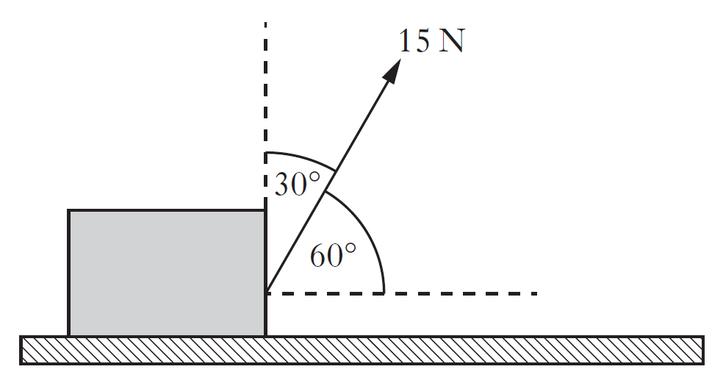
A box is placed on a horizontal surface.
A force of 15 N acts on the box as shown.
Calculate the horizontal and vertical components of the force.

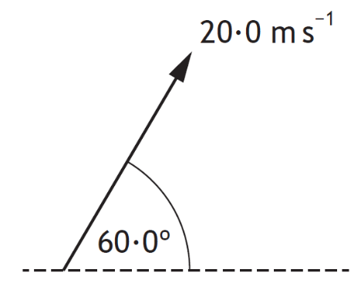
A javelin is thrown at an angle of 60·0° to the horizontal with a speed of 20·0 m s⁻¹.
The javelin is in flight for 3·50 s.
The effects of air resistance can be ignored.
Calculate the horizontal distance travelled by the javelin
6 f) | I can use resolution of vectors, vector addition, and appropriate relationships to solve problems involving projectiles.
OEQ
A stunt is being carried out during the making of a film.
A car is to be driven up a ramp on a moving lorry by a stunt driver, who will attempt to land the car safely on the roof of a second moving lorry. The car is to stop on the roof of the second lorry while this lorry is still moving.
Using your knowledge of physics, comment on the challenges involved in carrying out the stunt successfully.
6 g) | I can use Newton’s Law of Universal Gravitation to solve problems involving force, masses and their separation.
 | State the inverse square law of gravitation.
 | Show that the force of attraction between two large ships, each of mass 5·00 × 10⁷ kg and separated by a distance of 20 m, is 417 N.
 | Calculate the gravitational force between two cars parked 0·50 m apart. The mass of each car is 1000 kg.
 | In a hydrogen atom an electron orbits a proton in a circle with a radius of 5·30 × 10⁻¹¹ m. The mass of an electron is 9·11 × 10⁻³¹ kg and the mass of a proton is 1·67 × 10⁻²⁷ kg. Calculate the gravitational force of attraction between the proton and the electron in a hydrogen atom.
 | The distance between the Earth and the Sun is 1·50 × 10¹¹ m. The mass of the Earth is 5·98 × 10²⁴ kg and the mass of the Sun is 1·99 × 10³⁰ kg. Calculate the gravitational force between the Earth and the Sun.
 | Two protons exert a gravitational force of 1·16 × 10⁻³⁵ N on each other. The mass of a proton is 1·67 × 10⁻²⁷ kg. Calculate the distance separating the protons.
A satellite orbits a planet at a distance of 5·0 × 10⁷ m from the centre of the planet. The mass of the satellite is 2·5 × 10⁴ kg.
The mass of the planet is 4·0 × 10²⁴ kg.
Calculate the gravitational force acting on the satellite due to the planet is
7. | Special relativity
Eq
7 a) | I know that the speed of light in a vacuum is the same for all observers.
 | State the speed of light in a vacuum.
 | State Einstein’s two postulates.
7 b) | I know that measurements of space, time and distance for a moving observer are changed relative to those for a stationary observer, giving rise to time dilation and length contraction.
 | Explain the term time dilation
 | Explain the term length contraction
7 c) | I can use appropriate relationships to solve problems involving time dilation, length contraction and speed.
SQA H 2018
A spacecraft is travelling at 0·10c relative to a star.
Determine the speed of light emitted by the star as measured by an observer on the spacecraft
SQA H 2018
A spacecraft is travelling at a speed of 0·200c relative to the Earth.
The spacecraft emits a signal for 20·0 seconds as measured in the frame of reference of the spacecraft. Calculate the duration of the signal as measured by an observer on Earth.
A spaceship on a launch pad is measured to have a length L.
This spaceship has a speed of 2∙5 ⋅10⁸ ms⁻¹ as it passes a planet.
Which row in the table describes the length of the spaceship as measured by the pilot in the spaceship and an observer on the planet?
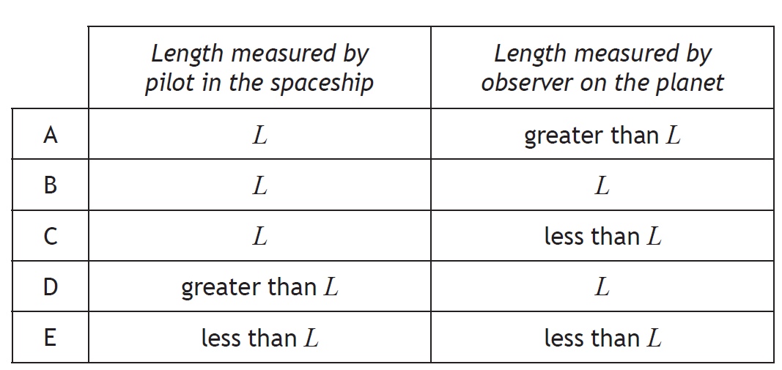
7. A galaxy is moving away from the Earth at a
velocity of 1·20 × 107 m s-1.
Light of wavelength 450 nm is emitted from
this galaxy.
When detected and measured on Earth this
light has a wavelength of
A 425 nm
B 432 nm
C 468 nm
D 475 nm
E 630 nm.

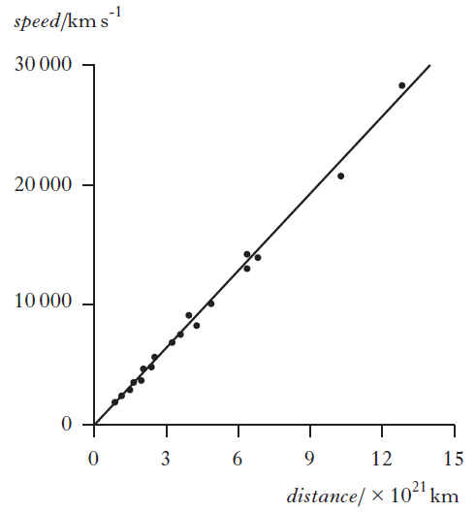
Galaxies at different distances from the Earth have been found to have different speeds.

The graph shows data for some distant galaxies.

A student studies this graph and makes the following statements.
I The speed of distant galaxies varies inversely with their distance from the Earth.
II The gradient of the line gives the value of Hubble’s constant.
III The unit for Hubble’s constant is s-1.

Sketch the graph and copy the correct statement(s)
8. | The expanding Universe
Eq | $v = H_{o}d$
8 a) | I know that the Doppler effect causes shifts in wavelengths of sound and light.
 | State the meaning of the Doppler effect.
8 b) | I can use appropriate relationship to solve problems involving the observed frequency, source frequency, source speed and wave speed.
The siren on an ambulance is emitting sound with a constant frequency of 900 Hz. The ambulance is travelling at a constant speed of 25 m s⁻¹ as it approaches and passes a stationary observer. The speed of sound in air is 340 m s⁻¹.Calculate
          - Calculate the frequency of the sound heard by the observer as the ambulance approaches.
Calculate the frequency of the sound heard by the observer as it moves away from the observer.
A train is travelling at a constant speed of 16·0 m s⁻¹ as it approaches a bridge.
A horn on the train emits sound of frequency 277 Hz.
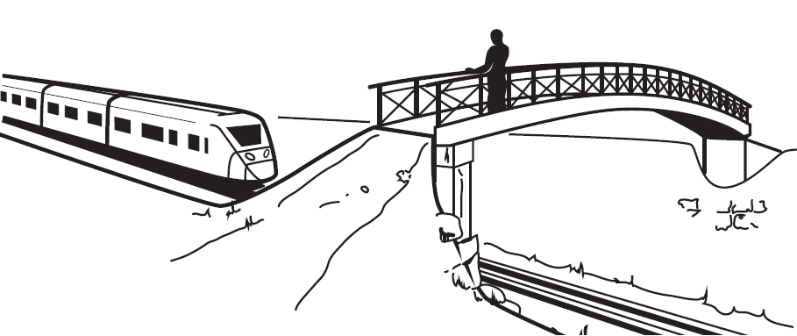
The sound is heard by a person standing on the bridge.
The speed of sound in air is 340 m s⁻¹. Calculate the frequency of the sound heard by the person on the bridge.
8 c) | I know that the light from objects moving away from us is shifted to longer wavelengths (redshift).
 | Explain the term redshift.
8 d) | I know that the redshift of a galaxy is the change in wavelength divided by the emitted wavelength. For slowly moving galaxies, redshift is the ratio of the recessional velocity of the galaxy to the velocity of light.
8 e) | I can use appropriate relationships to solve problems involving redshift, observed wavelength, emitted wavelength, and recessional velocity
An astronomer observes the spectrum of light from a star. The spectrum contains the emission lines for hydrogen. The astronomer compares this spectrum with the spectrum from a hydrogen lamp. The line which has a wavelength of 656 nm from the lamp is found to be shifted to 663 nm in the spectrum from the star.
Calculate the redshift of the light from this star.
SQA 2018
In the laboratory, a line in the hydrogen spectrum is observed at a wavelength of 656 nm. When the spectrum of light from a distant galaxy is viewed, this hydrogen line is now observed at a wavelength of 661 nm.
Determine the recessional velocity of the distant galaxy.
8 f) | I can use appropriate relationship to solve problems involving the Hubble constant, the recessional velocity of a galaxy and its distance from us.
The graph shows how the wavelength of the hydrogen alpha line for one of the stars in a binary pair varies with time, as observed on Earth.
Using information from the graph:
(i) determine the period of orbit of this star;
(ii) calculate the maximum recessional velocity of the star;
(iii) explain how the maximum approach velocity of the star compares to its maximum recessional velocity.
8 g) | I know that Hubble’s law allows us to estimate the age of the Universe.
8 h) | I know that measurements of the velocities of galaxies and their distance from us lead to the theory of the expanding Universe.
A student plots some of the original data from the 1929 paper by Edwin Hubble and adds the line shown in order to determine a value for the Hubble constant H0.
The student calculates the gradient of their line and obtains a value for
the Hubble constant of 2∙0 ⋅ 10−17 s−1.
The age of the universe can be calculated using the relationship

$$age of universe=\frac{1}{H_{0}}$$
(i) Calculate the age of the universe, in years, obtained when using the student’s value for the Hubble constant.
(ii) The current estimate for the age of the universe is 13∙8 ⋅ 10⁹ years.
        - State why the value obtained in (b)(i) is different from the current estimate for the age of the universe.
Suggest a change that the student could make to their graph to obtain a value closer to the current estimate for the age of the universe.
8 i) | I know that the mass of a galaxy can be estimated by the orbital speed of stars within it.
8 j) | I know that evidence supporting the existence of dark matter comes from estimations of the mass of galaxies.
8 k) | I know that evidence supporting the existence of dark energy comes from the accelerating rate of expansion of the Universe.
8 l) | I know that the temperature of stellar objects is related to the distribution of emitted radiation over a wide range of wavelengths.
8 m) | I know that the peak wavelength of this distribution is shorter for hotter objects than for cooler objects.
8 n) | I know that hotter objects emit more radiation per unit surface area per unit time than cooler objects.
8 o) | I know of evidence supporting the big bang theory and subsequent expansion of the Universe
The cooling of the Universe and cosmic microwave background radiation provide
evidence for
- the photoelectric effect
- the Bohr model of the atom
- the theory of special relativity
- the Big Bang theory
Newton’s Universal Law of Gravitation.
Hubble’s Law states that the universe is expanding. The expanding universe is one piece of evidence that supports the Big Bang theory.
State one other piece of evidence that supports the Big Bang theory.
OEQ
According to the lyrics of a popular comedy song:
The universe itself keeps on expanding and expanding in all of the directions it can whizz.
As fast as it can go, at the speed of light, you know, twelve million miles a minute, and that’s the fastest speed there is.

Use your knowledge of physics to comment on these lyrics.

Particles and Waves
No | CONTENT
9. | Forces on charged particles
Eq | $W=QV$ $E_{k}=\frac{1}{2}mv^{2}$
9 a) | I know that charged particles experience a force in an electric field.
i | State the definition of an electrical field
ii | State the causes of an electric field.
iii | Copy and complete the following  In an ________ field a ________ experiences a _________ . This causes the charge to accelerate (F=ma). If the charge is positive it will __________ the field lines, if the charge is negative the charge will move _______ from the field lines.
i | A student makes the following statements about particles in electric fields.  I. A neutron experiences a force in an electric field.  II. When an alpha particle is moved in an electric field work is done.  III. An electric field applied to a conductor causes the free electrons in the conductor to move.  Copy out the correct statement(s)
v | A student writes the following statements about electric fields.  I There is a force on a charge in an electric field.  II When an electric field is applied to a conductor, the free electric charges in the conductor move.  III Work is done when a charge is moved in an electric field.  Copy out the correct statement(s)
vi | The product, X, of a nuclear reaction passes through an electric field as shown.  Product X is  ….an alpha particle  …. a beta particle  …. gamma radiation  …. a fast neutron  …. a slow neutron.
vii | 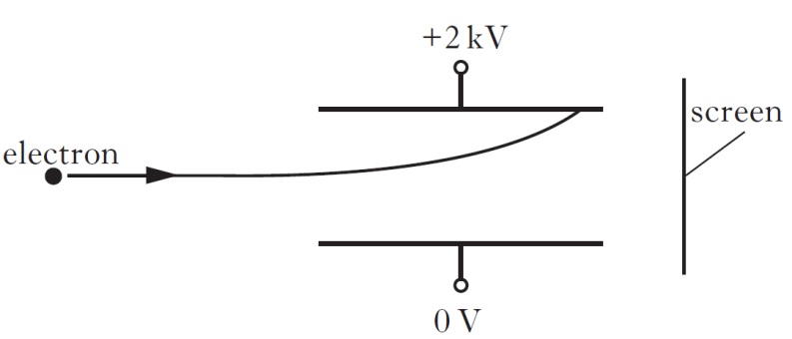  A potential difference of 2 kV is applied across two metal plates.  An electron passes between the metal plates and follows the path shown.  A student makes the following statements about changes that could be made to allow the electron to pass between the plates and reach the screen.  I Increasing the initial speed of the electron could allow the electron to reach the screen.  II Increasing the potential difference across the plates could allow the electron to reach the screen.  III Reversing the polarity of the plates could allow the electron to reach the screen.  Copy out the diagram and the correct statement(s)
9 b) | I know that electric fields exist around charged particles and between charged parallel plates.
Copy and complete these diagram to show the direction of the electric field.
+
+
+
+
+
+
+
+
+
+
+
+
-
-
-
-
-
-
-
-
-
-
-
-

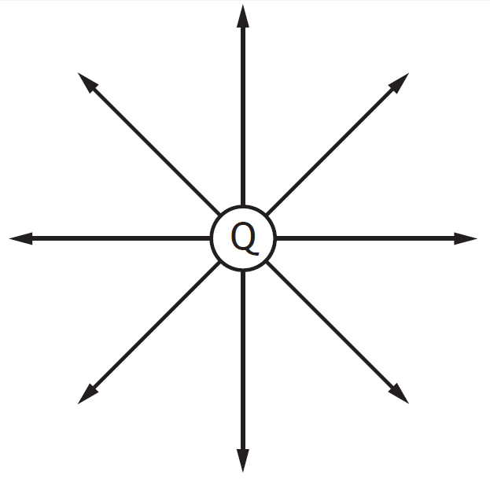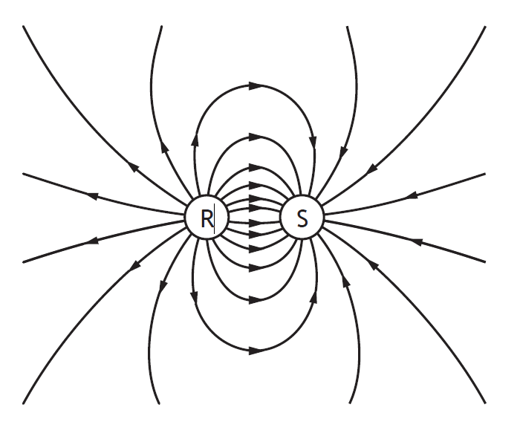
State the charge on particles Q, R and S
9 c) | I can sketch electric field patterns for single-point charges, systems of two-point charges and between two charged parallel plates (ignore end effects).
Draw the electric field pattern for the following point charges and pair of charges:
(a) (b) (c)

9 d) | I can determine the direction of movement of charged particles in an electric field.
Describe the motion of the small positive test charges in each of the following fields.
(a) (b
An electron travelling with a constant velocity enters a region where there is a uniform magnetic field. There is no change in the velocity of the electron. What information does this give about the magnetic field?

2. The diagram shows a beam of electrons as it enters the magnetic field between two magnets.
The electrons will:
A be deflected to the left (towards the N pole)
beam of
electrons
N
S
S
N
B be deflected to the right (towards the S pole)
C be deflected upwards
D be deflected downwards
E have their speed increased without any change in direction.

3. The diagrams show particles entering a region where there is a uniform magnetic field.

Use the terms: up, down, into the paper, out of the paper, left, right, no change in direction to describe the deflection of the particles in the magnetic field.

(a)
electron
magnetic field
(b)
magnetic field
alpha particle
(c)
neutron
magnetic field
(d)
proton
magnetic field
electron
magnetic field
(e)
proton
magnetic field
(f)
electron
x

x
x
x

x
x

x
x
x
x
x

x
x
x
x
x

x
x
x
x
x

x
x
x
x
magnetic field
(g)
proton
x

x

x

x

x

x

x

x

x

x

x

x

x

x

x

x

x

x

x

x

x

x

x

x

x

magnetic field
(h)

A proton enters a region of magnetic field as shown.
On entering the magnetic field the proton
….deflects into the page
….deflects out of the page
…. deflects towards the top of the page
…. deflects towards the bottom of the page
…. is not deflected.
      - Copy the diagrams below and describe the movement of the particle in the magnetic field.
      - Using the same magnetic fields as shown above replace each of the particles with an alpha particle. Describe the motion of the alpha particle due to the force from each field.
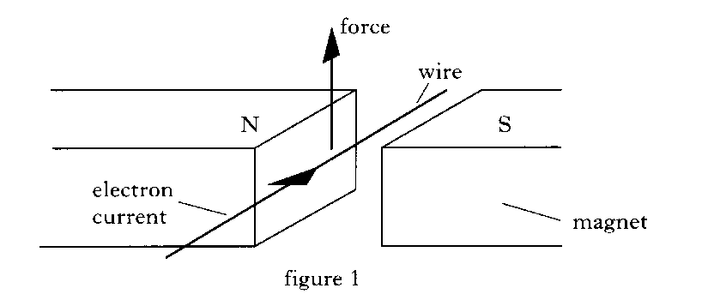
Adapted 1996 Credit Physics Paper

A current carrying wire is placed between the poles of a magnet. The direction of the electron current in the wire is as indicated in Figure 1. The conductor experiences an upward force as shown in Figure 1.
Draw a diagram to show the rule that determines the direction of the Force on this wire.
        - Figures 2 and 3 show other current carrying wires placed between the poles of the magnets. In each case, copy out the diagrams and indicate on figures 2 and 3 the direction of the force on the wire.
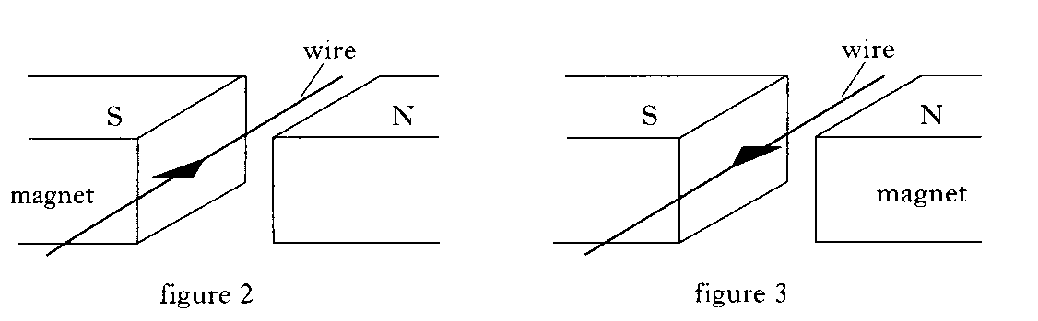

        - Figure 4 shows a simple electric motor with a coil WXYZ free to spin about a shaft PQ.
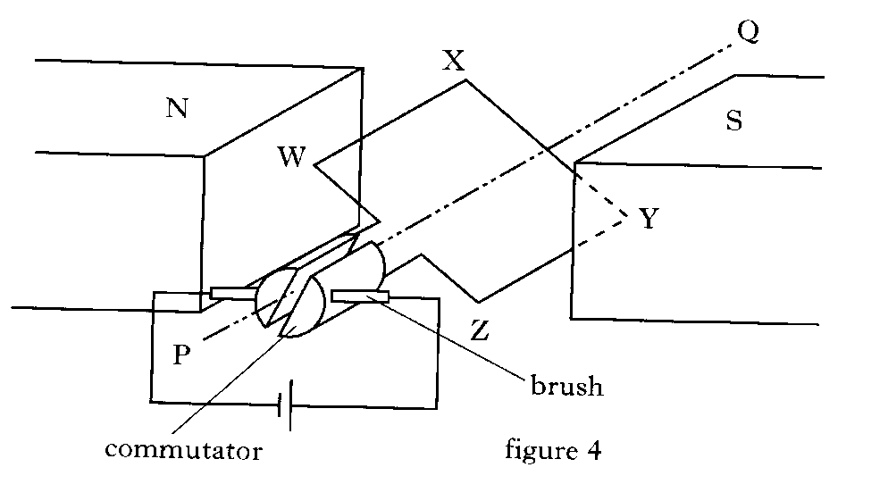
          - By looking at the diagram and using the conclusions you reached in part b) copy out the diagram and mark on your Figure 4
            - The direction of the electron current in the coil;
            - The directions of the forces on the coil;
            - The direction of the rotation of the coil.
        - In commercial motors, explain why;
          - More than one rotating coil is used;
          - Field coils rather than permanent magnets are used
An electron travels from west to east and passes into in a horizontal magnetic field directed towards the north.
        - Draw a labelled sketch to show this situation from above.
        - State the direction of the force on the electrons in the wire.
An electron is directed at 90° (right-angles) to the magnetic field lines of a horseshoe magnet.
The diagram shows the view from above the magnet. State the direction of the magnetic force.

The diagram shows from above a 0.1 m straight, horizontal length of metal wire which has been placed perpendicular (at 90°) to a horizontal magnetic field.
State the direction of the force on the electrons in the wire

An electron travels from south to north in a horizontal magnetic field directed from east to west.
(a) Draw a labelled sketch to show this situation from above.
(b) State the direction of the force.
A proton is placed parallel to a horizontal magnetic field.
- Draw a diagram of the set up
- State the direction of the force which acts on the proton.
9 e) | I can define voltage (potential difference)
 | Define the term potential difference
9 f) | I can solve problems involving the charge, mass, speed, and energy of a charged particle in an electric field and the potential difference through which it moves.
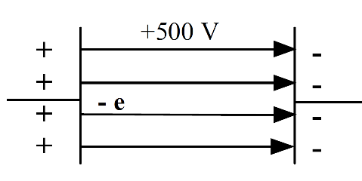
Mass of an electron = 9.1×10⁻³¹ kg
Charge on an electron = 1.6×10⁻¹⁹ C
The electron shown opposite is accelerated across a p.d. of 500 V.
(a) Calculate the electrical work done
(b) Calculate the kinetic energy it has gained
(c) Determine the final speed of the electron

An electron is accelerated from rest through a potential difference of 200 V. Calculate:
(a) the kinetic energy of the electron;
(b) the final speed of the electron.
Electrons released from the hot cathode are accelerated by a p.d. of 5.0 kV between the cathode and anode.
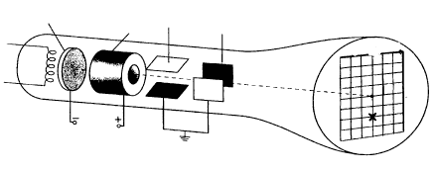
1) Assuming that an electron starts from rest at the cathode, calculate its speed just before it reaches the anode. (You may have to refer to the Science Data Booklet.)
2) State the effect on the speed of the electron just before it reaches the anode if the p.d. between the cathode and anode is halved. You must justify your answer.

(b) If the electron beam current is 15mA, determine the number of electrons that leave the cathode each second.
9 g) | I know that a moving charge produces a magnetic field.
9 h) | I can determine the direction of the force on a charged particle moving in a magnetic field for negative and positive charges using the slap rule or other method.
3. An electron volt (eV) is a unit of energy. It represents the change in potential energy of an electron that moves through a potential difference of 1 V. What is the equivalent energy of 1 eV in joules?
4. An electron has energy of 5 MeV. Calculate its energy in joules.

5. The diagram shows an electron accelerates between two parallel conducting plates A and B.
The p.d. between the plates is 500 V.

(a) Calculate the electrical work done in moving the electron from plate A to plate B.
(b) How much kinetic energy has the electron gained in moving from A to B?
(c) What is the speed of the electron just before it reaches plate B?

9 i) | I know the basic operation of particle accelerators in terms of acceleration by electric fields, deflection by magnetic fields and high-energy collisions of charged particles to produce other particles.
10. | Standard Model
10 a) | I have an understanding of the Standard Model
 | Explain what is meant by the term Standard Model.
A student makes the following statements about a proton.
I A proton is a fermion.
II A proton is a baryon.
III A proton is a meson.
Copy the correct statement(s)
The diagram shows a simple model of the atom.
Match each of the letters A, B, C and D with the correct word from the list below.
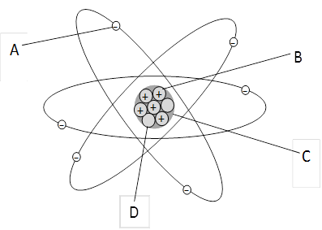
electron neutron nucleus proton


A science textbook contains the following diagram of an atom.

Use your knowledge of physics to comment on this diagram.

10 b) | I can describe the Standard Model in terms of types of particles and groups
Copy and complete the sentence:
An electron is a
boson, hadron, baryon, meson, lepton.
SQA Higher 2018
How many types of quark are there?
10 c) | I can use orders of magnitude and am aware of the range of orders of magnitude of length from the very small (sub-nuclear) to the very large (distance to furthest known celestial objects).
Prefix | Order of magnitude | Scientific notation | Decimal number
μ | 10–6 | 1 × 10–6 | 0·000 001
(1) | 103 | (2) | (3)
p | (4) | (5) | 0·000 000 000 001
(6) | 109 | 1 × 109 | (7)
(8) | 10–9 | (9) | (10)
Copy and complete the missing values to complete the table below. The first row is done for you.
List the following particles in order of size from smallest to largest.
electron; helium nucleus; proton
The table below lists ‘orders of magnitude’. From the list of dimensions given, place each in its appropriate place in the table.
Length of the Caledonian Canal Diameter of the Milky Way Smallest division on a tape measure Diameter of a proton Wavelength of ultraviolet light Diameter of a white blood cell Height of an oak tree Diameter of the Earth The worlds tallest building.
In the following table the numbers or words represented by the letters A, B, C, D, E, F and G are missing.

Order of magnitude/m | Object
10⁻¹⁵ | A
10⁻¹⁴ | B
10⁻¹⁰ | Diameter of hydrogen atom
10⁻⁴ | C
10⁰ | D
10³ | E
10⁷ | Diameter of Earth
10⁹ | F
10¹³ | Diameter of solar system
10²¹ | G
Match each letter with the correct words from the list below.
diameter of nucleus | diameter of proton | diameter of Sun
distance to nearest galaxy | height of Ben Nevis | size of dust particle

10 d) | I know that evidence for the existence of quarks comes from high-energy collisions between electrons and nucleons, carried out in particle accelerators.
10 e) | I know that in the Standard Model, every particle has an antiparticle.
 | The Standard Model refers to the best 'model' of matter we have from current research based on the particles things are made from and how they interact Describe the groups that make up the Standard Model
Name the particles represented by the following symbols.
(a) p (b) $\overline{p}$ (c) e (d)
(e) n (f) $\overline{n}$ (g) v (h) $\overline{ν}$

A particle can be represented by a symbol where M represents the mass number, A the atomic number and X identifies the type of particle, for example a proton can be represented by . Give the symbols, in this form, for the following particles.
(a) $\overline{p}$ (b) e (c) $\overline{e}$ (d) n (e) $\overline{n}$

 | Name the four types of leptons
 | State whether fermions are fundamental particles, you must explain your answer.
 | State the
Copy the statements that are correct
Three students each make a statement about antiparticles.
I An antiparticle has the same mass as its equivalent particle.
II An antiparticle has the same charge as its equivalent particle.
III Every elementary particle has a corresponding antiparticle.
Information on the sign and charge relative to proton charge of six types of quarks (and their corresponding antiquarks) is shown in the table.

Quark name | Charge relative to size of proton charge | Antiquark name | Charge relative to size of proton charge
Up | +2/3 | antiup | –2/3
Charm | +2/3 | anticharm | –2/3
Top | +2/3 | antitop | –2/3
Down | –1/3 | antidown | +1/3
strange | –1/3 | antistrange | +1/3
bottom | –1/3 | antibottom | +1/3
Calculate the charge of the following combinations of quarks:
- Information on the sign and charge relative to proton charge of six types of quarks (and their corresponding antiquarks) is shown in the table.

Quark name | Charge relative to size of proton charge | Antiquark name | Charge relative to size of proton charge
Up | +2/3 | antiup | –2/3
Charm | +2/3 | anticharm | –2/3
Top | +2/3 | antitop | –2/3
Down | –1/3 | antidown | +1/3
strange | –1/3 | antistrange | +1/3
bottom | –1/3 | antibottom | +1/3
Calculate the charge of the following combinations of quarks:
- two up quarks and one down quark
- one up quark and two down quarks
- two anti-up quarks and one anti-down quark
- one anti-up quark and two anti-down quarks.
- anti-up quark and two anti-down quarks.

The following diagram gives information on the Standard Model of Fundamental Particles and interactions
Use information from the diagram and your knowledge of physics to answer the following questions.
(a) Explain why particles such as leptons and quarks are known as Fundamental Particles.
(b) A particle called the sigma plus ( Σ+) has a charge of +1. It contains two different types of quark. It has two up quarks each having a charge of +2/3 and one strange quark. State the charge on the strange quark.
(c) Explain why the gluon cannot be the force mediating particle for the gravitational force.
Three students each make a statement about antiparticles.
I An antiparticle has the same mass as its equivalent particle.
II An antiparticle has the same charge as its equivalent particle.
III Every elementary particle has a corresponding antiparticle.
Copy out the correct statement(s)
An electron and another particle of identical mass pass through a uniform magnetic field. Their paths are shown in the diagram.

This observation provides evidence for the existence of
A neutrinos
B antimatter
C quarks
D protons
E force mediating particles.
10 f) | I know the evidence for the existence of antimatter
 | State what is meant by the term antimatter.
 | State one piece of evidence for the existence of antimatter
10 g) | I know the first evidence for the neutrino.
 | State the first evidence for the neutrino.
 | Explain how the evidence above lead to the discovery of the theory of a neutrino.
10 h) | I know the equation for β- decay (β+ decay not required)
 | State the equation for β- decay, ensure you explain each term.
10 i) | I know the term for matter particles
 | State the name of the group of matter particles
 | Matter particles can be divided into two groups. State the name of the two groups of particles.
Copy and complete the table by placing the fermions in the list below in the correct column of the table.
Bottom | charm | Down | electron | electron neutrino
Muon | muon neutrino |  | strange | tau
tau neutrino |  | Top | up

Quarks | Leptons

- State the difference between a hadron and a lepton in terms of the type of force experienced by each particle.
- Give one example of a hadron and one example of a lepton.
- To what group of particles do matter particles belong?

- To what group of particles do force mediating particles belong?

- Give examples of particles that are grouped under the heading of baryons.

- Give an example of a meson.

- Name a mediating particle which is responsible for a force which acts over
      - a short range;
      - an infinite range.

SQA NH 2017 Q7
The following diagram gives information on the Standard Model of fundamental particles.
(a) Explain why the proton and the neutron are not fundamental particles.
(b) An extract from a data book contains the following information about three types of sigma (Σ) particles. Sigma particles are made up of three quarks.
Particle | Symbol | Quark Content | Charge | Mean lifetime (s)
sigma plus | Σ+ | up up strange | +1 e | 8·0 × 10⁻¹¹
neutral sigma | Σ0 | up down strange | 0 7· | 4 × 10⁻²⁰
sigma minus | Σ− | down down strange | −1e | 1·5 × 10⁻¹⁰
(i) A student makes the following statement.
All baryons are hadrons, but not all hadrons are baryons.
Explain why this statement is correct.
(ii) The charge on an up quark is +2/3 e. Determine the charge on a strange quark.

(c)
(i) State the name of the force that holds the quarks together in the sigma (Σ) particle.

(ii) State the name of the boson associated with this force.

(d) Sigma minus (Σ−) particles have a mean lifetime of 1·5 ⋅ 10⁻¹⁰ s in their frame of reference.
Σ− are produced in a particle accelerator and travel at a speed of 0·9c relative to a stationary observer.
Calculate the mean lifetime of the Σ− particle as measured by this observer.
10 j) | I know the composition of hadrons.
 | State the meaning of the term hadron.
Hadrons can be divided into two types of particle,
- state the name of these groups
- explain the difference between these two types of hadrons.
 | State the particles that make up all hadrons.
 | A student states that “All hadrons are fundamental particles” Using your knowledge of Physics comment on the student’s statement.
How many types of quark are there?
8 | 6 | 4 | 3 | 2

 | State the names of the each group of hadron.
10 k) | I can define the term baryon.
 | Give three examples of a baryon
 | State what all baryons have in common.
10 l) | I know that mesons are made of quark–antiquark pairs.
 | State the difference between a meson and baryon.
 | Give three examples of mesons.
Physicists study subatomic particles using particle accelerators.
(a) Pions are subatomic particles made up of two quarks.
There are three types of pion:
π+ particles which have a charge of +1;
π– particles which have a charge of –1;
and π⁰ particles which have a zero charge.
The π+ particle is made up of an up quark and an anti-down quark.
(i) Is a pion classed as a baryon or a meson? Justify your answer.
(ii) The charge on an up quark is $+\frac{2}{3}$
Determine the charge on an anti-down quark.
(iii) The p– particle is the antiparticle of the π+ particle.
State the names of the quarks that make up a π– particle.
(iv) p+ particles have a mean lifetime of 2·6 × 10⁻⁸ s in their own frame of reference. In an experiment in a particle accelerator, p+ particles are accelerated to a velocity of 0·9 c.
Calculate the mean lifetime of these π⁺ particles relative to a stationary observer.
(b) Explain how particle accelerators, such as the Large Hadron Collider at CERN, are able to:
(i) accelerate charged particles;
(ii) deflect charged particles.
10 m) | I know that the force-mediating particles are bosons: photons (electromagnetic force), W- and Z-bosons (weak force), and gluons (strong force).
P&N Questions
State the group of particles to which force mediating particles belong.
State the name of the force mediating particles responsible for:
(i) the strong nuclear force;
(ii) the weak nuclear force.
 | State the mediating particle responsible for gravitational force
 | State the force which photons are responsible for
 | State the mediating particle which is responsible for a force which acts over a very short distance.
 | State the mediating particle which is responsible for a force which acts over a very large distance.
 | Protons have a positive charge. State the force that holds them together in the nucleus of an atom.
 | State the names of the three types of neutrinos
11. | Nuclear reactions
Eq | $$E=mc^{2}$$
11 a) | I can use nuclear equations to describe radioactive decay, fission (spontaneous and induced), with reference to mass and energy equivalence.
The last two changes in a radioactive decay series are shown below.
A Bismuth nucleus emits a beta particle and its product, a Polonium nucleus, emits an alpha particle.
$${}_{Q}^{P}{Bi} \underset{→}{ decay}{}_{S}^{R}{Bi} \underset{→}{ decay}{}_{82}^{208}{Pb}$$

Determine the numbers represented by P, Q, R and S
A smoke alarm contains a very small sample of the radioactive isotope
Americium-241, represented by the symbol

        - How many neutrons are there in a nucleus of this isotope?
        - This isotope decays by emitting alpha particles as shown in the following statement.
$${}_{95}^{241}{Am} →{}_{r}^{s}T+$$
(i) Determine the numbers represented by the letters r and s.
(ii) Identify the element T.
11 b) | I can use nuclear equations to describe fusion reactions, with reference to mass and energy equivalence.
11 c) | Use of an appropriate relationship to solve problems involving the mass loss and the energy released by a nuclear reaction. $E=mc^{2}$
11 d) | I know that nuclear fusion reactors require charged particles at a very high temperature (plasma) which have to be contained by magnetic fields.
11e | I can describe an experiment to verify the inverse square law for a point source of light
metre stick

low resistance voltmeter
selenium photovoltaic cell / light level meter

12. | Inverse square law
Eq | $I=\frac{P}{A}$ $I_{1}d_{1}^{2}=I_{2}d_{2}^{2}$
12 a) | I know that irradiance is the power per unit area incident on a surface.
12 b) | I can use the equation $I=\frac{P}{A}$ to solve problems involving irradiance, the power of radiation incident on a surface and the area of the surface.
12 c) | I know that irradiance is inversely proportional to the square of the distance from a point source.
12 d) | I can describe an experiment to verify the inverse square law for a point source of light
metre stick

low resistance voltmeter
selenium photovoltaic cell / light level meter

SQA Revised Higher2012
A student investigates how irradiance I varies with distance d from a small lamp.
The following apparatus is set up in a darkened laboratory.
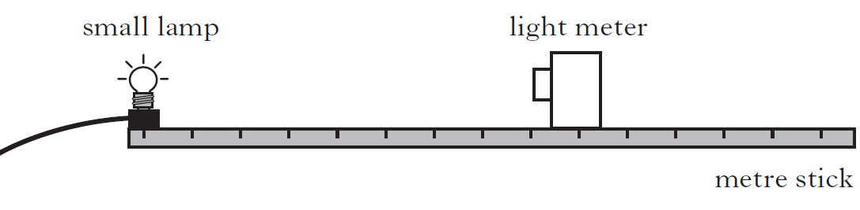
The results are used to produce the following graph.
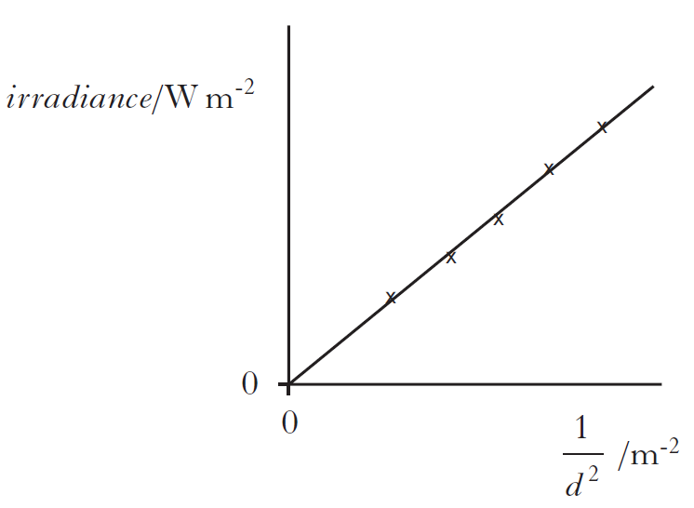
(a) Explain why this graph confirms the relationship $I =\frac{k}{d^{2}}$
(b) The irradiance of light from the lamp at a distance of 1·6 m is 4·0 W m⁻².
Calculate the irradiance of the light at a distance of 0·40 m from the lamp.
(c) The experiment is repeated with the laboratory lights switched on.
Copy the graph shown and, on the same axes, draw another line to show the results of the second experiment.
12 e) | I can use and $I_{1}d_{1}^{2}=I_{2}d_{2}^{2}$ to solve problems involving irradiance and distance from a point source of light.
 | Light from a point source is incident on a screen. The screen is 3∙0 m from the source. The irradiance at the screen is 8∙0 W m⁻². The light source is now moved to a distance of 12 m from the screen, calculate the irradiance now at the screen.
13. | Wave Particle Duality
Eq | $E=hf$ $E=\frac{hc}{λ}$ $E_{k}=hf-hf_{0} E_{k}=\frac{1}{2}mv^{2} and v=fλ$
13 a) | I know that evidence for the particle model of light.
i | State evidence for the particle model of light
13 b) | I know that photons of sufficient energy can eject electrons from the surface of materials (photoemission).
Part of the energy level diagram for an atom is shown.
X and Y represent two possible electron transitions.
Which of the following statements is/are correct?

I Transition Y produces photons of higher frequency than transition X.
II Transition X produces photons of longer wavelength than transition Y.
III When an electron is in the energy level E₀, the atom is ionised.

Copy out the correct statements
13 c) | I can use $E=hf$ and $E=\frac{hc}{λ}$ to solve problems involving the frequency and energy of a photon.
 | Electromagnetic radiation of frequency 9·0 × 10¹⁴ Hz is incident on a clean metal surface. The work function of the metal is 5·0 × 10^{–19} J. The maximum kinetic energy of a photoelectron released from the metal surface
13 d) | I know that the threshold frequency, f₀ is the minimum frequency of a photon required for photoemission.
13 e) | I know that the work function, W or hf₀ of a material is the minimum energy of a photon required to cause photoemission.
13 f) | I can use $E_{k}=hf-hf_{0}$ $E_{k}=\frac{1}{2}mv^{2} and v=fλ$ to solve problems involving the mass, maximum kinetic energy and speed of photoelectrons, the threshold frequency of the material, and the frequency and wavelength of the photons.
14. | Interference
Eq | $path difference=mλ or \left(m+\frac{1}{2}\right)λ$ where m =0,1,2. $d sinθ=mλ$
14 a) | I know the evidence for the wave model of light.
Which of the following proves that light is transmitted as waves?
- Light has a high velocity.
- Light can be reflected.
- Light irradiance reduces with distance.
- Light can be refracted.
- Light can produce interference patterns.
 | State the physical quantity dependant on the amplitude of a wave
 | When light waves are all in __________, we say that they are c________. When they are ____ of ______, there is no fixed relationship between the phases of the components that make up the beam.
 | State the test to determine whether some phenomenon is a wave process
 | State two characteristics behaviours of all waves
14 b) | I know that coherent waves have a constant phase relationship.
 | State the meaning of the term coherent.
If we have two coherent sources of light, each with wavelength, L, state the path
difference which gives,
(a) a maximum in the interference pattern
(b) a minimum in the pattern
14 c) | I can describe of the conditions for constructive and destructive interference in terms of the phase difference between two waves.
 | Explain the difference between constructive and destructive interference in terms of superposition of waves.
14 d) | I know that maxima are produced when the path difference between waves is a whole number of wavelengths
Two coherent light sources each produce light of wavelength 500 nm. If the
path difference between a point P and each source is 1.00 mm, determine the type of interference at P
14 e) | I know that minima are produced when the path difference between waves is an odd number of half-wavelengths respectively.
Waves from two coherent sources, S1 and S2, produce an interference pattern. Maxima are detected at the positions shown below.
The path difference S1P − S2P is 154 mm. Calculate the wavelength of the waves.
14 f) | I can use $path difference=mλ or \left(m+\frac{1}{2}\right)λ$ where m =0,1,2...  to solve problems involving the path difference between waves, wavelength and order number.
S1 and S2 are sources of coherent waves.
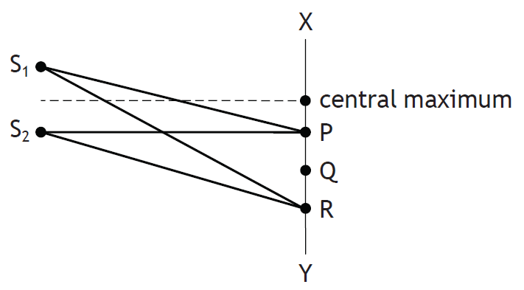
An interference pattern is obtained between X and Y.
The first order maximum occurs at P, where S1P = 200 mm and S2P = 180 mm.
Calculate the path difference (S1R − S2) for the third order maximum, at R.

SQA Higher 2010
A student is carrying out an experiment to investigate the interference of sound waves. She sets up the following apparatus.
The microphone is initially placed at point X which is the same distance from each loudspeaker. A maximum is detected at X.
(a) The microphone is now moved to the first minimum at Y as shown.
Calculate the wavelength of the sound waves.
(b) Loudspeaker 1 is now disconnected.
What happens to the amplitude of the sound detected by the microphone at Y?

14 g) | I can use $d sinθ=mλ$ to solve problems involving grating spacing, wavelength, order number and angle to the maximum.
 | State the effect of a grating on a beam of monochromatic light.
 | State the approximate wavelengths of red, green, and blue light
 | Describe a white light spectrum and how you can tell from its appearance whether it is made by a prism or a grating.
 | A grating has a line spacing of 0.01mm and causes a deviation of 17.46o between the central maximum and the 5th order maximum. What is the wavelength of the incident light?
 | Make a list of the measurements we need when finding the wavelength of a monochromatic light using a grating.
15. | Spectra
Eq | $E_{2}-E_{1}=hf$ and
15 a) | I have knowledge of the Bohr model of the atom.
SQA Higher 2018
In a laboratory experiment, light from a hydrogen discharge lamp is used to produce a line emission spectrum. The line spectrum for hydrogen has four lines in the visible region as shown.
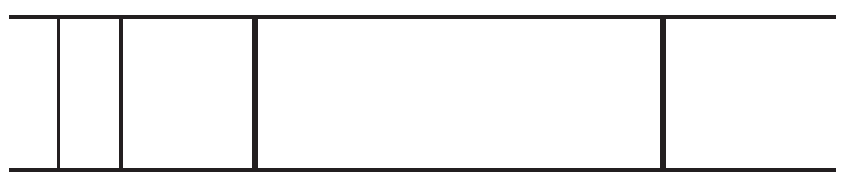
        - The production of the line spectrum can be explained using the Bohr model of the atom.
        - State two features of the Bohr model of the atom.
15 b) | I can explain the Bohr model of the atom using the terms ground state, energy levels, ionisation and zero potential energy.
15 c) | I know the mechanism of production of line emission spectra, continuous emission spectra and absorption spectra in terms of electron energy level transitions.
a) A sodium vapour lamp emits bright yellow light when electrons make transitions from one energy level to another within the sodium atoms.
- State whether electrons are moving to a higher or lower energy level when the light is emitted.
- Using the information provided in the data sheet, calculate the energy difference between these two electron energy levels in the sodium atom. 4

- A Bunsen flame containing vaporised sodium is placed between a sodium vapour lamp and a screen as shown.
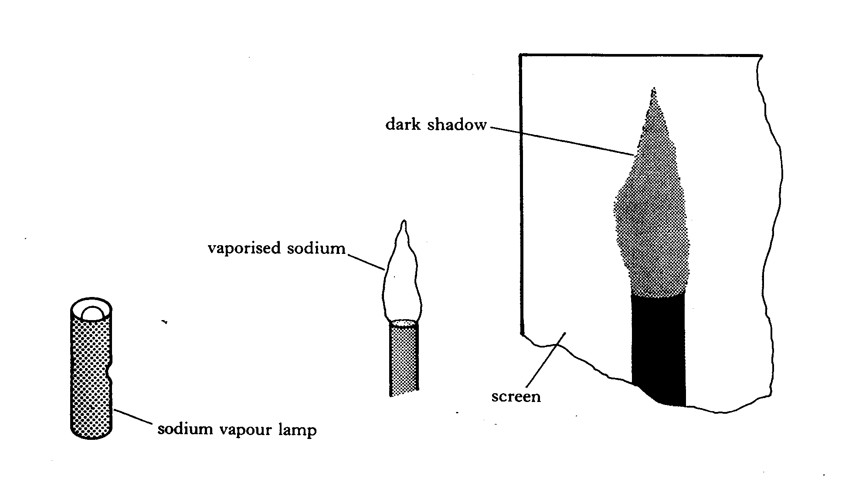
- Explain why a dark shadow of the flame is seen on the screen.
- The sodium vapour lamp is replaced with a cadmium vapour lamp.
Explain why there is now no dark shadow of the flame on the screen. 2
- The work function of sodium metal is 2.9 × 10 ⁻¹⁹ J.
Light of wavelength 5.4 ×10 ⁻⁷ m strikes the surface of this metal. What is the kinetic energy of the electrons emitted from the surface? 3
(9)

15 d) | I can use $E_{2}-E_{1}=hf$ and to solve problems involving energy levels and the frequency of the radiation emitted/absorbed.
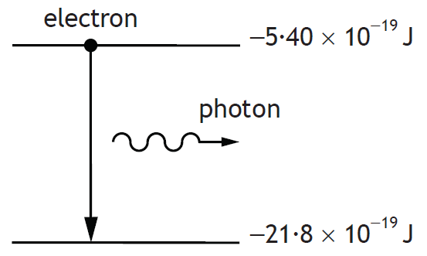

In an atom, a photon is emitted when an electron makes a transition from a higher energy level to a lower energy level as shown.
Calculate the wavelength of the radiation emitted due to an electron transition between the two energy levels shown.
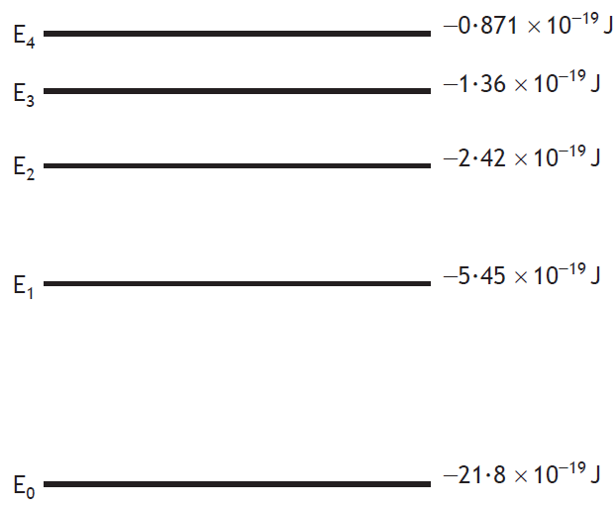
SQA Higher 2018
Some of the energy levels of the hydrogen atom are shown.

One of the spectral lines is due to electron transitions from E₃ to E1.
Determine the frequency of the photon emitted when an electron makes this transition.
15 e) | I know that the absorption lines (Fraunhofer lines) in the spectrum of sunlight provide evidence for the composition of the Sun’s outer atmosphere.
SQA Higher 2015
Light from the Sun is used to produce a visible spectrum.
A student views this spectrum and observes a number of dark lines as shown.
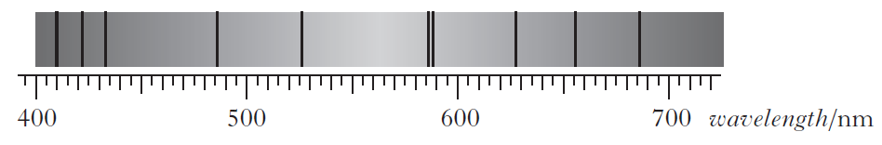
(a) Explain how these dark lines in the spectrum of sunlight are produced.
(b) One of the lines is due to hydrogen.
The position of this hydrogen line in the visible spectrum is shown for a distant galaxy, a nearby galaxy and the Sun.

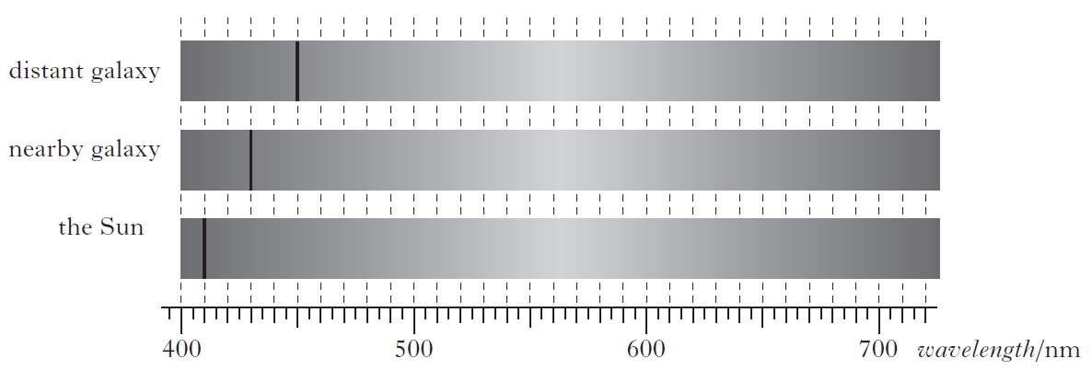 (i) Explain why the position of the line is different in each of the spectra.
(ii) Show that the redshift of the light from the distant galaxy is 0·098.
(iii) Calculate the approximate distance to the distant galaxy.
(c) Explain why the spectra in the diagram in part (b) support the theory of the expanding Universe.
16. | Refraction
Eq | $n=\frac{\sin{θ_{1}}}{\sin{θ_{2}}}=\frac{λ_{1}}{λ_{2}}=\frac{v_{1}}{v_{2}}$ and $v=fλ$ and
16 a) | I can define absolute refractive index of a medium.
i | Define the absolute refractive index of a medium
ii | State the ratio of the two measurements that remain constant when light travels obliquely from medium 1 to medium 2.
16 b) | I can use $n=\frac{\sin{θ_{1}}}{\sin{θ_{2}}}$ to solve problems involving absolute refractive index, the angle of incidence and the angle of refraction.
The frequency of a source is 10Hz and the speed of the waves it produces is
2ms-1. If these waves subsequently enter a medium where their speed
doubles to 4ms-1, what is their frequency?
16 c) | I can describe an experiment to determine the refractive index of a medium.
 | Describe the procedure for measuring the absolute refractive index of glass using monochromatic light.
16 d) | I can use $\frac{\sin{θ_{1}}}{\sin{θ_{2}}}=\frac{λ_{1}}{λ_{2}}=\frac{v_{1}}{v_{2}}$ and $v=fλ$ to solve problems involving the angles of incidence and refraction, the wavelength of light in each medium, the speed of light in each medium, and the frequency, including situations where light is travelling from a more dense to a less dense medium.
I | A glass block of absolute refractive index 1.56 has a ray of light incident upon it at an angle of 45.1°. Calculate the angle between this ray and the normal inside the block.
A ray of red light travels from air into water.
State the change, if any, in speed and frequency of a ray of red light as it travels from air into water.
A ray of monochromatic light passes from air into a block of glass as shown.

The wavelength of this light in air is 6·30 ⋅ 10⁻⁷ m.
The refractive index of the glass for this light is 1·50.
Calculate the frequency of this light in the glass
16 e) | I know that the refractive index of a medium increases as the frequency of incident radiation increases.
16 f) | I can define critical angle
 | Define the critical angle of a Perspex block.
16 g) | I know that total internal reflection occurs when the angle of incidence is greater than the critical angle.
16 h) | I can use to solve problems involving critical angle and absolute refractive index.

Electricity

No | CONTENT
17. | Monitoring and Measuring A.C.
eq | $V_{rms}=\frac{V_{peak}}{\sqrt{2}}$ $I_{rms}=\frac{I_{peak}}{\sqrt{2}}$
17a) | I know that an A.C. is a current which changes direction and instantaneous value with time.
17b) | I can use $V_{rms}=\frac{V_{peak}}{\sqrt{2}}$ $I_{rms}=\frac{I_{peak}}{\sqrt{2}}$ to solve problems involving peak and r.m.s. values.
 | The rms voltage of the mains supply is 230 V. Calculate the approximate value of the peak voltage.
17c) | I can determine the frequency, peak voltage and r.m.s. values from graphical data.
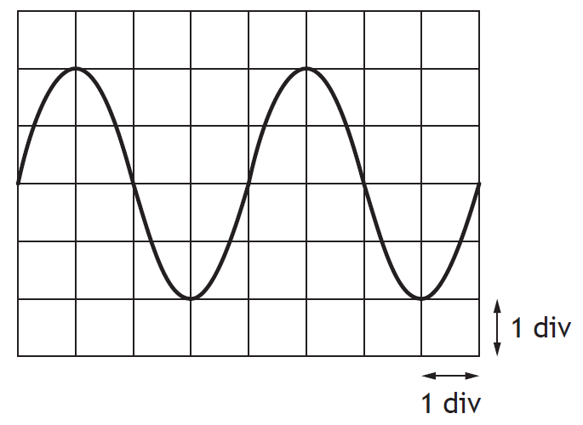
An oscilloscope is connected to the output terminals of a signal generator.
The trace displayed on the screen is shown.
The timebase of the oscilloscope is set at 30 ms/div.
Calculate the frequency of the output signal from the signal generator
 | .
A signal from a power supply is displayed on an oscilloscope.
The trace on the oscilloscope is shown.
The time-base is set at 0.01 s/div and the Y-gain is set at 4.0 V/div.
Calculate the r.m.s. voltage and the frequency of the signal.
SQA Higher 2010
A signal generator is connected to a lamp, a resistor and an ammeter in series. An oscilloscope is connected across the output terminals of the signal generator.

The oscilloscope control settings and the trace displayed on its screen are shown.

(a) For this signal calculate:
(i) the peak voltage;
(ii) the frequency.
(b) The frequency is now doubled. The peak voltage of the signal is kept constant.
State what happens to the reading on the ammeter.
(c) The resistor is now replaced by a capacitor.
The procedure in part (b) is repeated.
State what happens to the reading on the ammeter as the frequency is doubled.
17d) | I can use to determine the frequency.
18. | Current, potential difference, power and resistance
eq
Eq
a) | I can use relationships involving potential difference, current, resistance and power to analyse circuits even those that may involve several steps in the calculations.
A length of electrical cable for use at high voltages consists of a steel alloy conductor surrounded by six aluminium conductors as shown in the diagram.
The resistance of one kilometre of each type of conductor is shown below.
Resistance of 1 km of aluminium conductor = 0.60 Ω
Resistance of 1 km of steel alloy conductor = 4.0 Ω
Calculate the resistance of one kilometre of this cable. Give your answer to three decimal places. er
Marks
Another type of electrical cable has a much thicker conductor, of the same steel alloy, surrounded by nine aluminium conductors as shown.
The aluminium conductors have the same cross section area as those above.
Explain in what way does the resistance of 1 km of this cable differ from the resistance of 1 km of the cable above, you must justify your answer. 2
b) | I can correctly use calculations involving potential dividers circuits.
19. | Electrical sources and internal resistance
eq
a) | I can correctly use and explain the terms electromotive force (E.M.F), internal resistance, lost volts, terminal potential difference (t.p.d) ideal supplies, short circuits and open circuits.
Copy and complete the following using the correct statement to finish the sentence
The EMF of a battery is
……the total energy supplied by the battery
……the voltage lost due to the internal resistance of the battery
……the total charge that passes through the battery
……the number of coulombs of charge passing through the battery per second
……the energy supplied to each coulomb of charge passing through the battery.

b) | I can use $E=V+Ir$ and $V=IR$to solve problems involving EMF, lost volts, t.p.d., current, external resistance, and internal resistance.
c) | I can describe of an experiment to measure the EMF and internal resistance of a cell.
d) | I can determine electromotive force, internal resistance and short circuit current using graphical analysis.
20. | Capacitors
eq
a) | I know that a capacitor of 1 farad will store 1 coulomb of charge when the potential difference across it is 1 volt.
b) | I can use the equation C=Q/V to solve problems involving capacitance, charge and potential difference.
c) | I can use the equation Q = It to determine the charge stored on a capacitor for a constant charging current.
25. A student carries out three experiments to investigate the charging of a capacitor using a DC supply.
The graphs obtained from the experiments are shown.
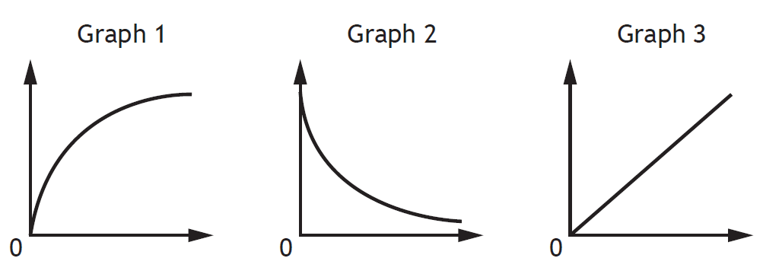
The axes of the graphs have not been labelled.
Which row in the table shows the labels for the axes of the graphs?

 | Graph 1 | Graph 2 | Graph 3
A | voltage and time | charge and voltage | current and time
B | current and time | voltage and time | charge and voltage
C | current and time | charge and voltage | voltage and time
D | voltage and time | current and time | charge and voltage
E | charge and voltage | current and time | voltage and time

The capacitance of a capacitor is 1000 μF. The potential difference (p.d.) across the capacitor is 100 V. The charge stored by the capacitor is 0∙10 C. The charge on the capacitor is now reduced to half its original value.
Calculate the capacitance of the capacitor and the p.d. across the capacitor, for this new value of charge.
d) | I know the total energy stored in a charged capacitor is equal to the area under a charge-potential difference graph.
The graph shows how the charge, Q, stored on a capacitor varies with the potential difference, V, across the capacitor.

Copy the statement(s) which is/are true
I The gradient of the graph represents the capacitance of the capacitor.
II The area under the graph represents the work done in charging the capacitor.
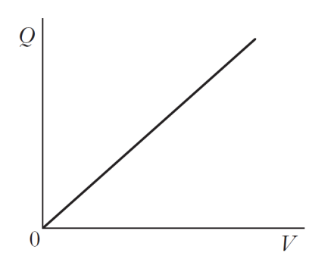
III The energy, E, stored in the capacitor is given by the equation E = QV.
e) | I can use $E=\frac{1}{2}QV=\frac{1}{2}CV^{2}=\frac{1}{2}\frac{Q^{2}}{C}$ to solve problems involving energy, charge, capacitance, and potential difference.
f) | I know the variation of current with time for both charging and discharging cycles of a capacitor in an RC circuit (charging and discharging curves).
g) | I know the variation of potential difference with time for both charging and discharging cycles of a capacitor in an RC circuit (charging and discharging curves).
h) | I know the effect of resistance and capacitance on charging and discharging curves in an RC circuit.
i) | I can describe experiments to investigate the variation of current in a capacitor and voltage across a capacitor with time, for the charging and discharging of capacitors
21. | Semiconductors and p-n junctions
a) | I know and can explain the terms conduction band and valence band.
b) | I know that solids can be categorised into conductors, semiconductors or insulators by their band structure and their ability to conduct electricity. Every solid has its own characteristic energy band structure. For a solid to be conductive, both free electrons and accessible empty states must be available.
Copy and complete the following passage replacing the letters X, Y and Z, which each represent a missing word.

Materials can be divided into three broad categories according to their electrical resistance.
X have a very high resistance.Y have a high resistance in their pure form but when small amounts of certain impurities are added, the resistance decreases. Z. have a low resistance.
A crystal of silicon is “doped” with arsenic. This means that a small number of the silicon atoms are replaced with arsenic atoms. The effect of the doping on the crystal is to
…. make it into a photodiode
…. make it into an insulator
…. increase its resistance
…. decrease its resistance
…. allow it to conduct in only one direction.
Copy and complete the paragraph using the correct ending statement.
c) | I can explain qualitatively the electrical properties of conductors, insulators and semiconductors using the electron population of the conduction and valence bands and the energy difference between the conduction and valence bands. (Reference to Fermi levels is not required.)
SQA Revised Higher 2013
Use band theory to explain how electrical conduction takes place in a pure semiconductor such as silicon. Your explanation should include the terms: electrons, valence band and conduction band.
d) | I know that the electrons in atoms are contained in energy levels. When the atoms come together to form solids, the electrons then become contained in energy bands separated by gaps.
e) | I know that for metals we have the situation where one or more bands are partially filled.
f) | I know that some metals have free electrons and partially filled valence bands, therefore they are highly conductive.
g) | I know that some metals have overlapping valence and conduction bands. Each band is partially filled and therefore they are conductive.
h) | I know that in an insulator, the highest occupied band (called the valence band) is full. The first unfilled band above the valence band is the conduction band. For an insulator, the gap between the valence band and the conduction band is large and at room temperature there is not enough energy available to move electrons from the valence band into the conduction band where they would be able to contribute to conduction. There is no electrical conduction in an insulator.
i) | I know that in a semiconductor, the gap between the valence band and conduction band is smaller and at room temperature there is sufficient energy available to move some electrons from the valence band into the conduction band allowing some conduction to take place. An increase in temperature increases the conductivity of a semiconductor.
j) | I know that, during manufacture, semiconductors may be doped with specific impurities to increase their conductivity, resulting in two types of semiconductor: p-type and n-type.
k) | I know that, when a semiconductor contains the two types of doping (p-type and n- type) in adjacent layers, a p-n junction is formed. There is an electric field in the p-n junction. The electrical properties of this p-n junction are used in a number of devices.
l) | I know and can explain the terms forward bias and reverse bias. Forward bias reduces the electric field; reverse bias increases the electric field in the p-n junction.
SQA Higher 2018
A signal generator is connected to an oscilloscope and a circuit as shown.
The student observes that the red LED is only lit when the ammeter gives a positive reading and the green LED is only lit when the ammeter gives a negative reading.
Explain these observations.
m) | I know that LEDs are forward biased p-n junction diodes that emit photons. The forward bias potential difference across the junction causes electrons to move from the conduction band of the n-type semiconductor towards the conduction band of the p- type semiconductor. Photons are emitted when electrons ‘fall’ from the conduction band into the valence band either side of the junction
SQA Higher 2018
A student connects a red LED and a blue LED, in turn, to a potato battery.
The LEDs are forward biased when connected.
The student observes that the battery will operate the red LED but not the blue LED.
The diagram represents the band structure of the blue LED.

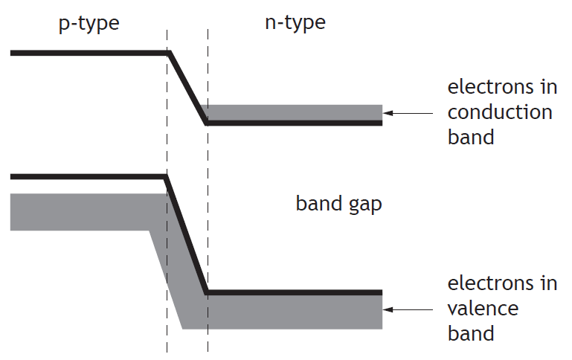
LEDs emit light when electrons fall from the conduction band into the valence band of the p-type semiconductor.
Explain, using band theory, why the blue LED will not operate with this battery.
n) | I know that solar cells are p-n junctions designed so that a potential difference is produced when photons are absorbed. (This is known as the photovoltaic effect.) The absorption of photons provides energy to ‘raise’ electrons from the valence band of the semiconductor to the conduction band. The p-n junction causes the electrons in the conduction band to move towards the n-type semiconductor and a potential difference is produced across the solar cell.

SKILLS,Variables & ANALYSIS Questions
Paper | Question
SQA Rev Higher 2013 | A student is investigating how the magnetic field strength at the centre of a coil of wire depends on the direct current in the coil. The strength of the magnetic field is measured with a magnetic field sensor placed in the centre of the coil. The sensor is connected to a computer as shown.  The computer displays values of magnetic field strength. The unit of magnetic field strength is the tesla (T).  (a) The student designs a circuit to vary and measure the current in the coil of wire. The circuit symbol for a coil of wire is shown.  Draw a circuit diagram to show how the current in the coil could be varied and measured.  (b) The following results are obtained.  Using graph paper, plot a graph of magnetic field strength against current.  (c) The student concludes that the results show that there is a systematic uncertainty in the measurements.  Suggest a reason why the student has come to this conclusion.
  Current in coil/A | Magnetic field strength/T
  0·20 | 1·4 × 10⁻⁴
  0·40 | 2·4 × 10⁻⁴
  0·60 | 3·0 × 10⁻⁴
  0·80 | 3·6 × 10⁻⁴
  1·00 | 4·6 × 10⁻⁴
SQA 2019
SQA 2018 | A student sets up an experiment to investigate the pressure due to a liquid as shown.  The pressure due to a liquid is given by the relationship  $$p = ρgh$$  where p is the pressure due to the liquid in pascals (Pa),  g is the gravitational field strength in N kg⁻¹,  ρ is the density of the liquid in kg m⁻³,  and h is the depth in the liquid in m.  (a) The student initially carries out the investigation using water.  The density of water is 1·00 × 103 kg m⁻³.  Calculate the pressure due to the water at a depth of 0·35 m.  (b) The student repeats the experiment with a different liquid.  The pressure meter is set to zero before the glass tube is lowered into the liquid. The student takes measurements of the pressure at various depths below the surface of the liquid.  The student records the following information.  (i) Draw a graph of p against h using graph paper.  (ii) Calculate the gradient of your graph.  (iii) Determine the density of this liquid.
  Depth, h (m) | Pressure, p (kPa)
  0·10 | 1·2
  0·20 | 2·5
  0·30 | 3·6
  0·40 | 4·9
  0·50 | 6·2
SQA 2014

Prescribed Practical Experiments
One example of a method has been exemplified for each practical. Many more alternatives are available and just as good.
1e | An experiment to measure the acceleration of an object down a slope
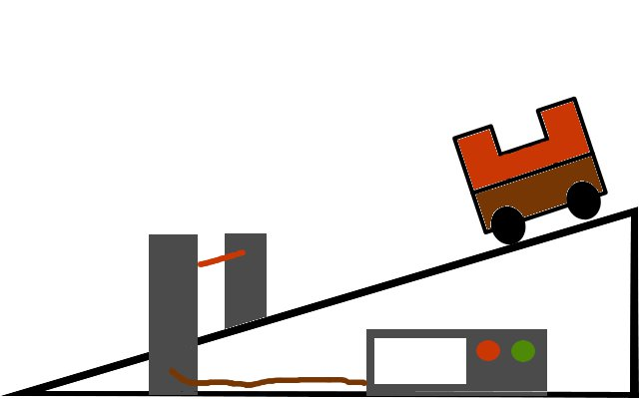

- Explain how this apparatus can be used to measure the acceleration of an object down a slope.
- Explain all the procedures you can take to minimise the uncertainties in your experiment.
4b | An experiment to measure the acceleration of a falling object.
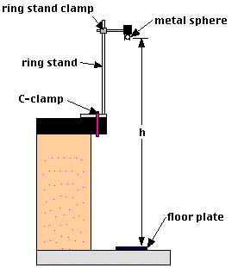

- Explain how this apparatus can be used to measure the acceleration of a falling object.
- Explain all the procedures you can take to minimise the uncertainties in your experiment.
15c | I can describe an experiment to determine the refractive index of a medium.
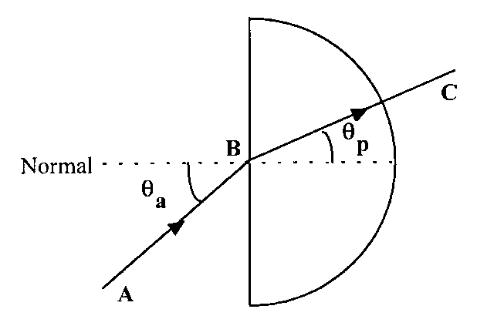

- Explain how this apparatus can be used to determine the refractive index of a medium.
- Explain all the procedures you can take to minimise the uncertainties in your experiment.
19c | I can describe of an experiment to measure the EMF and internal resistance of a cell.
A
V
A

- Explain how this apparatus can be used to measure the E.M.F and internal resistance of a cell.
- Explain all the procedures you can take to minimise the uncertainties in your experiment.
20i | I can describe experiments to investigate the variation of current in a capacitor and voltage across a capacitor with time, for the charging and discharging of capacitors
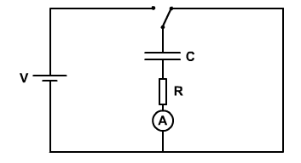

- Explain how this apparatus can be used to investigate the variation of current in a capacitor and voltage across a capacitor with time, for the charging and discharging of capacitors
- Explain all the procedures you can take to minimise the uncertainties in your experiment.

Notes

