
H

Higher Assignment
Guide Sheet B: Acceleration down slope

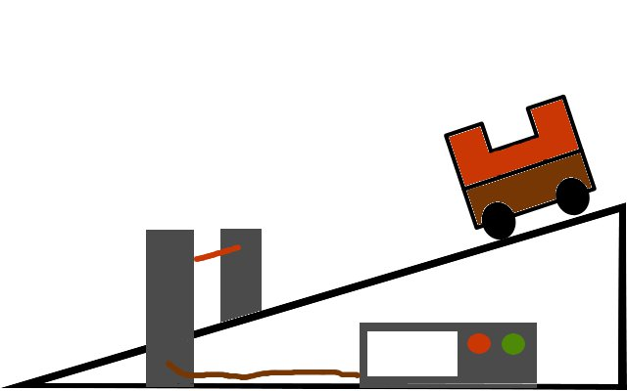

Instructions:

- Set up the apparatus as shown in the diagram.
- Measure the width of the masks, they should be equal.
- Measure the angle of the slope
- After selecting the acceleration programme, allow the trolley to run down the track.
- Repeat for a range of values
- Present the results to show how the angle of the slope affects the acceleration.

