
H

Higher Assignment
Guide Sheet A: 1/d²

Apparatus

12 V power supply, 12 V lamp, light sensor and/or light level meter, metre stick.

Instructions:
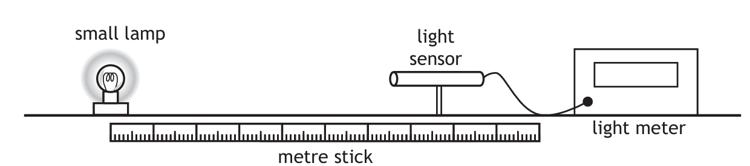

- Darken the room.
- Place the light detector a distance from the lamp.
- Measure the distance from the light detector to the lamp and the intensity of the light at this distance.
- Repeat for different distances between detector and lamp.
- Present your results.

Risk Assessment
- The light bulb may get hot, do not touch it.
- Do an electrical safety check by observing all the wires.
- Be observant to those around you.
- Do not overload the power supply or put too large a voltage across the bulb.

